

**CAPSTONE PROJECT REPORT**

**Report 3 – System Requirement Specification**

– Ho Chi Minh, January 2022 –

**Table of Contents**

III. Software Requirement Specification 11

1. Overall Description 11

1.1 Product Overview 11

1.2 Business Rules 11

2. User Requirements 18

2.1 Overview 18

2.1.1. Use Case Diagram 18

2.1.2. System Actors 19

2.1.3. Use Cases List 19

2.2. Use case specification 21

2.2.1 UC01 – Login 21

2.2.2 UC02 – Create account 23

2.2.3 UC03 – Update account 25

2.2.4 UC04 – Disable account 27

2.2.5 UC05 – View account list 28

2.2.6 UC06 – Reset password 30

2.2.7 UC07 – View account detail 31

2.2.8 UC08 – Create subject 33

2.2.9 UC09 – Update subject 34

2.2.10 UC10 – Disable subject 36

2.2.11 UC11 - View subject list 37

2.2.12 UC12 – Create semester 38

2.2.13 UC13 – Update semester 40

2.2.14 UC14 – Disable semester 41

2.2.15 UC15 – View semester list 43

2.2.16 UC16 – View semester detail 44

2.2.17 UC17 - Add subject to semester 46

2.2.18 UC18 – Remove subject from semester 47

2.2.19 UC19 – Create tool 48

2.2.20 UC20 – Update tool 50

2.2.21 UC21– Disable tool 51

2.2.22 UC22 – View tool list 52

2.2.23 UC23– Add tool to subject 54

2.2.24 UC24 – Remove tool from subject 55

2.2.25 UC25 – Create room 56

2.2.26 UC26 – Update room 58

2.2.27 UC27 – Disable room 59

2.2.28 UC28 – View room list 60

2.2.29 UC29 – View room detail 62

2.2.30 UC30 – Logout 63

2.2.31 UC31 – Change password 64

2.2.32 UC32 – View profile 66

2.2.33 UC33 – Update profile 67

2.2.34 UC34 – View notification list 69

2.2.35 UC35 – Update attendance 70

2.2.36 UC36 – View attendances of exam room 71

2.2.37 UC37 – Create report 72

2.2.38 UC38 – View assigned exam rooms 74

2.2.39 UC39 – View current exam rooms’ detail 75

2.2.40 UC40 – Register shift 76

2.2.41 UC41 – View report list 78

2.2.42 UC42 – Update report 79

2.2.43 UC43 – Create shift 80

2.2.44 UC44 – Update shift 82

2.2.45 UC45 – Delete shift 84

2.2.46 UC46 – View shift list 85

2.2.47 UC47 – View shift detail 87

2.2.48 UC48 – Lock shift 88

2.2.49 UC49 – Start shift registration 90

2.2.50 UC50 – Import examinees 91

2.2.51 UC51 – Remove examinees from semester’s subjects 92

2.2.52 UC52 – View subject assignments list 94

2.2.53 UC53 – Create exam room 95

2.2.54 UC54 – Update exam room 97

2.2.55 UC55 – Remove exam room 98

2.2.56 UC56 – View exam room detail 100

2.2.57 UC57 – Create attendance 101

2.2.58 UC58 – Delete attendance 103

2.2.59 UC59 – Export attendance 104

2.2.60 UC60 – View report list 105

2.2.61 UC61 – View report detail 107

2.2.62 UC62 – Resolve report 108

2.2.63 UC63 – View own exam schedules 109

2.2.64 UC64 – Check attendance 110

2.2.65 UC65 – Export locked shifts 112

2.2.66 UC66 – Assign staff 113

2.2.67 UC67 – Auto assign shifts 114

2.2.68 UC68 – View subject assignment detail 116

3. Functional Requirements 118

3.1 System Functional Overview 118

3.1.1. Screen Flow 118

● Manager 118

● Shift manager 118

● Staff 118

● Examinee 119

● Camera 119

3.1.2. Screen Authorization 120

3.1.3. Non-Screen Functions 122

3.1.5 Entity Relationship Diagram 123

● Non-attributes Entity Relationship Diagram (Crow’s foot notation) 123

● Entity Relationship Diagram (Crow’s foot notation) 123

● Entities list 124

4. Non-Functional Requirements 125

4.1 External Interfaces 125

a. User Interfaces 125

b. Software Interfaces 125

c. Hardware Interfaces 125

d. Communications Interfaces 125

4.2 Quality Attributes 125

a. Usability 125

b. Reliability 126

c. Performance 126

d. Dependability 126

● d1. Security 126

● d2. Safety 126

e. Supportability 126

f. Design Constraints 126

g. Support Documents 126

5. Other Requirements 127

5.1 Messages List 127

6. Algorithms 134

6.1 Face Detection 134

6.1.1 Define Problem 134

6.1.2 Requirement 134

6.1.3 Solution 134

6.1.3.1 MTCNN Architecture 134

6.2 Face Verification 140

6.2.1 Define Problem 140

6.2.2 Requirement 140

6.2.3 Solution 140

6.2.3.1 Siamese Network 141

6.2.3.2 ArcFace model 141

6.2.3.3 Distance Metric 143

6.2.3.4 Threshold 145

6.2.4 Model Evaluation 147

**Table of Figures**

Figure 1. Use case diagram 18

Figure 2. <Use case> Login 21

Figure 3. <Use case> Create account 23

Figure 4. <Use case> Update account 25

Figure 5. <Use case> Disable account 27

Figure 6. <Use case> View account list 28

Figure 7. <Use case> Reset password 30

Figure 8. <Use case> View account detail 31

Figure 9. <Use case> Create subject 33

Figure 10. <Use case> Update subject 34

Figure 11. <Use case> Disable subject 36

Figure 12. <Use case> View subject list 37

Figure 13. <Use case> Create semester 38

Figure 14. <Use case> Update semester 40

Figure 15. <Use case> Disable semester 41

Figure 16. <Use case> View semester list 43

Figure 17. <Use case> View semester detail 44

Figure 18. <Use case> Add subject to semester 46

Figure 19. <Use case> Remove subject from semester 47

Figure 20. <Use case> Create tool 48

Figure 21. <Use case> Update tool 50

Figure 22. <Use case> Disable tool 51

Figure 23. <Use case> View tool list 52

Figure 24. <Use case> Add tool to subject 54

Figure 25. <Use case> Remove tool from subject 55

Figure 26. <Use case> Create room 56

Figure 27. <Use case> Update room 58

Figure 28. <Use case> Disable room 59

Figure 29. <Use case> View room list 60

Figure 30. <Use case> View room detail 62

Figure 31. <Use case> Logout 63

Figure 32. <Use case> Change password 64

Figure 33. <Use case> View profile 66

Figure 34. <Use case> Update profile 67

Figure 35. <Use case> View notification list 69

Figure 36. <Use case> Update attendance 70

Figure 37. <Use case> View attendances of exam room 71

Figure 38. <Use case> Create report 72

Figure 39. <Use case> View assigned exam rooms 74

Figure 40. <Use case> View current exam room's detail 75

Figure 41. <Use case> Register shift 76

Figure 42. <Use case> View report list 78

Figure 43. <Use case> Update report 79

Figure 44. <Use case> Create shift 80

Figure 45. <Use case> Update shift 82

Figure 46. <Use case> Delete shift 84

Figure 47. <Use case> View shift list 85

Figure 48. <Use case> View shift detail 87

Figure 49. <Use case> Lock shift 88

Figure 50. <Use case> Start shift registration 90

Figure 51. <Use case> Import examinees 91

Figure 52. <Use case> Remove examinees from semester’s subjects 92

Figure 53. <Use case> View subject assignments list 94

Figure 54. <Use case> Create exam room 95

Figure 55. <Use case> Update exam room 97

Figure 56. <Use case> Remove exam room 98

Figure 57. <Use case> View exam room detail 100

Figure 58. <Use case> Create attendance 101

Figure 59. <Use case> Delete attendance 103

Figure 60. <Use case> Export attendance 104

Figure 61. <Use case> View report list 105

Figure 62. <Use case> View report detail 107

Figure 63. <Use case> Resolve report 108

Figure 64. <Use case> View own exam schedules 109

Figure 65. <Use case> Check attendance 110

Figure 66. <Use case> Export locked shifts 112

Figure 67. <Use case> Assign staff 113

Figure 68. <Use case> Auto assign shifts 114

Figure 69. <Use case> View subject assignment detail 116

Figure 70. Manager screen flow 118

Figure 71. Shift manager flow 118

Figure 72. Staff mobile screen flow 119

Figure 73. Examinee mobile screen flow 119

Figure 74. Camera screen flow 120

Figure 75. Non-attributes Entity Relationship Diagram (Crow’s foot notation) 123

Figure 76. Entity Relationship Diagram (Crow’s foot notation) 124

Figure 77: The architecture of P-Net, R-Net, and O-Net. 134

Figure 78. The original image 135

Figure 79: Stage 1 - Image Pyramid 135

Figure 80: Intersection Over Union (IoU) 136

Figure 81. Stage 1 – Image result 137

Figure 82. Stage 2 - Image before NMS 138

Figure 83: Stage 2 – Result image 138

Figure 84: Stage 3 - The final image 139

Figure 85. Cropped face 140

Figure 86: Siamese Network 141

Figure 87: Illustration of ArcFace 142

Figure 88: Softmax loss 142

Figure 89: Formula - ArcFace Loss Function 143

Figure 90: Example of class separation between Softmax and ArcFace 143

Figure 91. Example of examinee face images 143

Figure 92. Cosine distance 144

Figure 93. Euclidean distance 144

Figure 94. Normalize vector 144

Figure 95. Change subject of Squared Euclidean distance formula 145

Figure 96. Squared Euclidean distance proportional to Cosine distance 145

Figure 97. Size of dataset 146

Figure 98. A kernel density estimate (KDE) plot - Cosine distance 146

Figure 99. 68-95-99.7 rule for a Normal Distribution 147

Figure 100. Precision and Recall 148

Figure 101. Formula - F1 Score 148

**List of Tables**

Table 1. Business Rules 11

Table 2. System actors 19

Table 3. Use Cases List 19

Table 4. UC01 - Login 21

Table 5. UC02 - Create account 23

Table 6. UC03 - Update account 25

Table 7. UC04 - Disable account 27

Table 8. UC05 - View account list 28

Table 9. UC06 - Reset password 30

Table 10. UC07 - View account detail 31

Table 11. UC08 - Create subject 33

Table 12. UC09 - Update subject 34

Table 13. UC10 - Disable subject 36

Table 14. UC11 - View subject list 37

Table 15. UC12 - Create semester 38

Table 16. UC13 - Update semester 40

Table 17. UC14 - Disable semester 41

Table 18. UC15 - View semester list 43

Table 19. UC16 - View semester detail 44

Table 20. UC17 - Add subject to semester 46

Table 21. UC18 - Remove subject from semester 47

Table 22. UC19 - Create tool 48

Table 23. UC20 - Update tool 50

Table 24. UC21 - Disable tool 51

Table 25. UC22 - View tool list 52

Table 26. UC23 - Add tool to subject 54

Table 27. UC24 - Remove tool from subject 55

Table 28. UC25 - Create room 56

Table 29. UC26 - Update room 58

Table 30. UC27 - Disable room 59

Table 31. UC28 - View room list 60

Table 32. UC29 - View room detail 62

Table 33. UC30 - Logout 63

Table 34. UC31 - Change password 64

Table 35. UC32 - View profile 66

Table 36. UC33 - Update profile 67

Table 37. UC34 - View notification list 69

Table 38. UC35 - Update attendance 70

Table 39. UC36 - View attendances of exam room 71

Table 40. UC37 - Create report 72

Table 41. UC38 - View assigned exam room 74

Table 42. UC39 - View current exam room's detail 75

Table 43. UC40 - Register shift 76

Table 44. UC41 - View report list 78

Table 45. UC42 - Update report 79

Table 46. UC43 - Create shift 80

Table 47. UC44 - Update shift 82

Table 48. UC45 - Delete shift 84

Table 49. UC46 - View shift list 85

Table 50. UC47 - View shift detail 87

Table 51. UC48 - Lock shift 88

Table 52. UC49 – Start shift registration 90

Table 53. UC50 - Import examinees 91

Table 54. UC51 - Remove examinees from semester’s subjects 92

Table 55. UC52 - View subject assignment list 94

Table 56. UC53 - Create exam room 95

Table 57. UC54 - Update exam room 97

Table 58. UC55 - Remove exam room 98

Table 59. UC56 - View exam room detail 100

Table 60. UC57 - Create attendance 101

Table 61. UC58 – Delete attendance 103

Table 62. UC59 - Export attendance 104

Table 63. UC60 - View report list 105

Table 64. UC61 - View report detail 107

Table 65. UC62 - Resolve report 108

Table 66. UC63 - View own exam schedules 109

Table 67. UC64 - Check attendance 110

Table 68. UC65 - Export locked shifts 112

Table 69. UC66 - Assign staff 113

Table 70. UC67 - Auto assign shifts 114

Table 71. UC68 - View subject assignment detail 116

Table 72. Web screen authorization 120

Table 73. Mobile screen authorization 121

Table 74. Non-Screen Functions 122

Table 75. Entities list 124

Table 76. Message list 127

# III. Software Requirement Specification

## 1. Overall Description

### 1.1 Product Overview

Attendance system for the exams at FPTU HCM (VaLua) is a combined software system that helps automate a portion of exam attendance checking process by using AI to match the captured image to the current examinee’s vector face data. VaLua also provides a web application for manager in rooms semesters, subjects, tools, users management as well as for shift manager in shifts, examinees and reports management. Shift manager has automatic functionalities such as auto create shifts and auto assign staffs and can micromanage to join examinees from multiple subjects into one room. Staff and examinees view their schedules and conduct exams through the camera app.

### 1.2 Business Rules

Table 1. Business Rules

|  |  |
| --- | --- |
| **ID** | **Rule Definition** |
| BR-0001 | After a successful logout, any authenticated user becomes "Unauthenticated User" before being directed to login page |
| BR-0002 | An authentication token lasts for 1 hour and refresh token lasts for 1 week. |
| BR-0003 | After a successful logout, client applications will try to remove any web token of the user on the client side |
| BR-0004 | After creating a new account successfully, an email showing the password to login VaLua is sent to the new account's address. |
| BR-0005 | Account after being disabled cannot be used to access the VaLua until it is re-enable. |
| BR-0006 | Accounts with role "Shift Manager" are allowed to login to web while others roles such as "Staff" or "Examinee" to mobile apps. |
| BR-0010 | ID will be generated by the system |
| BR-0011 | Active objects can be updated, disabled or removed. |
| BR-0012 | Disabled objects(accounts, tools, subjects, semesters, rooms) can be re-enable |
| BR-0013 | Removed objects(shifts, subject examinees, exam rooms) are read only |
| BR-0015 | List item is sorted by last modified date descendingly in case no sorting parameter is found. |
| BR-0016 | Tables for management on website are limited at 20 items per page |
| BR-0017 | Tables not for management are limited at 5 items per page |
| BR-0018 | Tables for management on mobile app are limited at 10 items per page |
| BR-0020 | After checking attendance successfully, examinees must turn off their phone and leave anything but the allowed tools in the exam from them. |
| BR-0100 | VaLua only supports Google email provider, any user with an internal Google account can login with Google |
| BR-0101 | If user scan QR without the VaLua Staff application, VaLua Camera does not response and remains at the QR screen. |
| BR-0200 | Only manager can manage accounts |
| BR-0201 | Accounts can be filtered by both status and role as well as be searched by email, full name or company ID |
| BR-0202 | Examinees' accounts are required to have class code and face images to be able to check attendances for themselves. Each field has format as follow:  - Class code: required, text input, max length is 10 characters - Face images: optional, multiple files uploader, accept image formats (.jpeg, .png), must be 5 files, each should capture examinee's face from the front, 2 from the sides, 2 from upper and lower view. |
| BR-0203 | An account’s information format: - Full name: required, length between 3-50 characters. - Gender: should be "Male"or "Female" , default is "Male". - Birthdate: required, valid date, greater or equal to 7 years compare to present. - Phone number: required, 10 continuous digits, unique. - Email: required, unique, valid email. - Address: max length is 150 characters. - Image: must be a file in image formats (.jpeg, .png) - Company ID: required, unique, max length is 10 characters. |
| BR-0204 | Manager can create account with role "Staff" and "Examinee". Roles are permanent |
| BR-0600 | After resetting an account's password, an email is sent to that account's address to show the new password. |
| BR-0700 | Only manager can manage subjects as well as adding active tools to them or removing tools from them. |
| BR-0701 | A subject's information format: - Subject code: required, unique, length between 3-50 characters. - Name: required, max length is 50 characters. - Duration: integer, required, value is between 10-270. |
| BR-1000 | Subject list can be searched by subject code or name |
| BR-1001 | Subject list can be filtered by the status (Active/Inactive) |
| BR-1200 | Only manager can manage semesters and their subjects. |
| BR-1201 | A semester's information format:  - Name: required, unique, max length is 50 characters.  - Begin date: required, valid, greater than present.  - End date: required, valid, greater than begin date at least one day. |
| BR-1202 | The time of the semester taking place must not coincide with another semester. |
| BR-1300 | Manager can only update or disable active semesters that are not in progress. |
| BR-1400 | Disabling semesters results in no subjects can be added to them and no subject examinee can be obtained from import files that have the disabled semesters. |
| BR-1500 | List will be retrieved in descending order of last modified date and status with the order of status "Inactive" being last. |
| BR-1501 | Semester list can be searched by name |
| BR-1502 | Semester list can be obtained by the status (Inactive/Active), begin date and end date |
| BR-1700 | Available subjects to add to a semester are active subjects that have not been added to that semester. |
| BR-1900 | Only manager can manage tools |
| BR-1901 | A tool's information format: - Tool code: required, unique, length between 3-50 characters. - Name: required, max length is 50 characters. |
| BR-2500 | Only manager can manage rooms. |
| BR-2501 | A room's information format: - Name: required, unique, max length is 255. - Seat count: required, between 10 and 200, default value is 30. - Floor: required, obtained from the settings. - Description: optional, max length is 255 |
| BR-2502 | Room list can be searched by name or fliter by status (active or inactive). |
| BR-3400 | Users can only view their own notifications |
| BR-3500 | Only staff can view and update examinee's attendances. This action is allowed during the shift at the room they supervise. |
| BR-3501 | Staff can update an attendance based on its status as buttons on each attendance item: - "Unchecked": Check button - "Checked": Finish button and Uncheck button - "Finished": No button |
| BR-3502 | An attendance must start before staff check its finish time. Finished attendances can not be modified. |
| BR-3700 | Only staff can view, create and update reports of the room in their current shifts. |
| BR-3701 | If report type is "incident", the information will be empty: - Violator |
| BR-3702 | Report information format: - Description: required, max 500 character - Note: optional, max 500 character - Images: must be file format PNG, JPG - Violator: required with report type "regulation violation" |
| BR-3800 | Staff can only view their assigned exam rooms information only about time and location before the shift starts. |
| BR-4000 | Reserved staffs can not register shifts, they are unallowed to get available shifts to register from. |
| BR-4001 | Staffs may fail to register a shift if there are many other staffs trying to register that same shift. System sends an error message to those who failed to register a shift asking them to try another shift. |
| BR-4002 | If system register a staff to a room in a shift, all of its exam rooms are assigned to the staff as well. |
| BR-4300 | Only shift managers can mange shifts. |
| BR-4301 | Shift mangers can select a slot on the timeline at the "Create shift" modal. Selected time is applied to shift's inputs |
| BR-4302 | Shifts' status includes: - "Not ready": when that shift does not have any exam room or at least 1 exam room with "not ready" status. - "Staffing": when a shift manager has open registration for that shift. - "Ready": when all exam rooms of that shift are having "ready" status. - "Locked": when a shift manager has confirmed that shift is ready to start. - "On-going": when the begin time of that shift passes.  - "Finished": when the end time of that shift passes. - "Removed": when a shift manger removes that shift. |
| BR-4303 | A shift's information requires: - Semester: required, choose from active semesters. - Begin time: required, in dd/mm/yyyy hh:mm format, must be 24 hours later than now. - Finish time: required, in dd/mm/yyyy hh:mm format, must be later than begin time 15 minutes at the minimum and 8 hours maximum. Both start time and finish time must be in the chosen semester duration and must not be exactly the same with another shift. |
| BR-4401 | Only not ready shifts' start time and finish time can be modified. |
| BR-4402 | Locked shifts, finished shifts and ongoing shifts can not be modified as well as their exam rooms. |
| BR-4403 | Shifts must start before they finish. Shifts start then finish automatically. |
| BR-4500 | Ready shifts and not ready shifts can be removed. Removing shifts results in all of the shift's exam rooms are removed as well. |
| BR-4600 | Shifts list is shown in each semester and grouped by status with the following order: Ongoing > Staffing > Not ready > Ready > Locked > Finished > Removed. Shifts in each status group are sorted by last modified date. |
| BR-4601 | In the "Shifts" screen, if the selected semester is not specified, VaLua chooses the current semester. |
| BR-4800 | Only ready shifts can be locked with the "Lock shift" button. After locking a shifts, all staffs and exmainees who take participate will receive an email about their schedule. |
| BR-4801 | Shifts must be locked before starting. Otherwise, they are removed by the time they start. |
| BR-4900 | Only not ready shifts with at least 1 unstaffed exam room can be opened for registration with the "Start staffing" button. |
| BR-4901 | Only staffing shifts can be registered by staffs. |
| BR-5000 | Only shift manager can manage subject examinees' assigments. |
| BR-5001 | "Subject's examinee list uploaded file must be spreadsheet type (.xlsx or .csv) which follows this format: - File name: first the semester name then the subject code and finally the campus code followed by ""_"" character (eg: FALL2021_PRF192_HCM). - Columns name: ""RollNumber"", ""MemberCode"", ""LastName"", ""MiddleName"", ""FirstName"", ""Fullname"" and ""Email"" in left to right order. Each respectedly shows student code, email without provider address, examinee's last name, examinee's middle name, examinee's first name, email." |
| BR-5002 | When importing new examinees to a subject, all existing examinees in that subject will be ignored, including the removed ones. For any information which is not found in the system, an error message is written in the column next to the failed row. |
| BR-5003 | Upon importing subject's examinees successfully, all newly created subject's examinees' status are set to "unassigned". |
| BR-5004 | VaLua continues to import to the last file of an import request. Any exception will be gathered to show the import results to the shift manager. |
| BR-5005 | Subject examinee's status includes: - "Unassigned": when the examinee's number of attendance in the subject is fewer than the subject's number of exams. - "Assigned": when the examinee's number of attendance in the subject is equals to the subject's number of exams. - "Removed": when the examinee has been manually removed by shift manager from taking part in exams. |
| BR-5100 | Removing an examinee from a subject is permanent and the current shift manager must provide a reason for it. |
| BR-5300 | Only shift manager can manage exam rooms. |
| BR-5301 | Creating or updating an exam room in "ready" shifts requires the staff input. The shift manager must assign one of the reserved staffs to that exam room. |
| BR-5302 | When getting available rooms to add to the room table while creating exam rooms, two groups of rooms are shown:  - "Empty" - rooms that have no exam room in the current shift - "Occupied" - rooms that have at least 1 exam room in the current shift. If an exam room is created with an occupied room and its exam room have been assigned to a staff, that staff is automatically assigned to the new exam room. |
| BR-5303 | When shift manager selects the "Assign examinee" button while creating exam rooms, VaLua automatically assigns examinees in the selected subject and shows the attendance list of each room. In selecting rooms to assign, VaLua prioritize the room list that has the least empty seats. |
| BR-5304 | Examinees are assigned based on how close the total unassinged examinees is to the current room's seat count. VaLua prioritizes room that has the closest seat count. |
| BR-5400 | Exam rooms can be updated in certain cases: - If the current shift is not ready, room, staff and attendances can be updated. - If the current shift is staffing or ready, staff and attendances can be updated. |
| BR-5401 | Changing room of an exam room moves the previous room's attendances list into the new room. |
| BR-5500 | Removing exam rooms is allowed only in ready and not ready shifts. |
| BR-5501 | Removing exam rooms results in all of its attendances are deleted. System also checks subject assigments for each attending examinees. |
| BR-5700 | Creating or deleting attendances requires VaLua to check and update subject assignments for each related examinee. |
| BR-5900 | Only shift manager can download attendances report files in finished shifts. |
| BR-5901 | Exporting attendances in a shift downloads an Excel file with each sheet is an attendances list of an exam room. The sheet name is the exam room's name. Each attendance has the following information: - Examinee's student ID - Examinees' full name - Attendance's position - Attended at - the time the examinee checks in - Finished at - the time the staff finishes the examinee's attendance |
| BR-6000 | Only shift managers can all view reports and resolve them. |
| BR-6001 | Report types can be either "Violation" or "Incident". |
| BR-6100 | In report detail screen, the "Resolve" button is shown if the selected report is unresolved and only solution input is enabled. |
| BR-6200 | Shift managers can only resolve a report if it is unresolved. Resolving reports requires a solution and is allowed once per report. |
| BR-6300 | Examinees can only view exam rooms that they are assigned in. |
| BR-6400 | Examinees can only attempt to check in for a maximum 3 times. If examinees failed all 3 times, they wait until others has checked in then contact with the supervisor to manually check for them. |
| BR-6401 | Examinees can only check attendance in the exam room they are assigned to when the shift is ongoing. |
| BR-6500 | Locked shifts export has each shift as a sheet, each sheet containing an exam room list with subject, room, time and attendances information. |
| BR-6600 | Shift managers can assign both staffs and reserved staffs manually into a room. |
| BR-6601 | Assigning staffs automatically only assigns reserved staffs into rooms. |
| BR-6700 | Auto assign shifts prioritizes subjects with the longest duration. |
| BR-6701 | Auto assign shifts only creates shifts in the working days. |
| BR-6702 | Examinees who are auto assigned can only participate at most the maximum slots per day, default is 3 slots |
| BR-6703 | Auto assign shifts checks examinees in a subject and put them in slots distinctively. A subject has to skip to another slot or day if at least 1 examinee is in the current slot. |
| BR-6704 | Auto assign shifts can create cross timed shifts as long as there is no examinee who take more than one exam at a time. |
| BR-6705 | After assigning shifts successfully, a notification is sent to the shift manager indicating that shifts have been automatically assigned. |

## 2. User Requirements

### 2.1 Overview

#### 2.1.1. Use Case Diagram

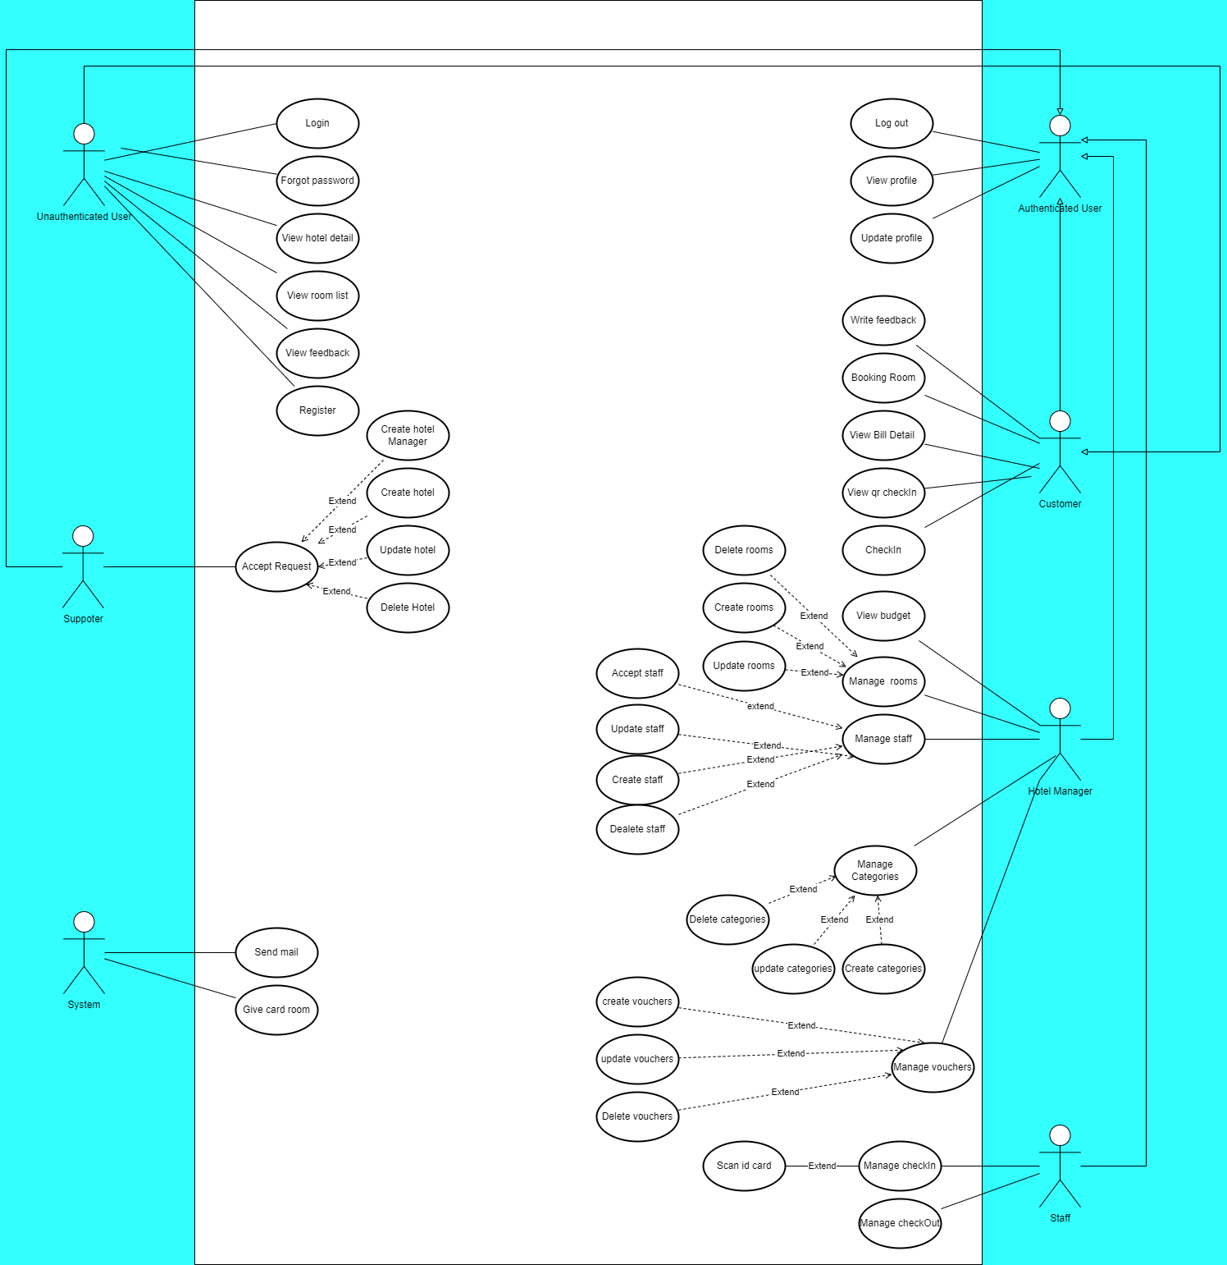

Figure 1. Use case diagram

#### 2.1.2. System Actors

Table 2. System actors

|  |  |  |
| --- | --- | --- |
| **#** | **Actor** | **Description** |
| 1 | Unauthenticated User | A user who has not logged in |
| 2 | Customer | A user who has logged in with role USER |
| 3 | Hotel Manager | A user who has logged in with role HOST |
| 4 | Staff | A user who has logged in with role STAFF |
| 5 | System Handler | Main system |
| 6 | Supporter | A user who has logged in with role ADMIN |
| 7 | Authenticated User | A user who has logged in |

#### 2.1.3. Use Cases List

Table 3. Use Cases List

|  |  |  |  |
| --- | --- | --- | --- |
| **ID** | **Use Case** | **Primary Actors** | **Secondary Actors** |
| UC01 | Login | Unauthenticated User |  |
| UC02 | Register | Unauthenticated User |  |
| UC03 | Forgot password | Unauthenticated User |  |
| UC04 | View hotel list | Unauthenticated User |  |
| UC05 | View Room list | Unauthenticated User |  |
| UC06 | View feedback | Unauthenticated User |  |
| UC07 | Log out | Authenticated User |  |
| UC08 | View profile | Authenticated User |  |
| UC09 | Update profile | Authenticated User |  |
| UC10 | Accept request | Supporter |  |
| UC11 | Create hotel manager | Supporter |  |
| UC12 | Create hotel | Supporter |  |
| UC13 | Update hotel | Supporter |  |
| UC14 | Delete hotel | Supporter |  |
| UC15 | Write feedback | Customer |  |
| UC16 | Booking room | Customer |  |
| UC17 | View bill detail | Customer |  |
| UC18 | View qr checkin | Customer |  |
| UC19 | checkin | Customer |  |
| UC20 | View budget | Hotel Manager |  |
| UC21 | Manage rooms | Hotel Manager |  |
| UC22 | Delete rooms | Hotel Manager |  |
| UC23 | Create rooms | Hotel Manager |  |
| UC24 | Update rooms | Hotel Manager |  |
| UC25 | Manage staff | Hotel Manager |  |
| UC26 | Accept staff | Hotel Manager |  |
| UC27 | Update staff | Hotel Manager |  |
| UC28 | Create staff | Hotel Manager |  |
| UC29 | Delete staff | Hotel Manager |  |
| UC30 | Manage categories | Hotel Manager |  |
| UC31 | Create categories | Hotel Manager |  |
| UC32 | Update categories | Hotel Manager |  |
| UC33 | Delete categories | Hotel Manager |  |
| UC34 | Manage vouchers | Hotel Manager |  |
| UC35 | Create vouchers | Hotel Manager |  |
| UC36 | Update vouchers | Hotel Manager |  |
| UC37 | Delete vouchers | Hotel Manager |  |
| UC38 | Manage checkin | Staff |  |
| UC39 | Scan id card | Staff |  |
| UC40 | Manage checkout | Staff |  |
| UC41 | Send mail | System |  |

### 2.2. Use case specification

#### 2.2.1 UC01 – Login

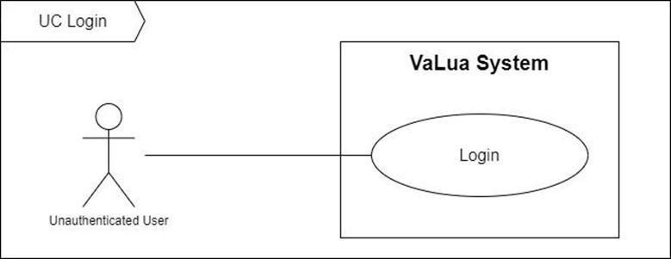

Figure 2. <Use case> Login

Table 4. UC01 - Login

|  |  |  |  |
| --- | --- | --- | --- |
| ID and Name: | **UC-01 Login** | | |
| Created By: | LongTC | Date Created: | 07/02/2022 |
| Primary Actor: | Unauthenticated user | Secondary Actors: |  |
| Description: | Unauthenticated users are required to login to use VaLua system. | | |
| Trigger: | An unauthenticated user tries to use VaLua. | | |
| Preconditions: | PRE-1. User has not logged in. | | |
| Post-conditions: | POST-1:   * Success: VaLua creates a new token and refresh token for the user then redirects the user to their home page. * Fail: VaLua shows an error message. | | |
| Normal Flow: | **1.0 Login** (Exception 1.0.E1)   1. Unauthenticated user starts up or attempts to use VaLua. 2. VaLua shows a login screen with a login panel including the following fields: (See alternative 1.1)    * Email: text input    * Password: password input    * Login button    * Login with Google button 3. User inputs email and password then selects the “Login” button. (See alternative 1.2, 1.3) 4. VaLua redirects the user to the dashboard or home page. (See exception 1.0.E2, 1.0.E3, 1.0.E4) | | |
| Alternative Flows: | **1.1 The current application is VaLua Camera**   1. VaLua shows an additional tab with a QR code to login. 2. Return to step 2 of the normal flow.   **1.2 User selects the “Login with Google” button**   1. User selects the “Login with Google” button. 2. VaLua shows a Google login popup associate with VaLua system. 3. User selects an account to login. 4. VaLua redirects the user to the dashboard or home page. (See exception 1.0.E5)   **1.3 User scans the QR code with their account on VaLua Staff**   1. User scans the QR code. 2. VaLua redirects staff to the exam room information screen. (See exception 1.0.E6)**.** | | |
| Exceptions: | **1.0.E1 Internet connection lost**   1. System shows the message (MSG0001).   **1.0.E2 Missing of required fields**   1. System shows a message asking the user to fill the required fields again (MSG0105, MSG0106).   **1.0.E3 User inputs at least 1 invalid field**   1. System shows a message asking the user to correct the fields (MSG0104).   **1.0.E4 User inputs incorrect email or password**   1. System shows a failed login attempt message (MSG0107).   **1.0.E5 User selects an external Google account**   1. System shows a failed login attempt message (MSG0103).   **1.0.E6 User scans QR code is not a staff**   1. System shows a failed login attempt message (MSG0102). | | |
| Priority: | High | | |
| Frequency of Use: | High | | |
| Business Rules: | BR-0001, BR-0002, BR-0003, BR-0004, BR-0005, BR-0100, BR-0101 | | |
| Other Information: | N/A | | |
| Assumptions: | N/A | | |

#### 2.2.2 UC02 – Create account

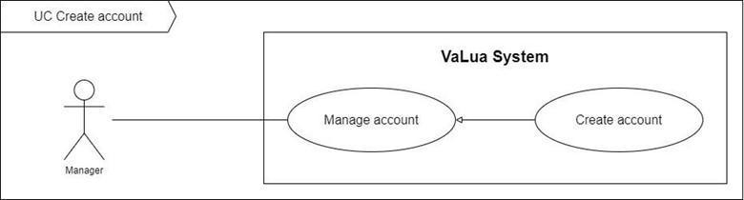

Figure 3. <Use case> Create account

Table 5. UC02 - Create account

|  |  |  |  |
| --- | --- | --- | --- |
| ID and Name: | **UC-02 Create account** | | |
| Created By: | HangNTK | Date Created: | 07/02/2022 |
| Primary Actor: | Manager | Secondary Actors: |  |
| Description: | A manager can create accounts for users. | | |
| Trigger: | A manager sends a create new account command by clicking on the “Create Account” button on the “Account” screen. | | |
| Preconditions: | PRE-1. Manager has already logged in to VaLua.  PRE-2. Current screen is “Account”. | | |
| Post-conditions: | POST-1:   * Success: VaLua updates the current tool’s information and shows a success message. * Fail: VaLua shows an error message. | | |
| Normal Flow: | **2.0 Create account** (Exception 2.0.E1)   1. Manager clicks the “Create account” button on the “Account” screen 2. VaLua shows a popup with VaLua user roles, each role includes:    * Role image: icon button    * Role name: text 3. Manager selects a role image. 4. VaLua shows a popup which contains a form to create a new account with these following fields: (See alternative 2.0)    * Company ID: text input    * Full name: text input    * Gender: drop down list    * Birthdate: date picker    * Phone: number input    * Email: text input    * Address: text input    * Image: upload file    * Create button 5. Manager inputs information and clicks on the “Create” button (see Alternative 2.1). 6. A new account has been added to VaLua and the system shows a success message dialog (MSG0200). (See Exception 2.1.E1, 2.1.E2, 2.1.E3, 2.1.E4) | | |
| Alternative Flows: | **2.0 The selected image is “Examinee”**   1. VaLua shows additional fields:    * Class code: text input.    * Face data images: multiple files uploader 2. Return to step 4 of the normal flow.   **2.1 Manager chooses “X” button**   1. Manager clicks on the “X” button. 2. VaLua closes the popup. | | |
| Exceptions: | **2.0.E1 Internet connection lost**   1. System shows the message (MSG0001).   **2.0.E2 Missing of required fields**   1. System shows a message asking the manager to fill the required fields again (MSG0202, MSG0203, MSG0204, MSG0205, MSG0206, MSG0207).   **2.0.E3 Manager inputs at least 1 invalid field**   1. System shows a message asking manager to correct the fields (MSG0208, MSG0209, MSG0210, MSG0211, MSG0212, MSG0213, MSG0214, MSG0215, MSG0216).   **2.0.E4 There already is an existing company ID, email or phone number**   1. System shows a message asking the manager to fill in another email, phone number or company ID (MSG0217, MSG0218, MSG0219). | | |
| Priority: | High | | |
| Frequency of Use: | Low | | |
| Business Rules: | BR-0004, BR-0010, BR-0011, BR-0200, BR-0202, BR-0203, BR-0204 | | |
| Other Information: | N/A | | |
| Assumptions: | * Company ID or student ID is a pre-existing ID provided by the school. | | |

#### 2.2.3 UC03 – Update account

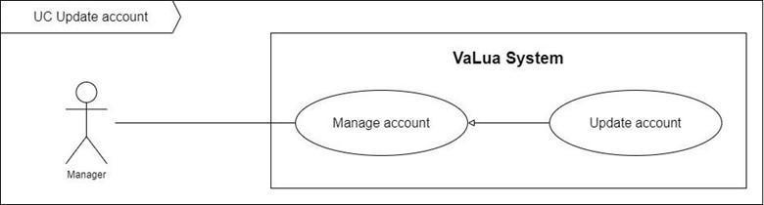

Figure 4. <Use case> Update account

Table 6. UC03 - Update account

|  |  |  |  |
| --- | --- | --- | --- |
| ID and Name: | **UC-03 Update account** | | |
| Created By: | HangNTK | Date Created: | 07/02/2022 |
| Primary Actor: | Manager | Secondary Actors: |  |
| Description: | A manager can update the account's information. | | |
| Trigger: | A manager sends an update account command. | | |
| Preconditions: | PRE-1. Manager has already logged in to VaLua.  PRE-2. Current screen is “Account” or “Account’s detail”. | | |
| Post-conditions: | POST-1:   * Success: VaLua updates account’s information and shows success messages. * Fail: VaLua shows error messages. | | |
| Normal Flow: | **3.0 Update account** (Exception 3.0.E1)   1. Manager clicks the “Edit” button of a specific account on the account list. (See alternative 3.0) 2. VaLua navigates to the “Account’s detail” screen with enable fields: (See alternative 3.1)    * Company ID: text input    * Full name: text input    * Gender: drop down list    * Birthdate: date picker    * Phone: number input    * Email: text input    * Address: text input    * Image: upload file    * Update button 3. Manager changes the account's information and clicks on the “Update Account” button. (See alternative 3.2) 4. VaLua updates the account's information and reloads the “Account’s detail” screen with a success message (MSG0300). (See Exception 3.1.E1, 3.1.E2, 3.1.E3, 3.1.E4) | | |
| Alternative Flows: | **3.0 Manager toggles the “Edit” icon button from Account’s detail screen.**   1. Manager toggles the “Edit” icon button on. 2. Return to step 2 of normal flow.   **3.0 The selected account’s role is “Examinee”**   1. VaLua shows additional information:    * Class code: text input in information panel.    * Update face images button 2. Return to step 2 of the normal flow.   **3.2 Manager toggles the “Edit” icon button off**   1. Manager toggles off the “Edit” icon button. 2. Information fields will be disable. | | |
| Exceptions: | **3.0.E1 Internet connection lost**   1. System shows the message (MSG0001).   **3.0.E2 Missing of required fields**   1. System shows a message asking the manager to fill the required fields again (MSG0202, MSG0203, MSG0204, MSG0205, MSG0206, MSG0207).   **3.0.E3 Manager inputs at least 1 invalid field**   1. System shows a message asking manager to correct the fields (MSG0208, MSG0209, MSG0210, MSG0211, MSG0212, MSG0213, MSG0214, MSG0215, MSG0216).   **3.0.E4 There already is an existing company ID, email or phone number**   1. System shows a message asking the manager to fill in another email, phone number or company ID (MSG0217, MSG0218, MSG0219). | | |
| Priority: | Low | | |
| Frequency of Use: | Medium | | |
| Business Rules: | BR-0011, BR-0200, BR-0202, BR-0203, BR-0204 | | |
| Other Information: | N/A | | |
| Assumptions: | * Company ID or student ID is a pre-existing ID provided by the school. | | |

#### 2.2.4 UC04 – Disable account

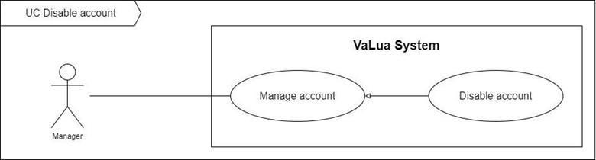

Figure 5. <Use case> Disable account

Table 7. UC04 - Disable account

|  |  |  |  |
| --- | --- | --- | --- |
| ID and Name: | **UC-04 Disable account** | | |
| Created By: | HangNTK | Date Created: | 07/02/2022 |
| Primary Actor: | Manager | Secondary Actors: |  |
| Description: | A manager can disable an account. | | |
| Trigger: | A manager sends a disable account command by clicking on the “Disable account” button in the “Account’s detail” screen or the “Disable” button of a specific account item in the “Account” screen. | | |
| Preconditions: | PRE-1. Manager has already logged in to VaLua.  PRE-2. Current screen is “Accounts” or “Account’s detail”. | | |
| Post-conditions: | POST-1:   * Success: Account’s status is “Inactive” and VaLua shows a success message. * Fail: VaLua shows an error message. | | |
| Normal Flow: | 1. **Disable account** (Exception 4.0.E1) 2. Manager clicks the “Disable” button of a specific account on the account list. (See alternative 4.0) 3. VaLua shows a confirmation dialog (MSG0401) and two buttons for manager to select:    * Cancel button    * Confirm button 4. Manager clicks on the “Confirm” button. (See alternative 4.1) 5. VaLua changes this account’s status to “Inactive” and shows the success message (MSG0400). | | |
| Alternative Flows: | **4.0 Manager chooses the “Disable Account” button from Account’s detail.**   1. Manager clicks the “Disable Account” button. 2. Return to step 2 of normal flow   **4.1 Manager chooses the “Cancel” button**   1. Manager clicks on the “Cancel” button. 2. VaLua closes the dialog. | | |
| Exceptions: | **4.0.E1 Internet connection lost**   1. System shows the message (MSG0001). | | |
| Priority: | Low | | |
| Frequency of Use: | Low | | |
| Business Rules: | BR-0005, BR-0011, BR-0200, BR-0202, BR-0203, BR-0204 | | |
| Other Information: | N/A | | |
| Assumptions: | N/A | | |

#### 2.2.5 UC05 – View account list

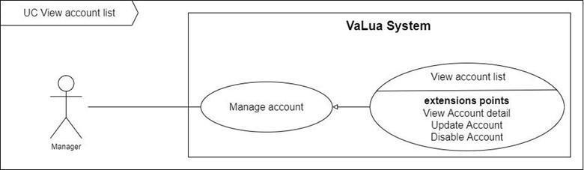

Figure 6. <Use case> View account list

Table 8. UC05 - View account list

|  |  |  |  |
| --- | --- | --- | --- |
| ID and Name: | **UC-05 View account list** | | |
| Created By: | HangNTK | Date Created: | 07/02/2022 |
| Primary Actor: | Manager | Secondary Actors: |  |
| Description: | A manager can view a list of accounts with filters and search. | | |
| Trigger: | A manager sends a view list of accounts by loading the “Account” screen or applying a filter or search in the search bar. | | |
| Preconditions: | PRE-1. Manager has already logged in to VaLua. | | |
| Post-conditions: | POST-1:   * Success: VaLua shows list of accounts. * Fail: VaLua shows error message. | | |
| Normal Flow: | **5.0 View account list** (Exception 5.0.E1)   1. Manager clicks on the “Account” item on the sidebar or applies a custom filter or search in the search bar on the “Account” screen. 2. VaLua shows list of accounts (see Exception 5.1.E1), each row item displays:    * Avatar: image    * ID: text    * Name: text    * Role: text    * Phone: text    * Email: text    * Status: text    * Action:      + View detail button      + Edit button (only for active accounts)      + Disable/Enable button | | |
| Alternative Flows: | N/A | | |
| Exceptions: | **5.0.E1 Internet connection lost**   1. System shows the message (MSG0001).   **5.1.E1 List of accounts is empty**   1. VaLua shows a message (MSG0002). | | |
| Priority: | Medium | | |
| Frequency of Use: | Medium | | |
| Business Rules: | BR-0015, BR-0016, BR-0200, BR-0201 | | |
| Other Information: | N/A | | |
| Assumptions: | N/A | | |

#### 2.2.6 UC06 – Reset password

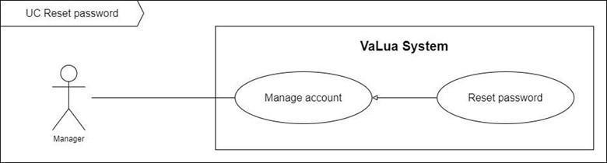

Figure 7. <Use case> Reset password

Table 9. UC06 - Reset password

|  |  |  |  |
| --- | --- | --- | --- |
| ID and Name: | **UC-06 Reset password** | | |
| Created By: | LongTC | Date Created: | 07/02/2022 |
| Primary Actor: | Manager | Secondary Actors: | N/A |
| Description: | Managers can reset any other accounts’ password on demand in case users can’t remember their password. | | |
| Trigger: | Manager sends a reset password request by clicking on the “Reset password” button in the user detail view. | | |
| Preconditions: | PRE-1. User has logged in as a manager  PRE-2. The current screen is “Account’s detail”. | | |
| Post-conditions: | POST-1:   * Success: VaLua changes the account’s password, sends an email with a new password for their account and shows a success message. * Fail: VaLua shows an error message. | | |
| Normal Flow: | **6.0 Reset Password** (Exception 6.0.E1)   1. Manager clicks on the “Reset Password” button. 2. VaLua shows a confirmation dialog: “Are you sure?” with 2 buttons:    * Yes: button    * No: button 3. Manager clicks on the “Yes” button. (See alternative 6.0) 4. VaLua shows success message (MSG0600) | | |
| Alternative Flows: | **6.0 Manager selects the “No” button**   1. Manager selects the “No” button. 2. VaLua closes the confirmation dialog and returns to the user detail view. | | |
| Exceptions: | **6.0.E1 Internet connection lost**   1. System shows the message (MSG0001). | | |
| Priority: | Low | | |
| Frequency of Use: | Low | | |
| Business Rules: | BR-0200, BR-0600 | | |
| Other Information: | N/A | | |
| Assumptions: | N/A | | |

#### 2.2.7 UC07 – View account detail

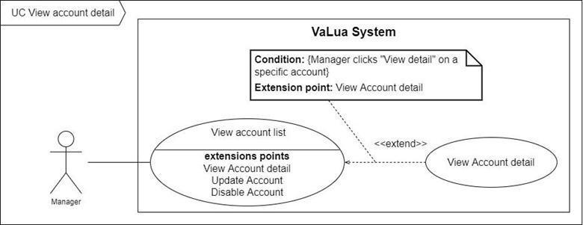

Figure 8. <Use case> View account detail

Table 10. UC07 - View account detail

|  |  |  |  |
| --- | --- | --- | --- |
| ID and Name: | **UC-07 View account detail** | | |
| Created By: | HangNTK | Date Created: | 07/02/2022 |
| Primary Actor: | Manager | Secondary Actors: |  |
| Description: | A manager can view detailed information about an account. | | |
| Trigger: | A manager sends a view account detail command by clicking on the “View detail” button of a specific account in “Account” screen. | | |
| Preconditions: | PRE-1. Manager has already logged in to VaLua.  PRE-2. Selected account exists in VaLua. | | |
| Post-conditions: | POST-1. VaLua shows detailed information of the account. | | |
| Normal Flow: | **7.0 View account detail** (Exception 7.0.E1)   1. Manager clicks on the “View detail” button of a specific account. 2. VaLua shows account detail information include: (See alternative 7.0)    * Account’s audit panel:      + Full name: text      + Avatar: image      + Role: text      + Status: text      + Last updated: text      + “Reset password” button      + “Disable account” button (or “Enable Account” button)    * Account information panel:      + Company ID: text      + Full name: text      + Gender: text      + Birthdate: text      + Phone number: text      + Email: text      + Address: text      + Edit icon: toggle button | | |
| Alternative Flows: | **7.0 The selected account’s role is “Examinee”**   1. VaLua shows additional information:    * Account’s audit panel:      + “Upload face images”: button    * Account information panel:      + Class code: text 2. Return to step 2 of the normal flow. | | |
| Exceptions: | **7.0.E1 Internet connection lost**   1. System shows the message (MSG0001) | | |
| Priority: | Medium | | |
| Frequency of Use: | Medium | | |
| Business Rules: | BR-0200 | | |
| Other Information: | N/A | | |
| Assumptions: | N/A | | |

#### 2.2.8 UC08 – Create subject

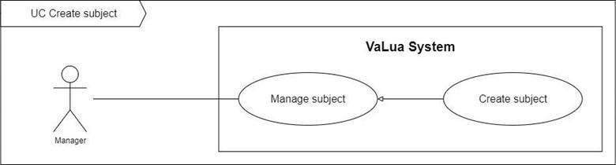

Figure 9. <Use case> Create subject

Table 11. UC08 - Create subject

|  |  |  |  |
| --- | --- | --- | --- |
| ID and Name: | **UC-08 Create subject** | | |
| Created By: | LongTC | Date Created: | 07/02/2022 |
| Primary Actor: | Manager | Secondary Actors: |  |
| Description: | A manager can create subjects. | | |
| Trigger: | A manager sends a create subject command | | |
| Preconditions: | PRE-1. Manager has already logged in to VaLua.  PRE-2. The subject exists in VaLua. | | |
| Post-conditions: | POST-1:   * Success: VaLua creates a new subject and shows a success message. * Fail: VaLua shows an error message. | | |
| Normal Flow: | **8.0 Create subject** (Exception 8.0.E1)   1. Manager clicks the “Create subject” button. 2. VaLua shows a popup with following fields:    * Subject code: text input    * Name: text input    * Duration: number    * Tool: dropdown multiple items selector    * Create button 3. Manager inputs the subject's information then clicks on the “Create” button. 4. VaLua saves the subject and shows a success message (MSG0705) (See Exception 8.0.E2, 8.0.E3, 8.0E4) | | |
| Alternative Flows: | N/A | | |
| Exceptions: | **8.0.E1 Internet connection lost**   1. System shows the message (MSG0001).   **8.0.E2 Missing of required fields**   1. System shows a message asking the manager to fill the required fields again (MSG0704, MSG0705, MSG0706).   **8.0.E3 Manager inputs at least 1 invalid field**   1. System shows a message asking the manager to correct the fields (MSG0701, MSG0702, MSG0703).   **8.0.E4 There already is an existing subject code**   1. System shows a message asking the manager to fill the subject code again (MSG0700). | | |
| Priority: | Medium | | |
| Frequency of Use: | Medium | | |
| Business Rules: | BR-0700, BR-0701 | | |
| Other Information: | N/A | | |
| Assumptions: | N/A | | |

#### 2.2.9 UC09 – Update subject

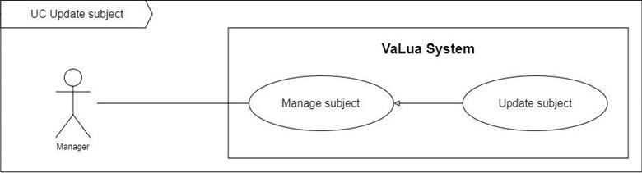

Figure 10. <Use case> Update subject

Table 12. UC09 - Update subject

|  |  |  |  |
| --- | --- | --- | --- |
| ID and Name: | **UC-09 Update subject** | | |
| Created By: | LongTC | Date Created: | 12/01/2022 |
| Primary Actor: | Manager | Secondary Actors: |  |
| Description: | A manager can update a subject information | | |
| Trigger: | A manager sends an update subject command by clicking on the “Edit” button of a specific subject item. | | |
| Preconditions: | PRE-1. Manager has already logged in to VaLua.  PRE-2. Current screen is “Subject”. | | |
| Post-conditions: | POST-1:   * Success: VaLua updates the subject and shows a success message. * Fail: VaLua shows an error message. | | |
| Normal Flow: | **9.0 Update subject** (Exception 9.0.E1)   * Manager clicks the “Edit” button on a specific subject item. * VaLua shows a popup contains a form to update subject:   + Subject code: text input   + Subject name: text input   + Duration: number   + Tool: dropdown multiple items selector   + Update button * Manager inputs information and clicks on the “Update” button. (See Alternative 9.0) * A new subject has been added to VaLua and the system shows a success message (MSG0800). (See Exception 9.1.E1, 9.1.E2) | | |
| Alternative Flows: | **9.0 Manager chooses “X” button**   1. Manager clicks on the “X” button. 2. VaLua closes the popup. | | |
| Exceptions: | **9.0.E1 Internet connection lost**   1. System shows the message (MSG0001).   **9.1.E1 Missing of required fields**   1. System shows a message asking the manager to fill the required fields again (MSG0704, MSG0705, MSG0706).   **9.1.E2 Manager inputs field not valid**   1. System shows a message asking the manager to fill the fields again (MSG0701, MSG0702, MSG0703).   **9.1.E3 There already is an existing tool code**   1. System shows a message asking the manager to fill the subject code again (MSG0700). | | |
| Priority: | Medium | | |
| Frequency of Use: | Low | | |
| Business Rules: | BR-0700, BR-0701 | | |
| Other Information: | N/A | | |
| Assumptions: | N/A | | |

#### 2.2.10 UC10 – Disable subject

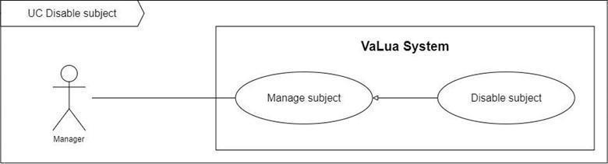

Figure 11. <Use case> Disable subject

Table 13. UC10 - Disable subject

|  |  |  |  |
| --- | --- | --- | --- |
| ID and Name: | **UC-10 Disable subject** | | |
| Created By: | LongTC | Date Created: | 12/01/2022 |
| Primary Actor: | Manager | Secondary Actors: |  |
| Description: | A manager can disable a subject and enable it back. | | |
| Trigger: | A manager sends a disable subject command by clicking on the “Disable” button from the “Actions” menu of a specific subject on the “Subject” screen. | | |
| Preconditions: | PRE-1. Manager has already logged in to VaLua.  PRE-2. Current screen is “Subject”. | | |
| Post-conditions: | POST-1:   * Success: VaLua disables the current subject and shows a success message. * Fail: VaLua shows an error message. | | |
| Normal Flow: | **10.0 Disable subject** (Exception 10.0.E1)   1. Manager clicks the “Disable” button of a specific tool item from the tool list. 2. VaLua shows a confirmation popup with a message (MSG0901) and 2 options:    * Cancel button    * Confirm button 3. Manager clicks on the Confirm button. (See Alternative 10.0) 4. VaLua disables the subject then shows a success message (MSG0900). | | |
| Alternative Flows: | **10.0 Manager chooses “X” button or cancel button**   1. Manager clicks on the “X” button or the cancel button. 2. VaLua closes the popup. | | |
| Exceptions: | **10.0.E1 Internet connection lost**   1. System shows a message (MSG0001). | | |
| Priority: | Low | | |
| Frequency of Use: | Low | | |
| Business Rules: | BR-0700 | | |
| Other Information: | N/A | | |
| Assumptions: | N/A | | |

#### 2.2.11 UC11 - View subject list

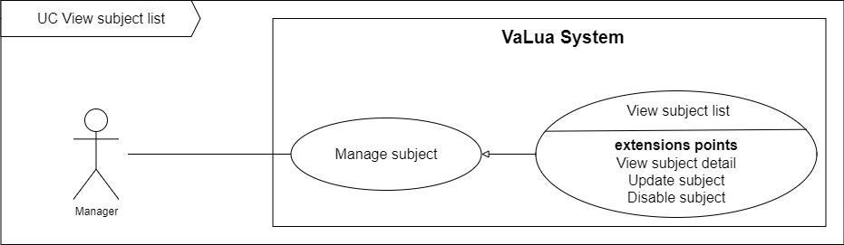

Figure 12. <Use case> View subject list

Table 14. UC11 - View subject list

|  |  |  |  |
| --- | --- | --- | --- |
| ID and Name: | **UC-11 View subject list** | | |
| Created By: | LongTC | Date Created: | 12/01/2022 |
| Primary Actor: | Manager | Secondary Actors: |  |
| Description: | A manager can view a list of subjects in “Subject” screen. | | |
| Trigger: | A manager sends a view subject list command by clicking on the “Subject” tab from the tab menu. | | |
| Preconditions: | PRE-1. Manager has already logged in to VaLua. | | |
| Post-conditions: | POST-1:   * Success: VaLua shows a list of subjects * Fail: VaLua shows an error message. | | |
| Normal Flow: | **11.0 View subject list** (Exception 11.0.E1)   1. Manager clicks the “Subject” tab from the tab menu. (See alternative 11.0) 2. VaLua shows a list of subjects, each item contains:  * Subject code: text * Subject name: text * Duration: number * Allowed tools: number with detail tooltip * Status: text * Actions: button menu with:   + Edit button (View detail button for disabled subjects)   + Disable button | | |
| Alternative Flows: | **11.0 Manager is already at “Subject” screen and inputs search criteria**   1. Manager enters a text in search bar or customizes the subject filter then clicks on the search button. 2. VaLua gets a list of subjects accordingly then return to step 2 of the normal flow. | | |
| Exceptions: | **11.0.E1 Internet connection lost**   1. System shows message (MSG0001). | | |
| Priority: | Medium | | |
| Frequency of Use: | Medium | | |
| Business Rules: | BR-1000 | | |
| Other Information: | N/A | | |
| Assumptions: | N/A | | |

#### 2.2.12 UC12 – Create semester

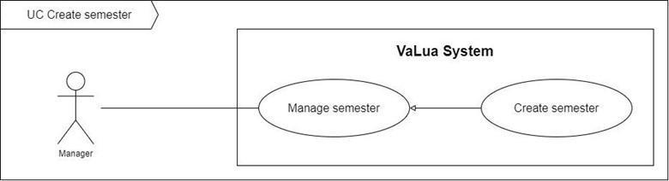

Figure 13. <Use case> Create semester

Table 15. UC12 - Create semester

|  |  |  |  |
| --- | --- | --- | --- |
| ID and Name: | **UC-12 Create semester** | | |
| Created By: | HangNTK | Date Created: | 07/02/2022 |
| Primary Actor: | Manager | Secondary Actors: |  |
| Description: | A manager creates the new semester. | | |
| Trigger: | A manager sends a create new semester command by clicking on the “Create Semester” button on the “Semester” screen. | | |
| Preconditions: | PRE-1. Manager has already logged in to VaLua System.  PRE-2. Current screen is “Semester”. | | |
| Post-conditions: | POST-1:   * Success: VaLua system creates new semester and shows success message. * Fail: VaLua system shows an error message. | | |
| Normal Flow: | **12.0 Create semester** (Exception 12.0.E1)   1. Manager clicks the “Create Semester” button on the “Semester” screen. 2. VaLua System shows popup contains required information form of the room:    * Name: text input    * Begin date: date picker    * End date: date picker    * Create button 3. Manager inputs information and clicks on the “Create” button. (see Alternative 12.0) 4. A new semester was added to the VaLua System and the system shows a success message dialog (MSG1200). (see Exception 12.1.E1, 12.1.E2, 12.1.E3) | | |
| Alternative Flows: | **12.0 Manager chooses “X” button**   1. Manager clicks on the “X” button. 2. VaLua System closes the popup. | | |
| Exceptions: | **12.0.E1 Internet connection lost**   1. System shows a message (MSG0001).   **12.1.E1 Missing of required fields**   1. VaLua System shows a message asking manager to fill the required fields again (MSG1201).   **12.1.E2 Manager inputs field not valid**   1. VaLua System shows messages asking manager to fill the fields again (MSG1203, MSG1204, MSG1205, MSG1206).   **12.1.E3 Manager inputs semester name exists in the system**   1. VaLua System shows a message asking manager to fill semester name again (MSG1202). | | |
| Priority: | High | | |
| Frequency of Use: | Low | | |
| Business Rules: | BR-0010, BR-1200, BR-1201, BR-1202 | | |
| Other Information: | N/A | | |
| Assumptions: | N/A | | |

#### 2.2.13 UC13 – Update semester

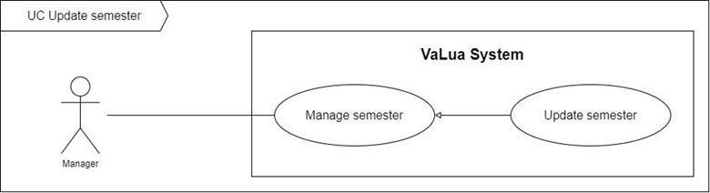

Figure 14. <Use case> Update semester

Table 16. UC13 - Update semester

|  |  |  |  |
| --- | --- | --- | --- |
| ID and Name: | **UC-13 Update semester** | | |
| Created By: | HangNTK | Date Created: | 07/02/2022 |
| Primary Actor: | Manager | Secondary Actors: |  |
| Description: | A manager can update the semester's information. | | |
| Trigger: | A manager sends an update semester command. | | |
| Preconditions: | PRE-1. Manager has already logged in to VaLua System.  PRE-2. Current screen is “Semester” or “Semester’s detail”. | | |
| Post-conditions: | POST-1:   * Success: VaLua System updates semester’s information and shows success messages. * Fail: VaLua System shows error messages. | | |
| Normal Flow: | **13.0 Update semester** (Exception 13.0.E1)   1. Manager clicks the “Edit” button of a specific semester on the semester list. (see Alternative 13.0) 2. VaLua System navigates to the “Semester’s detail” screen with enabled fields:    * Name: text input    * Begin date: date picker    * End date: date picker    * “Update semester” button 3. Manager changes the semester's information and clicks on the “Update semester” button. (see Alternative 13.1) 4. VaLua System updates semester’s information and reloads “Semester’s detail” screen with success message (MSG1300). (see Exception 13.1.E1, 13.1.E2, 13.1.E3) | | |
| Alternative Flows: | **13.0 Manager chooses “Edit” icon from Semester’s detail.**   1. Manager clicks the “Edit” icon. 2. Return to step 2 of normal flow.   **13.1 Manager chooses “Edit” icon a second time**   1. Manager clicks on the “Edit” icon a second time. 2. Information fields are disabled. | | |
| Exceptions: | **13.0.E1 Internet connection lost**   1. System shows the message (MSG0001).   **13.1.E1 Missing of required fields**   1. VaLua System shows a message asking manager to fill the required fields again (MSG1201).   **13.1.E2 Manager inputs field not valid**   1. VaLua System shows messages asking manager to fill the fields again (MSG1203, MSG1204, MSG1205, MSG1206).   **13.1.E3 Manager inputs semester name exists in the system**   1. VaLua System shows a message asking manager to fill semester name again (MSG1202). | | |
| Priority: | Low | | |
| Frequency of Use: | Low | | |
| Business Rules: | BR-1200, BR-1201, BR-1202, BR-1300 | | |
| Other Information: | N/A | | |
| Assumptions: | N/A | | |

#### 2.2.14 UC14 – Disable semester

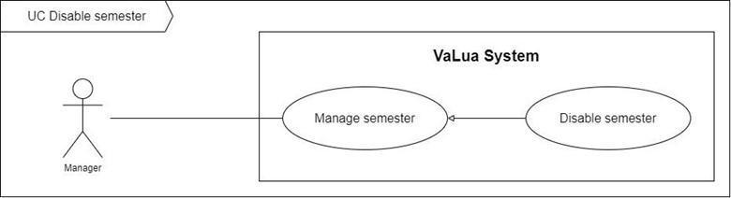

Figure 15. <Use case> Disable semester

Table 17. UC14 - Disable semester

|  |  |  |  |
| --- | --- | --- | --- |
| ID and Name: | **UC-14 Disable semester** | | |
| Created By: | HangNTK | Date Created: | 07/02/2022 |
| Primary Actor: | Manager | Secondary Actors: |  |
| Description: | A manager can disable a semester. | | |
| Trigger: | A manager sends a disable semester command. | | |
| Preconditions: | PRE-1. Manager has already logged in to VaLua System.  PRE-2. Current screen is “Semester” or “Semester’s detail”. | | |
| Post-conditions: | POST-1:   * Success: Semester’s status is “Inactive” and VaLua System shows a success message. * Fail: VaLua System shows an error message. | | |
| Normal Flow: | **14.0 Disable semester** (Exception 14.0.E1)   1. Manager clicks the “Disable” button of a specific semester on the semester list. (see Alternative 14.0) 2. VaLua System shows confirm dialog (MSG1400) and two buttons for manager to select:    * Cancel button    * Confirm button 3. Manager clicks on the “Confirm” button. (see Alternative 14.1) 4. VaLua System changes this semester’s status to “Inactive” and shows the success message (MSG1401). | | |
| Alternative Flows: | **14.0 Manager chooses the “Disable Semester” button from Semester’s detail.**   1. Manager clicks the “Disable Semester” button. 2. Return to step 2 of normal flow.   **14.1 Manager chooses “Cancel” button**   1. Manager clicks on the “Cancel” button. 2. VaLua System closes dialog. | | |
| Exceptions: | **14.0.E1 Internet connection lost**   1. System shows a message (MSG0001). | | |
| Priority: | Medium | | |
| Frequency of Use: | Low | | |
| Business Rules: | BR-1200, BR-1300, BR-1400 | | |
| Other Information: | N/A | | |
| Assumptions: | N/A | | |

#### 2.2.15 UC15 – View semester list

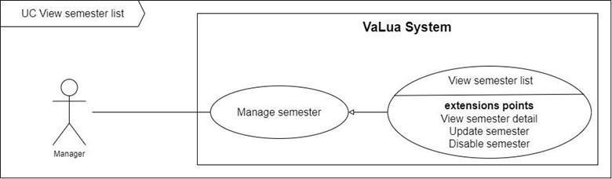

Figure 16. <Use case> View semester list

Table 18. UC15 - View semester list

|  |  |  |  |
| --- | --- | --- | --- |
| ID and Name: | **UC-15 View semester list** | | |
| Created By: | HangNTK | Date Created: | 07/02/2022 |
| Primary Actor: | Manager | Secondary Actors: |  |
| Description: | A manager can view list of semesters | | |
| Trigger: | A manager sends a view list of semesters command | | |
| Preconditions: | PRE-1. Manager has already logged in to VaLua System. | | |
| Post-conditions: | POST-1:   * Success: VaLua System shows list of semesters. * Fail: VaLua System shows error message. | | |
| Normal Flow: | **15.0 View semester list** (Exception 15.0.E1)   1. Manager clicks on the “Semester” item on the sidebar to send a request to view the list of semesters. 2. VaLua System shows list of semesters (see Exception 15.1.E1), each row item displays:    * Name: text    * Begin date: date    * End date: date    * Status: text    * Action:      + View detail button      + Edit button      + Disable/Enable button | | |
| Alternative Flows: | N/A | | |
| Exceptions: | **15.0.E1 Internet connection lost**   1. System shows a message (MSG0001).   **15.1.E1 List of cameras is empty**   1. VaLua System shows a message (MSG0002). | | |
| Priority: | Medium | | |
| Frequency of Use: | Medium | | |
| Business Rules: | BR-0016, BR-1200, BR-1500, BR-1501, BR-1502 | | |
| Other Information: | N/A | | |
| Assumptions: | N/A | | |

#### 2.2.16 UC16 – View semester detail

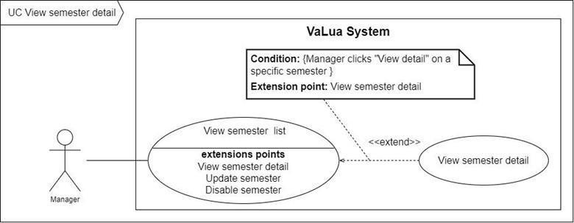

Figure 17. <Use case> View semester detail

Table 19. UC16 - View semester detail

|  |  |  |  |
| --- | --- | --- | --- |
| ID and Name: | **UC-16 View semester detail** | | |
| Created By: | HangNTK | Date Created: | 07/02/2022 |
| Primary Actor: | Manager | Secondary Actors: |  |
| Description: | A manager can view detailed information about a semester. | | |
| Trigger: | A manager sends a view semester detail command. | | |
| Preconditions: | PRE-1. Manager has already logged in to VaLua System.  PRE-2. Semester exists in VaLua System. | | |
| Post-conditions: | POST-1. VaLua System shows detailed information of the semester. | | |
| Normal Flow: | **16.0 View semester detail** (Exception 16.0.E1)   1. Manager clicks on the “View detail” button for a specific semester. 2. VaLua System shows semester detail information include:    * Semester’s card:      + Semester’s name: text      + Status: text      + Last updated: datetime      + “Disable Semester” button    * Semester’s information:      + Name: text input      + Begin date: date picker      + End date: date picker    * Subject list of semesters:      + Search subject field      + “Add Subject” button      + List Subjects, each row item displays:        - Subject Code: text        - Name: text        - Status: text        - “Remove from semester” button | | |
| Alternative Flows: | N/A | | |
| Exceptions: | **16.0.E1 Internet connection lost**   1. System shows the message (MSG0001). | | |
| Priority: | Medium | | |
| Frequency of Use: | Medium | | |
| Business Rules: | BR-0016, BR-1200, BR-1000 | | |
| Other Information: | N/A | | |
| Assumptions: | N/A | | |

#### 2.2.17 UC17 - Add subject to semester

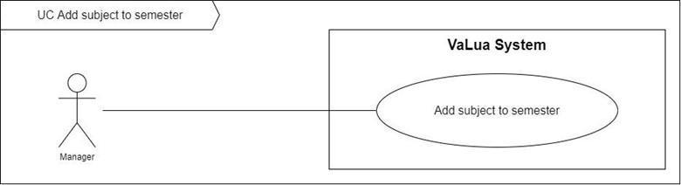

Figure 18. <Use case> Add subject to semester

Table 20. UC17 - Add subject to semester

|  |  |  |  |
| --- | --- | --- | --- |
| ID and Name: | **UC-17 Add subject to semester** | | |
| Created By: | HangNTK | Date Created: | 07/02/2022 |
| Primary Actor: | Manager | Secondary Actors: |  |
| Description: | A manager can add subjects to a semester. | | |
| Trigger: | A manager sends an add subject to a semester command by clicking on the “Add Subject” button. | | |
| Preconditions: | PRE-1. Manager has already logged in to VaLua System.  PRE-2. Semester’s status is “Active”.  PRE-3. Current screen is “Semester’s detail” | | |
| Post-conditions: | POST-1:   * Success: VaLua System add subjects to a semester shows success message. * Fail: VaLua System shows an error message | | |
| Normal Flow: | **17.0 Add subject to semester** (Exception 17.0.E1)   1. Manager clicks on the “Add Subject” button. 2. VaLua System popups drop down list of subject’s code and “Add” button (see Exception 17.1.E1) 3. Manager chooses specific subjects and clicks on the button “Add” (see Alternative 17.0) 4. VaLua System adds subjects to semester and shows success message (MSG1700). | | |
| Alternative Flows: | **17.0 Manager chooses “X” button**   1. Manager clicks on the “X” button. 2. VaLua System closes the popup. | | |
| Exceptions: | **17.0.E1 Internet connection lost**   1. System shows a message (MSG0001).   **17.1.E1 List of subjects is empty**   1. VaLua System shows a message (MSG0002) | | |
| Priority: | High | | |
| Frequency of Use: | Medium | | |
| Business Rules: | BR-1700 | | |
| Other Information: | N/A | | |
| Assumptions: | N/A | | |

#### 2.2.18 UC18 – Remove subject from semester

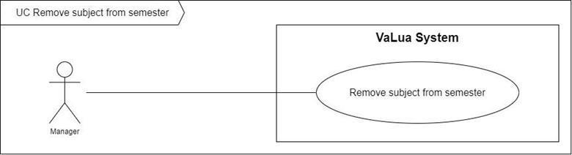

Figure 19. <Use case> Remove subject from semester

Table 21. UC18 - Remove subject from semester

|  |  |  |  |
| --- | --- | --- | --- |
| ID and Name: | **UC-18 Remove subject from semester** | | |
| Created By: | HangNTK | Date Created: | 07/02/2022 |
| Primary Actor: | Manager | Secondary Actors: |  |
| Description: | A manager can remove a subject from the semester. | | |
| Trigger: | A manager sends a remove subject from a semester command by clicking on the “Remove subject” button. | | |
| Preconditions: | PRE-1. Manager has already logged in to VaLua System.  PRE-2. Semester already contains subjects.  PRE-3. Current screen is “Semester’s detail” | | |
| Post-conditions: | POST-1:   * Success: VaLua System removes a subject from a semester and shows a success message. * Fail: VaLua System shows an error message | | |
| Normal Flow: | **18.0 Remove subjects from semester** (Exception 18.0.E1)   1. Manager clicks on the “Remove subject” button of a specific subject. 2. System shows confirm dialog (MSG1800) with two buttons:    * Cancel button    * Confirm button 3. Manager clicks on “Confirm” button (see Alternative 18.0) 4. VaLua System removes subject from semester and shows success message (MSG1801) (See exception 18.0.E2). | | |
| Alternative Flows: | **18.0 Manager chooses “Cancel” button**   1. Manager clicks on the “Cancel” button. 2. VaLua System closes the dialog. | | |
| Exceptions: | **18.0.E1 Internet connection lost**   1. System shows a message (MSG0001).   **18.0.E2 Semester is in progress**   1. System shows a message (MSG1802). | | |
| Priority: | Medium | | |
| Frequency of Use: | Medium | | |
| Business Rules: | BR-1200 | | |
| Other Information: | N/A | | |
| Assumptions: | N/A | | |

#### 2.2.19 UC19 – Create tool

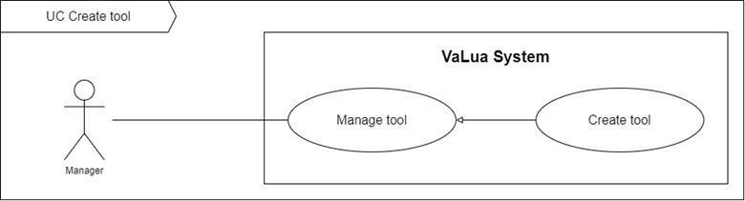

Figure 20. <Use case> Create tool

Table 22. UC19 - Create tool

|  |  |  |  |
| --- | --- | --- | --- |
| ID and Name: | **UC-19 Create tool** | | |
| Created By: | LongTC | Date Created: | 07/02/2022 |
| Primary Actor: | Manager | Secondary Actors: |  |
| Description: | A manager can create tools allowed in some subjects. | | |
| Trigger: | A manager sends a create tool command by clicking on the “Create tool” button on the “Tool” screen. | | |
| Preconditions: | PRE-1. Manager has already logged in to VaLua.  PRE-2. Current screen is “Tool”. | | |
| Post-conditions: | POST-1:   * Success: VaLua creates a new tool and shows a success message. * Fail: VaLua shows an error message. | | |
| Normal Flow: | **19.0 Create tool** (Exception 19.0.E1)   1. Manager clicks on the “Create tool” button. 2. VaLua shows a popup with following fields:    * Tool code: text input    * Name: text input    * Create button 3. Manager inputs tool’s information then clicks on the “Create” button. 4. VaLua saves the tool and shows a success message (MSG1900) (See Exception 19.0.E2, 19.0.E3, 19.0E4) | | |
| Alternative Flows: | N/A | | |
| Exceptions: | **19.0.E1 Internet connection lost**   1. System shows the message (MSG0001).   **19.0.E2 Missing of required fields**   1. System shows a message asking manager to fill the required fields again (MSG1901, MSG1902).   **19.0.E3 Manager inputs at least 1 invalid field**   1. System shows a message asking manager to correct the fields (MSG1903, MSG1904).   **19.0.E4 There already is an existing tool code**   1. System shows a message asking manager to fill the tool code again (MSG1905). | | |
| Priority: | Medium | | |
| Frequency of Use: | Medium | | |
| Business Rules: | BR-1900, BR-1901 | | |
| Other Information: | N/A | | |
| Assumptions: | N/A | | |

#### 2.2.20 UC20 – Update tool

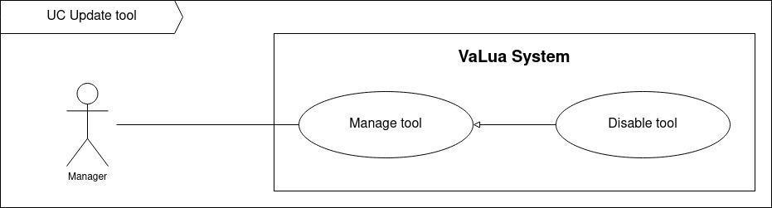

Figure 21. <Use case> Update tool

Table 23. UC20 - Update tool

|  |  |  |  |
| --- | --- | --- | --- |
| ID and Name: | **UC-20 Update tool** | | |
| Created By: | LongTC | Date Created: | 07/02/2022 |
| Primary Actor: | Manager | Secondary Actors: |  |
| Description: | A manager can update tools’ information. | | |
| Trigger: | A manager sends an update tool command by clicking on the “edit” button from the “Actions” menu from the “Tool” screen. | | |
| Preconditions: | PRE-1. Manager has already logged in to VaLua.  PRE-2. Current screen is “Tool”. | | |
| Post-conditions: | POST-1:   * Success: VaLua updates the current tool’s information and shows a success message. * Fail: VaLua shows an error message. | | |
| Normal Flow: | **20.0 Update tool** (Exception 20.0.E1)   1. Manager clicks the “Edit” button of a specific tool item from the tool list. 2. VaLua shows a popup contains a form to update this tool:    * Code: text input    * Name: text input    * Update button 3. Manager changes the tool’s information and clicks on the update button. (See Alternative 9.0) 4. VaLua updates tool’s information and reloads the “Tool” screen with a success message (MSG2000). (See Exception 20.1.E1, 20.1.E2) | | |
| Alternative Flows: | **20.0 Manager chooses “X” button**   1. Manager clicks on the “X” button. 2. VaLua closes the popup. | | |
| Exceptions: | **20.0.E1 Internet connection lost**   1. System shows the message (MSG0001).   **20.0.E2 Missing of required fields**   1. System shows a message asking manager to fill the required fields again (MSG1901, MSG1902).   **20.0.E3 Manager inputs at least 1 invalid field**   1. System shows a message asking manager to correct the fields (MSG1903, MSG1904).   **20.0.E4 There already is an existing tool code**   1. System shows a message asking manager to fill the tool code again (MSG1905). | | |
| Priority: | Low | | |
| Frequency of Use: | Low | | |
| Business Rules: | BR-0011, BR-0012, BR-1900, BR-1901 | | |
| Other Information: | N/A | | |
| Assumptions: | N/A | | |

#### 2.2.21 UC21– Disable tool

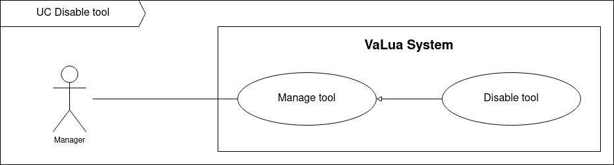

Figure 22. <Use case> Disable tool

Table 24. UC21 - Disable tool

|  |  |  |  |
| --- | --- | --- | --- |
| ID and Name: | **UC-21 Disable tool** | | |
| Created By: | LongTC | Date Created: | 07/02/2022 |
| Primary Actor: | Manager | Secondary Actors: |  |
| Description: | A manager can disable the tool as well as enable it back the same way. | | |
| Trigger: | A manager sends a disable tool command. | | |
| Preconditions: | PRE-1. Manager has already logged in to VaLua.  PRE-2. Current screen is “Tool”. | | |
| Post-conditions: | POST-1:   * Success: Tool’s status is “Inactive” and VaLua shows a success message. * Fail: VaLua shows an error message. | | |
| Normal Flow: | **21.0 Disable tool** (Exception 10.0.E1)   1. Manager clicks on the “Disable” button of a specific tool from its action menu on the tool list screen. 2. VaLua shows confirm dialog (MSG2101) and two buttons for manager to select:  * Cancel button * Confirm button  1. Manager clicks on the “Confirm” button. (See Alternative 21.0) 2. VaLua changes this tool’s status to “Inactive” and shows the success message (MSG2100). | | |
| Alternative Flows: | **21.0 Manager chooses “Cancel” button or “X” button**   1. Manager clicks on the “Cancel” button or “X” button. 2. VaLua closes the dialog. | | |
| Exceptions: | **21.0.E1 Internet connection lost**   1. System shows a message (MSG0001). | | |
| Priority: | Low | | |
| Frequency of Use: | Low | | |
| Business Rules: | BR-0011, BR-0012, BR-1900 | | |
| Other Information: | N/A | | |
| Assumptions: | N/A | | |

#### 2.2.22 UC22 – View tool list

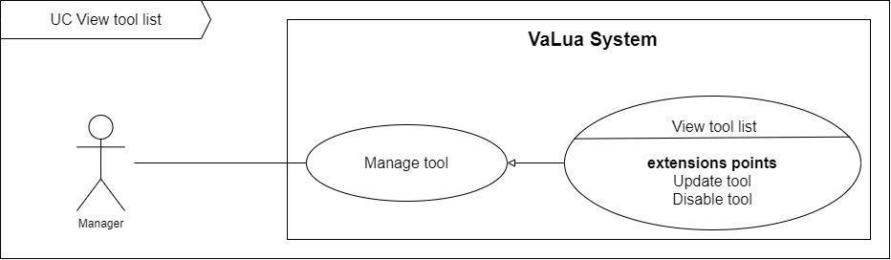

Figure 23. <Use case> View tool list

Table 25. UC22 - View tool list

|  |  |  |  |
| --- | --- | --- | --- |
| ID and Name: | **UC-22 View tool list** | | |
| Created By: | LongTC | Date Created: | 07/02/2022 |
| Primary Actor: | Manager | Secondary Actors: |  |
| Description: | A manager can view list of tools. | | |
| Trigger: | A manager sends a view list of tools command by clicking on the “Tool” tab or submit search input on the “Tool” screen. | | |
| Preconditions: | PRE-1. Manager has already logged in to VaLua. | | |
| Post-conditions: | POST-1:   * Success: VaLua shows a list of tools. * Fail: VaLua shows error message. | | |
| Normal Flow: | **22.0 View tool list** (Exception 22.0.E1)   1. Manager clicks on the “Tool” tab or submit search inputs parameters on the “Tool” screen. 2. VaLua shows a list of tools accordingly (see Exception 22.1.E1), each row item displays:    * Tool code: text    * Name: text    * Status: text    * Action:  * Edit button * Disable/Enable button | | |
| Alternative Flows: | N/A | | |
| Exceptions: | **22.0.E1 Internet connection lost**   1. System shows message (MSG0001).   **22.1.E1 List of tools is empty**   1. VaLua shows message (MSG2201). | | |
| Priority: | Medium | | |
| Frequency of Use: | Medium | | |
| Business Rules: | BR-0015, BR-0016, BR-1900 | | |
| Other Information: | N/A | | |
| Assumptions: | N/A | | |

#### 2.2.23 UC23– Add tool to subject

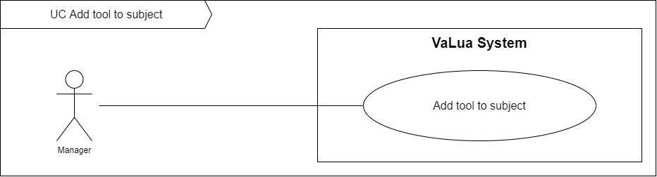

Figure 24. <Use case> Add tool to subject

Table 26. UC23 - Add tool to subject

|  |  |  |  |
| --- | --- | --- | --- |
| ID and Name: | **UC-23 Add tool to subject** | | |
| Created By: | LongTC | Date Created: | 07/02/2022 |
| Primary Actor: | Manager | Secondary Actors: |  |
| Description: | A manager can add some tools to allowed them to be used in certain subjects. | | |
| Trigger: | A manager sends a add tool to subject command | | |
| Preconditions: | PRE-1. Manager has already logged in to VaLua. | | |
| Post-conditions: | POST-1:   * Success: VaLua shows list of rooms. * Fail: VaLua shows error message. | | |
| Normal Flow: | **23.0 Add tool to subject** (Exception 23.0.E1)   1. Manager clicks on the “Edit” button from a specific subject item. 2. VaLua popups a dialog with tool information with the following fields:  * Subject name: text * Subject code: text * Subject duration: number * Subject’s tool list  1. Manager selects the tool list and add tools to the current subject then click on the “Update” button. 2. VaLua updates the current subject and shows a success message (MSG0800) | | |
| Alternative Flows: | N/A | | |
| Exceptions: | **23.0.E1 Internet connection lost**   1. System shows message (MSG0001). | | |
| Priority: | Medium | | |
| Frequency of Use: | Medium | | |
| Business Rules: | BR-0700, BR-0701 | | |
| Other Information: | N/A | | |
| Assumptions: | N/A | | |

#### 2.2.24 UC24 – Remove tool from subject

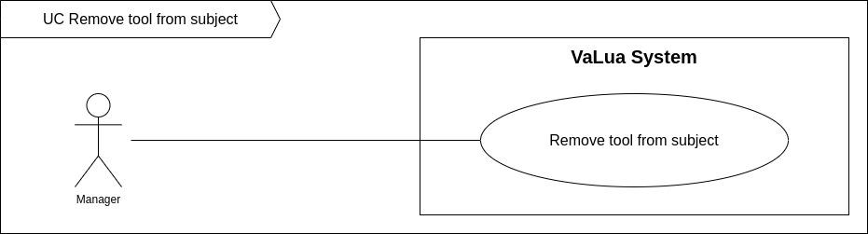

Figure 25. <Use case> Remove tool from subject

Table 27. UC24 - Remove tool from subject

|  |  |  |  |
| --- | --- | --- | --- |
| ID and Name: | **UC-24 Remove tool to subject** | | |
| Created By: | LongTC | Date Created: | 07/02/2022 |
| Primary Actor: | Manager | Secondary Actors: |  |
| Description: | The manager can remove tools from a specific subject. | | |
| Trigger: | A manager sends a add tool to subject command | | |
| Preconditions: | PRE-1. Manager has already logged in to VaLua. | | |
| Post-conditions: | POST-1:   * Success: VaLua saves the current tool and shows a success message. * Fail: VaLua shows an error message. | | |
| Normal Flow: | **24.0 Remove tool from subject** (Exception 24.0.E1)   1. Manager clicks on the “Edit” button from a specific subject item. 2. VaLua popups a dialog with tool information with the following fields:  * Subject name: text * Subject code: text * Subject duration: number * Subject’s tool list  1. Manager selects the tool list and removes tools to the current subject then clicks on the “Update” button. 2. VaLua updates the current subject and shows a success message (MSG0800). | | |
| Alternative Flows: | N/A | | |
| Exceptions: | **24.0.E1 Internet connection lost**   1. System shows a message (MSG0001). | | |
| Priority: | Medium | | |
| Frequency of Use: | Medium | | |
| Business Rules: | BR-0700, BR-0701 | | |
| Other Information: | N/A | | |
| Assumptions: | N/A | | |

#### 2.2.25 UC25 – Create room

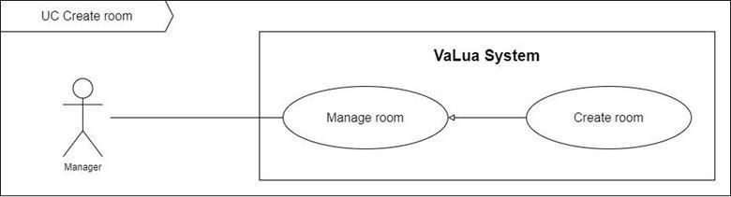

Figure 26. <Use case> Create room

Table 28. UC25 - Create room

|  |  |  |  |
| --- | --- | --- | --- |
| ID and Name: | **UC-25 Create room** | | |
| Created By: | DucNT | Date Created: | 07/02/2022 |
| Primary Actor: | Manager | Secondary Actors: |  |
| Description: | The manager can create a new room. | | |
| Trigger: | The manager sends a create new room command by clicking on the “Create room” button on the “Room” screen. | | |
| Preconditions: | PRE-1. Manager has already logged in to VaLua.  PRE-2. Current screen is “Room”. | | |
| Post-conditions: | POST-1:   * Success: VaLua creates a new room and shows a success message. * Fail: VaLua shows an error message. | | |
| Normal Flow: | **25.0 Create room** (Exception 25.0.E1)   1. Manager clicks the “Create room” button on the “Room” screen. 2. VaLua shows popup contains required information form of the room:    * Name: text input    * Seat count: number input    * Floor: dropdown selector    * Description: text area    * Create button 3. Manager inputs information and clicks on the “Create” button. (see Alternative 25.0) 4. A new room was added to the VaLua and the system shows a success message dialog (MSG2500) (see Exception 25.1.E1, 25.1.E2) | | |
| Alternative Flows: | **25.0 Manager chooses “X” button**   1. Manager clicks on the “X” button. 2. VaLua closes the popup. | | |
| Exceptions: | **25.0.E1 Internet connection lost**   1. System shows a message (MSG0001).   **25.1.E1 Missing of required fields**   1. VaLua shows a message asking the manager to fill the required fields again (MSG2501, MSG2502, MSG2503).   **25.1.E2 Manager inputs field not valid**   1. VaLua shows a message asking the manager to fill the fields again (MSG2504, MSG2505, MSG2506). | | |
| Priority: | Medium | | |
| Frequency of Use: | Medium | | |
| Business Rules: | BR-0010, BR-2500, BR-2501 | | |
| Other Information: | N/A | | |
| Assumptions: | N/A | | |

#### 2.2.26 UC26 – Update room

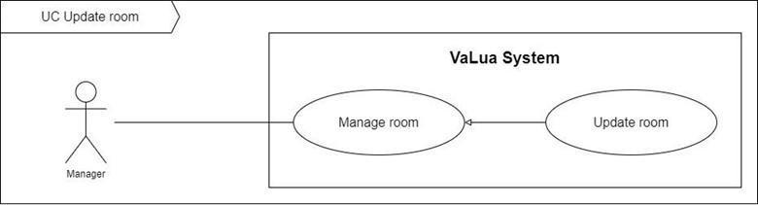

Figure 27. <Use case> Update room

Table 29. UC26 - Update room

|  |  |  |  |
| --- | --- | --- | --- |
| ID and Name: | **UC-26 Update room** | | |
| Created By: | DucNT | Date Created: | 18/02/2022 |
| Primary Actor: | Manager | Secondary Actors: |  |
| Description: | A manager can update the room's information. | | |
| Trigger: | A manager sends an update room command. | | |
| Preconditions: | PRE-1. Manager has already logged in to VaLua.  PRE-2. Current screen is “Room” or “Room’s detail”. | | |
| Post-conditions: | POST-1:   * Success: VaLua updates the room's information and shows a success message. * Fail: VaLua shows error message. | | |
| Normal Flow: | **26.0 Update room** (Exception 26.0.E1)   1. Manager clicks the “Edit” button of a specific room on the room list. (see Alternative 26.0) 2. VaLua navigates to the “Room’s detail” screen with enable fields:    * Name: text input    * Floor: drop down list    * Seat count: drop down list    * Description: text input    * “Update room” button 3. Manager changes the room's information and clicks on the “Update” button. (see Alternative 26.1) 4. VaLua updates room’s information and reloads “Room’s detail” screen with success message (MSG26). (see Exception 26.1.E1, 26.1.E2) | | |
| Alternative Flows: | **26.0 Manager chooses “Edit” icon from Room’s detail.**   1. Manager clicks the “Edit” icon. 2. Return to step 2 of normal flow   **26.1 Manager chooses “Edit” button a second time**   1. Manager clicks on the “Edit” button a second time. 2. Information fields are disabled. | | |
| Exceptions: | **26.0.E1 Internet connection lost**   1. System shows a message (MSG0001).   **26.1.E1 Missing of required fields**   1. VaLua shows a message asking the manager to fill the required fields again (MSG2501, MSG2502, MSG2503).   **26.1.E2 Manager inputs field not valid**   1. VaLua shows a message asking the manager to fill the fields again (MSG2504, MSG2505, MSG2506). | | |
| Priority: | Medium | | |
| Frequency of Use: | Low | | |
| Business Rules: | BR-0010, BR-0011, BR-2500, BR-2501 | | |
| Other Information: | N/A | | |
| Assumptions: | N/A | | |

#### 2.2.27 UC27 – Disable room

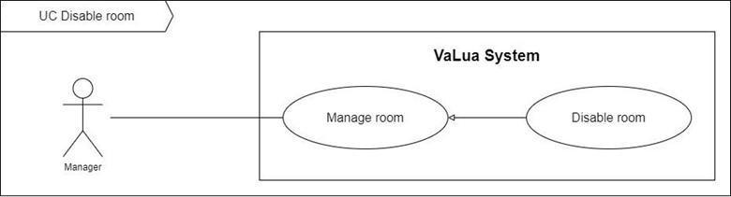

Figure 28. <Use case> Disable room

Table 30. UC27 - Disable room

|  |  |  |  |
| --- | --- | --- | --- |
| ID and Name: | **UC-27 Disable room** | | |
| Created By: | DucNT | Date Created: | 18/02/2022 |
| Primary Actor: | Manager | Secondary Actors: |  |
| Description: | A manager can disable the room. | | |
| Trigger: | A manager sends a disable room command. | | |
| Preconditions: | PRE-1. Manager has already logged in to VaLua.  PRE-2. Current screen is “Room” or “Room’s detail”. | | |
| Post-conditions: | POST-1:   * Success: Room’s status is “Inactive” and shows a success message. * Fail: VaLua shows an error message. | | |
| Normal Flow: | **27.0 Disable room** (Exception 27.0.E1)   1. Manager clicks the “Disable” button of a specific room on the room list. (see Alternative 27.0) 2. VaLua shows confirm dialog (MSG2507) and two buttons for manager to select:    * Cancel button    * Confirm button 3. Manager clicks on the “Confirm” button. (see Alternative 27.1) 4. VaLua changes this room’s status to “Inactive” and shows the success message (MSG2508). | | |
| Alternative Flows: | **27.0 Manager chooses “Disable Room” button in Room’s detail.**   1. Manager clicks the “Disable Room” button. 2. Return to step 2 of normal flow   **27.1 Manager chooses “Cancel” button**   1. Manager clicks on the “Cancel” button. 2. VaLua closes the dialog. | | |
| Exceptions: | **27.0.E1 Internet connection lost**   1. System shows a message (MSG0001). | | |
| Priority: | Low | | |
| Frequency of Use: | Low | | |
| Business Rules: | BR-0011, BR-2500 | | |
| Other Information: | N/A | | |
| Assumptions: | N/A | | |

#### 2.2.28 UC28 – View room list

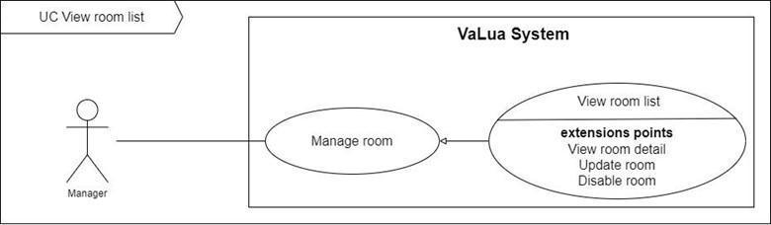

Figure 29. <Use case> View room list

Table 31. UC28 - View room list

|  |  |  |  |
| --- | --- | --- | --- |
| ID and Name: | **UC-28 View room list** | | |
| Created By: | DucNT | Date Created: | 21/02/2022 |
| Primary Actor: | Manager | Secondary Actors: |  |
| Description: | A manager can view list of rooms | | |
| Trigger: | A manager sends a view rooms list command by clicking on the “Room” item on the sidebar. | | |
| Preconditions: | PRE-1. Manager has already logged in to VaLua. | | |
| Post-conditions: | POST-1:   * Success: VaLua shows a list of rooms. * Fail: VaLua shows an error message. | | |
| Normal Flow: | **28.0 View room list** (Exception 28.0.E1)   1. Manager clicks on the “Room” item on the sidebar to send a request to view the list of rooms. 2. VaLua shows list of rooms (see Exception 28.1.E1), each row item displays:    * Name: text    * Floor: number    * Seats count: number    * Status: text    * Action:  * Edit button * View detail button * Disable/Enable button | | |
| Alternative Flows: | N/A | | |
| Exceptions: | **28.0.E1 Internet connection lost**   1. System shows a message (MSG0001).   **28.1.E1 List of rooms is empty**   1. VaLua shows a message (MSG0002). | | |
| Priority: | Medium | | |
| Frequency of Use: | Medium | | |
| Business Rules: | BR-2500, BR-0015, BR-0016, BR-2502 | | |
| Other Information: | N/A | | |
| Assumptions: | N/A | | |

#### 2.2.29 UC29 – View room detail

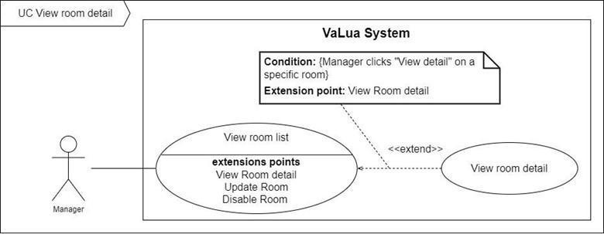

Figure 30. <Use case> View room detail

Table 32. UC29 - View room detail

|  |  |  |  |
| --- | --- | --- | --- |
| ID and Name: | **UC-29 View room detail** | | |
| Created By: | DucNT | Date Created: | 21/02/2022 |
| Primary Actor: | Manager | Secondary Actors: |  |
| Description: | A manager can view detailed information about a room by clicking on the “View detail” from the action menu of a specific room item.. | | |
| Trigger: | A manager sends a view room detail command. | | |
| Preconditions: | PRE-1. Manager has already logged in to VaLua.  PRE-2. Room exists in VaLua. | | |
| Post-conditions: | POST-1. VaLua shows detailed information of the room. | | |
| Normal Flow: | **29.0 View room detail** (Exception 29.0.E1)   1. Manager clicks on the “View detail” button. 2. VaLua shows the room’s detail information include:    * Room’s card:      + Room’s name: text      + Status: text      + Last updated: datetime      + “Disable room” button    * Room’s information      + Name: text      + Floor: drop down list      + Seat count: number      + Description: text | | |
| Alternative Flows: | N/A | | |
| Exceptions: | **29.0.E1 Internet connection lost**   1. System shows a message (MSG0001). | | |
| Priority: | Medium | | |
| Frequency of Use: | Medium | | |
| Business Rules: | BR-2500 | | |
| Other Information: | N/A | | |
| Assumptions: | N/A | | |

#### 2.2.30 UC30 – Logout

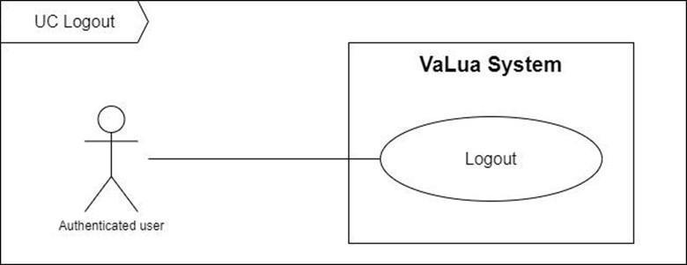

Figure 31. <Use case> Logout

Table 33. UC30 - Logout

|  |  |  |  |
| --- | --- | --- | --- |
| ID and Name: | **UC-30 Logout** | | |
| Created By: | DucNT | Date Created: | 21/02/2022 |
| Primary Actor: | Authenticated User | Secondary Actors: | N/A |
| Description: | Terminate current user’s session from the system | | |
| Trigger: | Authenticated User sends a request to log out from the system | | |
| Preconditions: | PRE-1. User has already logged in the VaLua. | | |
| Post-conditions: | POST-1:   * Success: User’s session has been terminated. * Fail: VaLua shows error messages. | | |
| Normal Flow: | **30.0 Logout** (Exception 30.0.E1)   1. Authenticated User taps or clicks on the “Logout” button. 2. VaLua terminates user’s session then redirects them to login page or screen | | |
| Alternative Flows: | N/A | | |
| Exceptions: | **30.0.E1 Internet connection lost**   1. System shows a message (MSG0001). | | |
| Priority: | High | | |
| Frequency of Use: | High | | |
| Business Rules: | BR-0001, BR-0003 | | |
| Other Information: | N/A | | |
| Assumptions: | N/A | | |

#### 2.2.31 UC31 – Change password

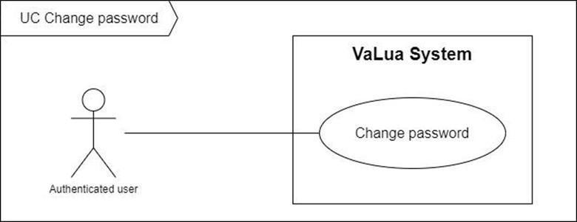

Figure 32. <Use case> Change password

Table 34. UC31 - Change password

|  |  |  |  |
| --- | --- | --- | --- |
| ID and Name: | **UC-31 Change password** | | |
| Created By: | DucNT | Date Created: | 21/02/2021 |
| Primary Actor: | Authenticated User | Secondary Actors: |  |
| Description: | Authenticated Users should change their default password after the first login and periodically for personal security | | |
| Trigger: | Authenticated User sends a request to change their current password by being prompted to change their default password or hitting the “Change Password” button in the profile view. | | |
| Preconditions: | PRE-1. User has already logged into VaLua. | | |
| Post-conditions: | POST-1:   * Success: VaLua updates user’s password and shows a success message * Fail: VaLua shows an error messages. | | |
| Normal Flow: | **31.0 Change password** (Exception 31.0.E1)   1. User hits on the “Change Password” button in profile view or currently on the change password popup after a successful login. 2. VaLua shows a popup with 3 fields:    * Current password: password input    * New password: password input    * Confirm password: password input    * “Update” button 3. User enters a new password for both inputs then hits the “Update” button. 4. VaLua updates the user's password then shows a success message (MSG3101) (see 31.0.E2, 31.0.E3). | | |
| Alternative Flows: | N/A | | |
| Exceptions: | **31.0.E1 Internet connection lost**   1. System shows a message (MSG0001).   **31.1.E1 Missing of required fields**   1. VaLua shows a message asking the user to fill the required fields again (MSG3102, MSG3104).   **31.1.E2 Inputs field not valid**   1. VaLua shows a message asking the user to fill the fields again (MSG3103). | | |
| Priority: | Medium | | |
| Frequency of Use: | Low | | |
| Business Rules: | N/A | | |
| Other Information: | N/A | | |
| Assumptions: | N/A | | |

#### 2.2.32 UC32 – View profile

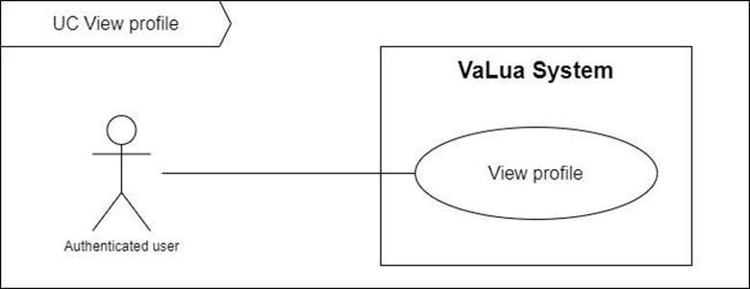

Figure 33. <Use case> View profile

Table 35. UC32 - View profile

|  |  |  |  |
| --- | --- | --- | --- |
| ID and Name: | **UC-32 View profile** | | |
| Created By: | DucNT | Date Created: | 21/02/2022 |
| Primary Actor: | Authenticated User | Secondary Actors: |  |
| Description: | Authenticated Users can view their profile | | |
| Trigger: | Authenticated User sends a request to get their profile by tapping on user icon button or clicking on the view profile button | | |
| Preconditions: | PRE-1. User has already logged into VaLua. | | |
| Post-conditions: | POST-1:   * Success: VaLua shows user’s profile information in a new screen or page. * Fail: VaLua shows an error message. | | |
| Normal Flow: | **32.0 View profile** (Exception 32.0.E1)   1. User taps on the user icon button or clicks on the view profile button. 2. VaLua shows user profile screen with the following panels:  * Personal information: * Profile picture: image * Full Name: text * Role: text * Gender: dropdown list item * Date of birth: text * Phone: text * Email: text * Address: text * Update profile: button * Authentication information: * Full name: text * Profile picture: image * Role: text, role name * Upload image: text button * Update password: text button | | |
| Alternative Flows: | N/A | | |
| Exceptions: | **32.0.E1 Internet connection lost**   1. System shows a message (MSG0001). | | |
| Priority: | Medium | | |
| Frequency of Use: | Low | | |
| Business Rules: | N/A | | |
| Other Information: | N/A | | |
| Assumptions: | N/A | | |

#### 2.2.33 UC33 – Update profile

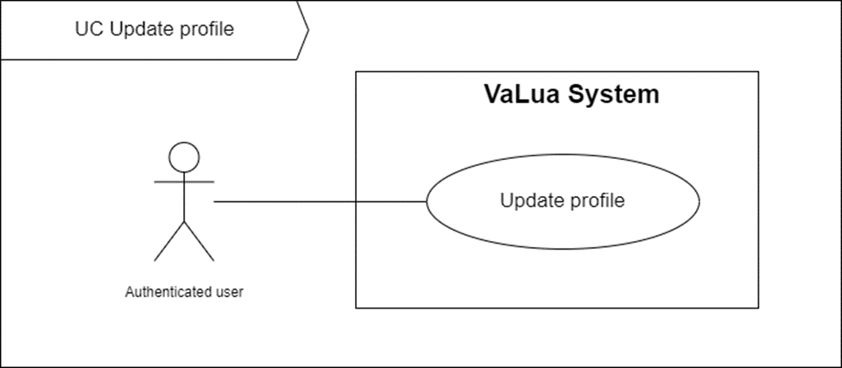

Figure 34. <Use case> Update profile

Table 36. UC33 - Update profile

|  |  |  |  |
| --- | --- | --- | --- |
| ID and Name: | **UC-33 Update profile** | | |
| Created By: | DucNT | Date Created: | 21/02/2022 |
| Primary Actor: | Authenticated User | Secondary Actors: |  |
| Description: | This feature enables authenticated users to modify their personal information | | |
| Trigger: | Authenticated User sends a request to update their profile by tapping or clicking on the update profile button in profile information screen or page | | |
| Preconditions: | PRE-1. User has already logged into VaLua.  PRE-2. User is currently at view profile screen or page | | |
| Post-conditions: | POST-1:   * Success: VaLua shows a success message. * Fail: VaLua shows error messages. | | |
| Normal Flow: | **33.0 Update profile** (Exception 33.0.E1)   1. User taps or clicks the update profile button. 2. VaLua transform the following information into input fields:  * Profile picture: upload file * Full Name: text input * Gender: dropdown selector * Date of birth: date picker * Phone: number input * “Update profile” button  1. User entered these above fields then taps or clicks on the “Update profile” button 2. VaLua shows the success message (MSG3300) (see Exception 33.1.E1, 33.1.E2) | | |
| Alternative Flows: | N/A | | |
| Exceptions: | **33.0.E1 Internet connection lost**   1. System shows a message (MSG0001).   **33.1.E1 User fails to enter required fields**   1. VaLua shows a message asking the user to fill the required fields again (MSG3101, MSG3302, MSG3303).   **33.1.E2 User inputs fields not valid**   1. VaLua shows a message asking the user to fill the fields again (MSG3304, MSG3305). | | |
| Priority: | Medium | | |
| Frequency of Use: | Low | | |
| Business Rules: | N/A | | |
| Other Information: | N/A | | |
| Assumptions: | N/A | | |

#### 2.2.34 UC34 – View notification list

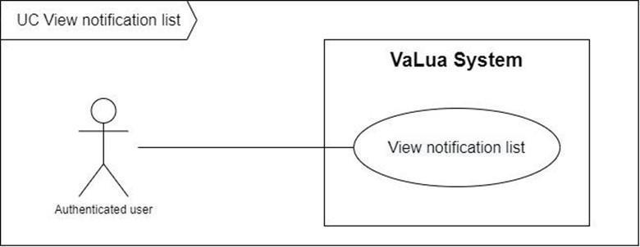

Figure 35. <Use case> View notification list

Table 37. UC34 - View notification list

|  |  |  |  |
| --- | --- | --- | --- |
| ID and Name: | **UC-34 View notifications list** | | |
| Created By: | DucNT | Date Created: | 21/02/2022 |
| Primary Actor: | Authenticated User | Secondary Actors: |  |
| Description: | Authenticated Users can view their notifications list | | |
| Trigger: | Authenticated User sends a request to view their notifications by tapping or clicking on the “View all notification” icon button. | | |
| Preconditions: | PRE-1. User has already logged into VaLua. | | |
| Post-conditions: | POST-1:   * Success: VaLua shows user’s notifications list in a new screen or page. * Fail: VaLua shows an error message. | | |
| Normal Flow: | **34.0 View notification list** (Exception 34.0.E1)   1. User taps on or clicks on the “View all notification” button. 2. VaLua shows user’s notifications list with followings information (see alternative 34.0):  * Type: icon image * Header: text * Time lasted: datetime, difference between current time and notification’s created time * View item: button | | |
| Alternative Flows: | **34.0 User has no notification**   1. VaLua shows a message (MSG3400). | | |
| Exceptions: | **34.0.E1 Internet connection lost**   1. System shows a message (MSG0001). | | |
| Priority: | Medium | | |
| Frequency of Use: | High | | |
| Business Rules: | BR-0015, BR-3400 | | |
| Other Information: | N/A | | |
| Assumptions: | N/A | | |

#### 2.2.35 UC35 – Update attendance

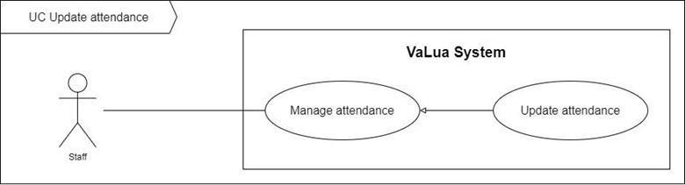

Figure 36. <Use case> Update attendance

Table 38. UC35 - Update attendance

|  |  |  |  |
| --- | --- | --- | --- |
| ID and Name: | **UC-35 Update attendance** | | |
| Created By: | DucNT | Date Created: | 21/02/2022 |
| Primary Actor: | Staff | Secondary Actors: |  |
| Description: | A staff can update attendances of the room they are currently supervising. This action includes check, uncheck and finish an attendance. | | |
| Trigger: | Staff sends an update attendance request by tapping on one of the update attendance buttons in the attendance list screen. | | |
| Preconditions: | PRE-1. Staff has already logged in to VaLua.  PRE-2. Staff is currently assigned to a room in a shift.  PRE-3. The current screen is “Attendance list”. | | |
| Post-conditions: | POST-1:   * Success: VaLua updates the selected attendance and shows a success message. * Fail: VaLua shows an error message. | | |
| Normal Flow: | **35.0 Update attendance** (Exception 35.0.E1)   1. Staff swipes right on a specific attendance item. (See alternative 35.0) 2. VaLua shows an update button based on the current status on the attendance at the direction of the swipe:  * Check button: for unchecked attendances. * Uncheck button: for checked attendances. * Finish button: for checked but unfinished attendances.  1. Staff taps on the according update button 2. VaLua updates the attendance and shows the success message (MSG3500). | | |
| Alternative Flows: | **35.0 Staff swipe left on the attendance** (Exception 35.0.E1)   1. Staff swipes left on the attendance. 2. If the current attendance is checked but unfinished, return to step 2 of the normal flow. | | |
| Exceptions: | **35.0.E1 Internet connection lost**   1. System shows a message (MSG0001). | | |
| Priority: | Medium | | |
| Frequency of Use: | Medium | | |
| Business Rules: | BR-3500, BR-3501, BR-3502 | | |
| Other Information: | N/A | | |
| Assumptions: | N/A | | |

#### 2.2.36 UC36 – View attendances of exam room

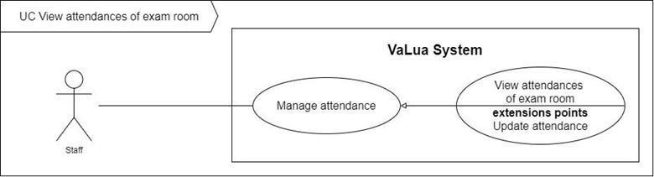

Figure 37. <Use case> View attendances of exam room

Table 39. UC36 - View attendances of exam room

|  |  |  |  |
| --- | --- | --- | --- |
| ID and Name: | **UC-36 View attendances of exam room** | | |
| Created By: | DucNT | Date Created: | 21/02/2022 |
| Primary Actor: | Staff | Secondary Actors: |  |
| Description: | A staff can view the attendances of their assigned exam room. | | |
| Trigger: | Staff sends a request to view the attendances of their assigned exam room by tapping on the “Attendances” button at the exam room dashboard screen. | | |
| Preconditions: | PRE-1. Staff has already logged in to VaLua.  PRE-2. Staff is currently assigned to a room in a shift. | | |
| Post-conditions: | POST-1:   * Success: VaLua shows the attendance list of the exam room in the “Attendance” screen. * Fail: VaLua shows error messages. | | |
| Normal Flow: | **36.0 View attendances of exam room** (Exception 36.0.E1)   1. Staff taps on the “Attendances” button. 2. VaLua shows list attendances of the exam rooms followings information: (see Exception 36.1.E1):  * Attendance pie chart: * Attendance list item: * Seat position: number * Avatar: image * Company ID: text * Name: text * Attendance status: icon | | |
| Alternative Flows: | N/A | | |
| Exceptions: | **36.0.E1 Internet connection lost**   1. System shows a message (MSG0001). | | |
| Priority: | Medium | | |
| Frequency of Use: | Medium | | |
| Business Rules: | BR-3500 | | |
| Other Information: | N/A | | |
| Assumptions: | N/A | | |

#### 2.2.37 UC37 – Create report

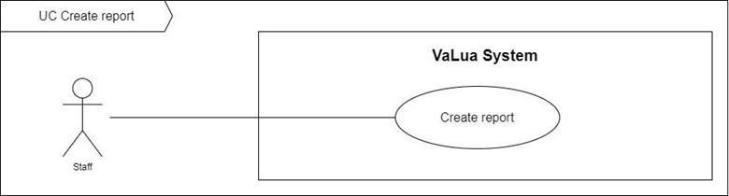

Figure 38. <Use case> Create report

Table 40. UC37 - Create report

|  |  |  |  |
| --- | --- | --- | --- |
| ID and Name: | **UC37 – Create report** | | |
| Created By: | DucNT | Date Created: | 21/02/2022 |
| Primary Actor: | Staff | Secondary Actors: |  |
| Description: | Staff create a report in case something goes wrong in their assigned shift to the shift manager to resolve it. | | |
| Trigger: | Staff sends a create report request by tapping on the “Submit” button at the create report screen. | | |
| Preconditions: | PRE-1. Users is logged in as a staff  PRE-2. Current screen is “Exam room dashboard” screen | | |
| Post-conditions: | POST-1:   * Success: VaLua creates report then shows a success message * Fail: VaLua shows error messages. | | |
| Normal Flow: | **37.0 Create report** (Exception 37.1.E1)   1. Staff taps on the “Create report” button. 2. VaLua show a modal bottom showing the report types, each type includes:    * Report type name: text    * Report type icon: icon 3. Staff select a report type 4. VaLua shows the create report screen with the following fields: (See alternative 37.0)    * Description: text input    * Note: text input    * Image: image file picker 5. Staff input information and taps on the “Submit” button. 6. VaLua saves the report and shows a success message (MSG3700) (see Exception 37.1.E1) | | |
| Alternative Flows: | **37.0 The selected report type is “Violation”**   1. VaLua shows additional fields:    * Violator: dropdown button. 2. Return to step 4 of the normal flow. | | |
| Exceptions: | **37.0.E1 Internet connection lost**   1. System shows a message (MSG0001).   **37.1.E1 Missing of required fields**   1. VaLua shows a message asking the staff to fill the required fields again (MSG3701, MSG3702, MSG3703). | | |
| Priority: | Medium | | |
| Frequency of Use: | Medium | | |
| Business Rules: | BR-0010, BR-3700, BR-3701, BR-3702 | | |
| Other Information: | N/A | | |
| Assumptions: | N/A | | |

#### 2.2.38 UC38 – View assigned exam rooms

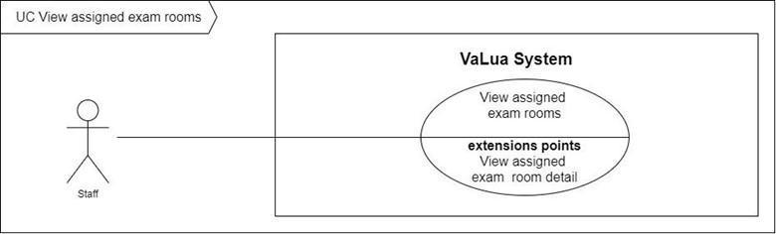

Figure 39. <Use case> View assigned exam rooms

Table 41. UC38 - View assigned exam room

|  |  |  |  |
| --- | --- | --- | --- |
| ID and Name: | **UC-38 View assigned exam rooms** | | |
| Created By: | DucNT | Date Created: | 21/02/2022 |
| Primary Actor: | Staff | Secondary Actors: |  |
| Description: | A staff can view their assigned exam rooms. | | |
| Trigger: | Staff sends a request to view their assigned exam rooms by tapping on the “Assigned shifts” button at the dashboard view. | | |
| Preconditions: | PRE-1. Staff has already logged in to VaLua. | | |
| Post-conditions: | POST-1:   * Success: VaLua shows staff’s assigned exam rooms list in “Assigned shifts” screen * Fail: VaLua shows error messages. | | |
| Normal Flow: | **38.0 View assigned exam rooms** (Exception 38.0.E1)   1. Staff taps on the “Assigned shifts” button. 2. VaLua shows exam rooms list information with followings information: (see Exception 38.1.E1):  * Assigned exam room item: * Begin and finish time: text * Room: Text | | |
| Alternative Flows: | N/A | | |
| Exceptions: | **38.0.E1 Internet connection lost**   1. System shows a message (MSG0001). | | |
| Priority: | Medium | | |
| Frequency of Use: | High | | |
| Business Rules: | BR-0015, BR-0018, BR-3800 | | |
| Other Information: | N/A | | |
| Assumptions: | N/A | | |

#### 2.2.39 UC39 – View current exam rooms’ detail

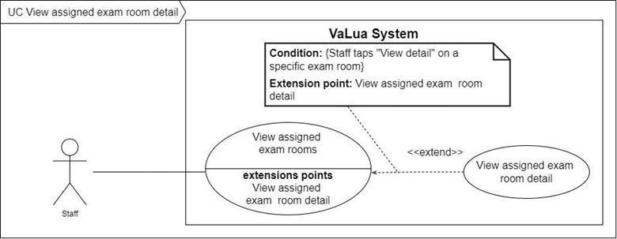

Figure 40. <Use case> View current exam room's detail

Table 42. UC39 - View current exam room's detail

|  |  |  |  |
| --- | --- | --- | --- |
| ID and Name: | **UC-39 View current exam room’s detail** | | |
| Created By: | DucNT | Date Created: | 21/02/2022 |
| Primary Actor: | Staff | Secondary Actors: |  |
| Description: | Staff are directed to view detailed information about exam rooms at the room they supervise during a shift. | | |
| Trigger: | A staff sends a view assigned exam room detail request after logging in VaLua Camera. | | |
| Preconditions: | PRE-1. Staff has already logged in to VaLua. | | |
| Post-conditions: | POST-1:   * Success: VaLua shows detailed information of the assigned exam room. * Fail: VaLua shows error messages. | | |
| Normal Flow: | **39.0 View assigned exam room detail** (Exception 39.0.E1)   1. Staff taps on the “Info” button in exam room dashboard or logins VaLua Camera in the shift for the first time. 2. VaLua shows exam rooms’ detail information include: (see Exception 39.1.E1)  * Date: Datetime * Time: Datetime * Room: Text * Subject: Text * Tool: Text * Total examinees: number | | |
| Alternative Flows: | N/A | | |
| Exceptions: | **39.0.E1 Internet connection lost**   1. System shows a message (MSG0001). | | |
| Priority: | Medium | | |
| Frequency of Use: | Medium | | |
| Business Rules: | BR-3800 | | |
| Other Information: | N/A | | |
| Assumptions: | N/A | | |

#### 2.2.40 UC40 – Register shift

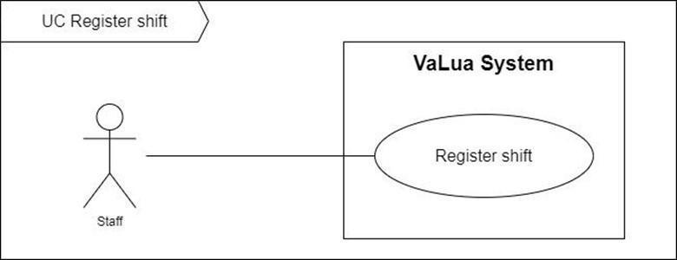

Figure 41. <Use case> Register shift

Table 43. UC40 - Register shift

|  |  |  |  |
| --- | --- | --- | --- |
| ID and Name: | **UC-40 Register shift** | | |
| Created By: | DucNT | Date Created: | 21/02/2022 |
| Primary Actor: | Staff | Secondary Actors: |  |
| Description: | Staffs can register shifts which they supervise. | | |
| Trigger: | Staff sends a register request by tapping on the “Register” button from a specific shift item in the “Shift registration” screen. | | |
| Preconditions: | PRE-1. Staff has already logged in to VaLua Staff.  PRE-2. The current screen is Home. | | |
| Post-conditions: | POST-1:   * Success: VaLua shows staff’s assigned exam rooms list in “My shifts” screen * Fail: VaLua shows an error message. | | |
| Normal Flow: | **40.0 Register shift** (Exception 40.0.E1)   1. Staff taps on the “Shift registration” button. 2. VaLua shows exam rooms list information with followings information: (See exception 40.0.E2):  * Available shift item: * Begin and finish time: text * Remaining slots: number * Time of day’s icon * Checkbox  1. Staff select shifts that they want to register. 2. Staff taps on the “Register” button. 3. VaLua shows a confirmation dialog including a confirmation message (MSG4001) and 2 buttons:    1. “Cancel” button    2. “OK” button 4. Staff taps on the “OK” button. (See alternative 40.0) 5. VaLua assigns staff to the first unstaffed room in each of the selected shifts then shows the success message (MSG4000). (See exception 40.0.E3) | | |
| Alternative Flows: | **40.0 Staff taps on the “Cancel” button.**   1. Staff taps on the “Cancel” button. 2. VaLua closes the dialog. | | |
| Exceptions: | **40.0.E1 Internet connection lost**   1. System shows a message (MSG0001).   **40.0.E2 Opening shift list is empty**   1. System shows a message (MSG0002).   **40.0.E3 There is no remaining slot to assign the staff**   1. System shows an error message (MSG4002). | | |
| Priority: | Medium | | |
| Frequency of Use: | High | | |
| Business Rules: | BR-0015, BR-0018, BR-4000, BR-4001, BR-4002 | | |
| Other Information: | N/A | | |
| Assumptions: | N/A | | |

#### 2.2.41 UC41 – View report list

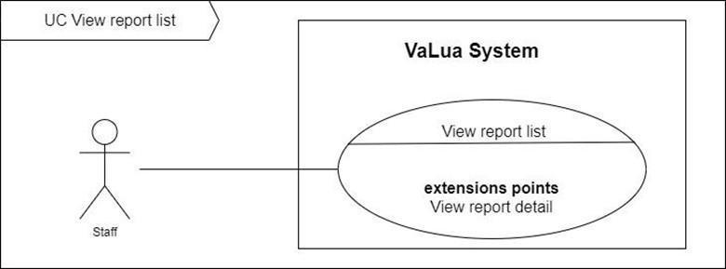

Figure 42. <Use case> View report list

Table 44. UC41 - View report list

|  |  |  |  |
| --- | --- | --- | --- |
| ID and Name: | **UC-41 View report list** | | |
| Created By: | DucNT | Date Created: | 21/02/2022 |
| Primary Actor: | Staff | Secondary Actors: |  |
| Description: | A staff can view a report list of their assigned exam rooms. | | |
| Trigger: | Staff sends a request to view their assigned exam rooms by tapping on the “Reports” button at the dashboard view. | | |
| Preconditions: | PRE-1. Staff has already logged in to VaLua Camera.  PRE-2. The currently screen is “Exam room dashboard” | | |
| Post-conditions: | POST-1:   * Success: VaLua shows a list of reports in the current shift in the room the staff is supervising. * Fail: VaLua shows an error message. | | |
| Normal Flow: | **41.0 View report list** (Exception 41.0.E1)   1. Staff taps on the “Reports” button. 2. VaLua shows a list of reports, each item has the following fields: (see Exception 41.0.E2):  * Type: icon image and text * Created at: date time in text | | |
| Alternative Flows: | N/A | | |
| Exceptions: | **41.0.E1 Internet connection lost**   1. System shows a message (MSG0001).   **41.0.E2 The report list is empty**   1. System shows a message (MSG0002). | | |
| Priority: | Medium | | |
| Frequency of Use: | High | | |
| Business Rules: | BR-0015, BR-0018, BR-3700 | | |
| Other Information: | N/A | | |
| Assumptions: | Staff is currently supervising an ongoing shift in a room. | | |

#### 2.2.42 UC42 – Update report

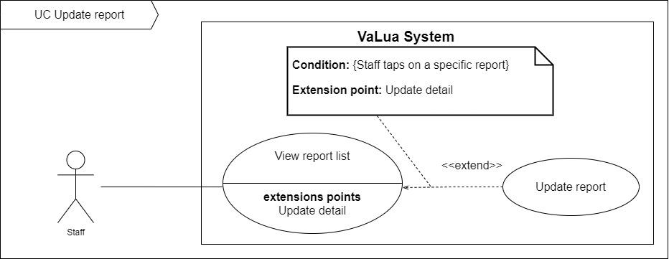

Figure 43. <Use case> Update report

Table 45. UC42 - Update report

|  |  |  |  |
| --- | --- | --- | --- |
| ID and Name: | **UC-42 Update report** | | |
| Created By: | DucNT | Date Created: | 21/02/2022 |
| Primary Actor: | Staff | Secondary Actors: |  |
| Description: | A staff can update a report of their assigned exam rooms. | | |
| Trigger: | Staff sends a request to update a report by tapping on a specific report item in the “Report list” screen. | | |
| Preconditions: | PRE-1. Staff has already logged in to VaLua Camera.  PRE-2. The currently screen is “Report list” | | |
| Post-conditions: | POST-1:   * Success: VaLua updates the report and shows a success message. * Fail: VaLua shows an error message. | | |
| Normal Flow: | **42.0 Update report** (Exception 42.0.E1)   1. Staff taps on a report item from the “Report list” screen. 2. VaLua shows detail of the report, information including: (See alternative 42.0)  * Description: text box input * Note: text box input * Image: single image uploader  1. Staff inputs information then taps on the “Submit” button. 2. VaLua saves the report and shows a success message (MSG4200). (See exception 42.0.E2) | | |
| Alternative Flows: | **42.0 The selected report type is “Violation”**   1. VaLua shows additional fields:    * Violator: dropdown button. 2. Return to step 2 of the normal flow. | | |
| Exceptions: | **42.0.E1 Internet connection lost**   1. System shows a message (MSG0001).   **42.0.E2 Missing of required fields**   1. VaLua shows a message asking the manager to fill the required fields again (MSG3701, MSG3702, MSG3703). | | |
| Priority: | Medium | | |
| Frequency of Use: | High | | |
| Business Rules: | BR-0015, BR-0018, BR-3700 | | |
| Other Information: | N/A | | |
| Assumptions: | Staff is currently supervising an ongoing shift in a room. | | |

#### 2.2.43 UC43 – Create shift

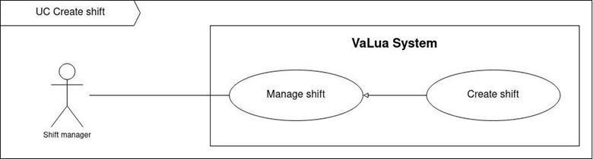

Figure 44. <Use case> Create shift

Table 46. UC43 - Create shift

|  |  |  |  |
| --- | --- | --- | --- |
| ID and Name | **UC-43 Create Shift** | | |
| Created By: | LongTC | Date Created: | 07/02/2022 |
| Primary Actor: | Shift Manager | Secondary Actors: |  |
| Description: | Shift managers can create a new shift. | | |
| Trigger: | A shift manager sends a create a new shift command by clicking on “Add shift” button from the “Actions” dropdown on the “Shifts” screen. | | |
| Preconditions: | PRE-1. Shift manager has already logged in to VaLua.  PRE-2. Current screen is “Shifts”. | | |
| Post-conditions: | POST-1:   * Success: VaLua creates a new shift and shows a success message. * Fail: VaLua shows an error message. | | |
| Normal Flow: | **43.0 Create shift** (Exception 43.0.E1)   1. Shift manager clicks on the “Add shift” button. 2. VaLua pops up the “Create shift” modal with 2 panels:  * Shift overview panel containing all existing shifts on the week’s timeline and the followings controls:   + Previous week button   + Next week button * Shift create form with the following fields:   + Semester: text combo box selector   + Begin time: date and time picker   + End time: date and time picker  1. Shift manager inputs information and clicks on the “Create” button. 2. VaLua saves the shift then shows a success message dialog (MSG4300). (See Exception 43.1.E1) | | |
| Alternative Flows: | N/A | | |
| Exceptions: | **43.0.E1 Internet connection lost**   1. System shows an error message (MSG0001).   **43.1.E1 Time inputs are missing or invalid**   1. VaLua shows a message asking shift manager to fill the fields again (MSG4301, MSG4302, MSG4303, MSG4304, MSG4305, MSG4306, MSG4307, MSG4308). | | |
| Priority: | High | | |
| Frequency of Use: | Medium | | |
| Business Rules: | BR-0010, BR-4300, BR-4301, BR-4302, BR-4303, BR-4403 | | |
| Other Information: | N/A | | |
| Assumptions: | N/A | | |

#### 2.2.44 UC44 – Update shift

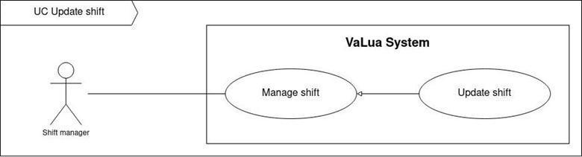

Figure 45. <Use case> Update shift

Table 47. UC44 - Update shift

|  |  |  |  |
| --- | --- | --- | --- |
| ID and Name | **UC-44 Update shift** | | |
| Created By: | LongTC | Date Created: | 07/02/2022 |
| Primary Actor: | Shift Manager | Secondary Actors: |  |
| Description: | Shift managers can update shift’s information. | | |
| Trigger: | A shift manager sends an update shift command by clicking on the “Edit” button from the “Actions” list of the selected shift or toggle the edit icon button on in the “Shift’s detail” screen. | | |
| Preconditions: | PRE-1. Shift manager has already logged in to VaLua.  PRE-2. Current screen is “Shift” or “Shift’s detail”. | | |
| Post-conditions: | POST-1:   * Success: VaLua updates shift’s information and shows success a message. * Fail: VaLua shows an error message. | | |
| Normal Flow: | **44.0 Update shift** (Exception 44.0.E1)   1. Shift manager clicks the “Edit” button of a specific shift from the “Actions” menu on the shift list. (See Alternative 44.0) 2. VaLua navigates to the “Shift’s detail” screen with a shift information card containing these fields:    * Semester: searchable dropdown list    * Begin time: date time picker    * End time: date time picker    * Last updated: date time in text    * Status: text    * “Update” button    * “Delete” button 3. Shift manager changes shift’s information and clicks on the “Update” button. (See Alternative 44.1) 4. VaLua updates shift’s information and navigates to “Shift’s detail” screen with success message (MSG4400). (See Exception 44.1.E1) | | |
| Alternative Flows: | **44.0 Shift manager chooses “Edit” icon from shift’s detail.**   1. Shift manager clicks the “Edit” icon. 2. Return to step 2 of normal flow.   **44.1 Shift manager chooses “Edit” icon again**   1. Shift manager clicks on “Edit” button the second time. 2. VaLua shows confirm dialog: “Do you really want to cancel this action? All information here will be lost.” and two buttons for user to select:  * Yes button * No button  1. Shift manager clicks on “Yes” button. (See Alternative 44.2) 2. VaLua reloads the “Shift’s detail” screen with no edited fields.   **44.2 Shift manager chooses “No” button**   1. Shift manager clicks on “No” button. 2. Return to step 3 of normal flow | | |
| Exceptions: | **44.0.E1 Internet connection lost**   1. System shows message (MSG0001).   **44.1.E1 Time inputs are missing or invalid**   1. VaLua shows message asking shift manager to fill the fields again (MSG4301, MSG4302, MSG4303, MSG4304, MSG4305, MSG4306, MSG4307, MSG4308). | | |
| Priority: | Low | | |
| Frequency of Use: | Low | | |
| Business Rules: | BR-4300, BR-4303, BR-4401, BR-4402 | | |
| Other Information: | N/A | | |
| Assumptions: | N/A | | |

#### 2.2.45 UC45 – Delete shift

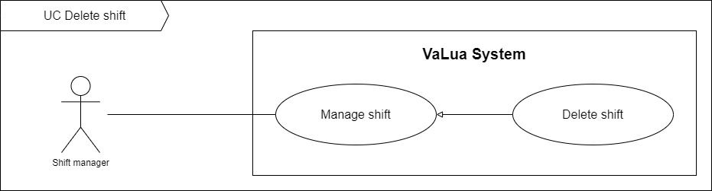

Figure 46. <Use case> Delete shift

Table 48. UC45 - Delete shift

|  |  |  |  |
| --- | --- | --- | --- |
| ID and Name: | **UC-45 Delete shift** | | |
| Created By: | LongTC | Date Created: | 07/02/2022 |
| Primary Actor: | Shift manager | Secondary Actors: |  |
| Description: | Shift managers can delete shift. | | |
| Trigger: | A shift manager sends a delete shift command. | | |
| Preconditions: | PRE-1. Shift manager has already logged in to VaLua.  PRE-2. Current screen is “Shift” or “Shift’s detail”. | | |
| Post-conditions: | POST-1:   * Success: VaLua sets the shift’s status to “Removed” and shows success a message. * Fail: VaLua shows an error message. | | |
| Normal Flow: | **45.0 Delete shift** (Exception 45.0.E1)   1. Shift manager clicks on the “Delete” button of a specific shift on the shifts list. (See Alternative 45.0) 2. VaLua shows a confirmation dialog: “Do you want to delete this shift? This action can’t be reversed (MSG4501).” with two buttons to select:    * “Confirm” button    * “Cancel” button 3. Shift manager clicks on the “Confirm” button. (See Alternative 45.1) 4. VaLua changes this shift’s status to “Removed” and shows the success message (MSG4500). | | |
| Alternative Flows: | **45.0 Shift manager clicks on the “Delete” button from the shift detail screen.**   1. Shift manager clicks on the “Delete” button. 2. Return to step 2 of normal flow.   **45.1 Shift manager chooses the “Cancel” button**   1. Shift manager clicks on the “Cancel” button. 2. VaLua closes the confirmation dialog. | | |
| Exceptions: | **45.0.E1 Internet connection lost**   1. System shows message (MSG0001). | | |
| Priority: | Low | | |
| Frequency of Use: | Low | | |
| Business Rules: | BR-4300, BR-4500 | | |
| Other Information: | N/A | | |
| Assumptions: | N/A | | |

#### 2.2.46 UC46 – View shift list

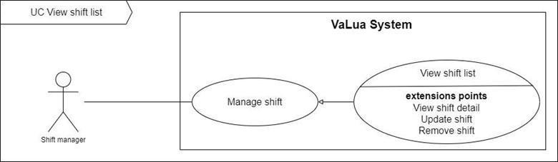

Figure 47. <Use case> View shift list

Table 49. UC46 - View shift list

|  |  |  |  |
| --- | --- | --- | --- |
| ID and Name: | **UC-46 View shift list** | | |
| Created By: | LongTC | Date Created: | 07/02/2022 |
| Primary Actor: | Shift manager | Secondary Actors: |  |
| Description: | Shift managers can view a shift list. | | |
| Trigger: | A shift manager sends a view exam shift list command by clicking on the “Shift” tab on the sidebar. | | |
| Preconditions: | PRE-1. Shift manager has already logged in to VaLua. | | |
| Post-conditions: | POST-1:   * Success: VaLua shows list of exam shifts. * Fail: VaLua shows error messages. | | |
| Normal Flow: | **46.0 View shift list** (Exception 46.0.E1)   1. Shift manager clicks on “Shift” tab on the sidebar to send request to view list of shifts (See alternative 46.0, alternative 46.1). 2. VaLua shows list of shifts (see Exception 46.1.E1), each row item displays:    * Begin time: date time in text    * Finish time: date time in text    * Status: text    * “Actions”: buttons menu containing “View detail”, “Edit” and “Delete” buttons. | | |
| Alternative Flows: | **46.0 Shift manager is currently on the “Shift list” screen and selects another semester from the semester selector.**   1. Shift manager clicks on the dropdown icon of the semester selector. 2. VaLua shows available semesters as a list with each item has its semester name in text. 3. Shift manager selects a semester. 4. Return to step 2 of normal flow.   **46.1 Shift manager is currently on the “Shift list” screen and selects another status in the filter.**   1. Shift manager clicks on the filter button. 2. VaLua shows a dropdown containing shift’s statues list 3. Shift manager selects a status. 4. Return to step 2 of normal flow. | | |
| Exceptions: | **46.0.E1 Internet connection lost**   1. System shows a message (MSG0001).   **46.1.E1 List of shifts is empty**   1. VaLua shows a message (MSG0002). | | |
| Priority: | High | | |
| Frequency of Use: | High | | |
| Business Rules: | BR-0016, BR-4300, BR-4600, BR-4601 | | |
| Other Information: | N/A | | |
| Assumptions: | N/A | | |

#### 2.2.47 UC47 – View shift detail

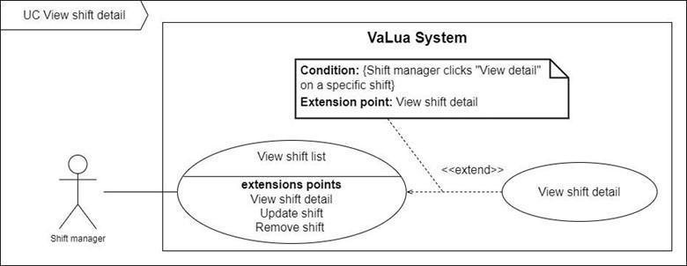

Figure 48. <Use case> View shift detail

Table 50. UC47 - View shift detail

|  |  |  |  |
| --- | --- | --- | --- |
| ID and Name: | **UC-47 View shift detail** | | |
| Created By: | LongTC | Date Created: | 07/02/2022 |
| Primary Actor: | Shift Manager | Secondary Actors: |  |
| Description: | Shift managers can view detailed information about a shift. | | |
| Trigger: | A shift manager sends a view exam shift detail command by clicking on the “View detail” from the “Actions” buttons menu of a specific shift list item. | | |
| Preconditions: | PRE-1. Shift manager or staff has already logged in to VaLua.  PRE-2. Shift exists in VaLua. | | |
| Post-conditions: | POST-1. VaLua shows detailed information of the shift. | | |
| Normal Flow: | **47.0 View exam shift detail** (Exception 47.0.E1)   1. Shift manager clicks on the “View detail” button. 2. VaLua shows shift detail information include:    * Shift information card:      + Semester: text, semester name      + Begin time: date time in text      + End time: date time in text      + Last updated date: date time in text      + Status: text      + “Update” button      + “Delete” button    * Shift information card showing an exam room table whose item has these following fields:      + Room name: text, exam room name      + Subject: text, subject name      + Room: text, room name      + Staff: text, staff’s full name      + Status: text      + “Actions” buttons menu containing “Assign”, “View detail”, “Edit” and “Delete” buttons | | |
| Alternative Flows: | N/A | | |
| Exceptions: | **47.0.E1 Internet connection lost**   1. System shows an error message (MSG0001). | | |
| Priority: | Medium | | |
| Frequency of Use: | Medium | | |
| Business Rules: | BR-0015, BR-0016, BR-4300, BR-4401, BR-4402, BR-4800, BR-4801, BR-4900 | | |
| Other Information: | N/A | | |
| Assumptions: | N/A | | |

#### 2.2.48 UC48 – Lock shift

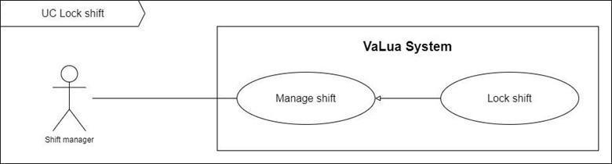

Figure 49. <Use case> Lock shift

Table 51. UC48 - Lock shift

|  |  |  |  |
| --- | --- | --- | --- |
| ID and Name: | **UC-48 Lock shift** | | |
| Created By: | LongTC | Date Created: | 07/02/2022 |
| Primary Actor: | Shift manager | Secondary Actors: |  |
| Description: | Shift managers can lock shifts in batch or in a shift’s detail screen. | | |
| Trigger: | A shift manager sends a lock shift command by clicking on the “Lock shifts” button from the “Lock shifts selection” dialog or clicking on the “Lock shift” button on the “Shift’s detail” screen. | | |
| Preconditions: | PRE-1. Shift manager has already logged in to VaLua.  PRE-2. Current screen is “Shift” or “Shift’s detail”. | | |
| Post-conditions: | POST-1:   * Success: VaLua sets the shift’s status to “Locked”, sends emails to all participants and shows success a message. * Fail: VaLua shows an error message. | | |
| Normal Flow: | **48.0 Lock shift** (Exception 48.0.E1)   1. Shift manager clicks on the “Lock all” button from the “Actions” menu at the “Shift” screen. (See Alternative 48.0) 2. VaLua shows a popup prompting the user to select from the ready to lock shifts with each shift containing:    * Selected: checkbox    * Shift start time and end time: date and time 3. Shift manager selects shifts and clicks on the “Lock shifts” button. (See Alternative 48.1) 4. VaLua changes selected shifts’ status to “Locked”, sends email to participants and shows the success message (MSG4800). | | |
| Alternative Flows: | **48.0 Shift manager clicks on the “Lock shift” button from the shift detail screen.**   1. Shift manager clicks on the “Lock shift” button. 2. VaLua updates the shift’s status to “Locked”, sends email to participants and shows the success message (MSG4801).   **48.1 Shift manager chooses the “X” button**   1. Shift manager clicks on the “X” button. 2. VaLua closes the selection dialog. | | |
| Exceptions: | **48.0.E1 Internet connection lost**   1. System shows message (MSG0001). | | |
| Priority: | High | | |
| Frequency of Use: | Medium | | |
| Business Rules: | BR-4300, BR-4800, BR-4801 | | |
| Other Information: | N/A | | |
| Assumptions: | N/A | | |

#### 2.2.49 UC49 – Start shift registration

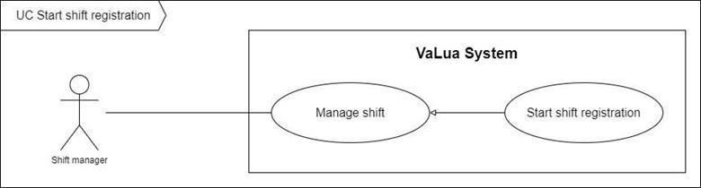

Figure 50. <Use case> Start shift registration

Table 52. UC49 – Start shift registration

|  |  |  |  |
| --- | --- | --- | --- |
| ID and Name: | **UC-49 Start shift registration** | | |
| Created By: | LongTC | Date Created: | 07/02/2022 |
| Primary Actor: | Shift manager | Secondary Actors: |  |
| Description: | Shift managers can start shift registrations in batch or in a shift’s detail screen. | | |
| Trigger: | A shift manager sends an open registration command by clicking on the “Start” button from the “Start staffing selection” dialog or clicking on the “Start staffing” button on the “Shift’s detail” screen. | | |
| Preconditions: | PRE-1. Shift manager has already logged in to VaLua.  PRE-2. Current screen is “Shift” or “Shift’s detail”. | | |
| Post-conditions: | POST-1:   * Success: VaLua sets the shift’s status to “Staffing”, sends notifications to all staffs and shows success a message. * Fail: VaLua shows an error message. | | |
| Normal Flow: | **49.0 Start shift registration** (Exception 49.0.E1)   1. Shift manager clicks on the “Start staffing” button from the “Actions” menu at the “Shift” screen. (See Alternative 49.0) 2. VaLua shows a popup prompting the user to select from the ready to lock shifts with each shift containing:    * Selected: checkbox    * Shift start time and end time: date and time 3. Shift manager selects shifts and clicks on the “Start” button. (See Alternative 49.1) 4. VaLua changes selected shifts’ status to “Staffing”, sends notifications to staffs and shows the success message (MSG4900). | | |
| Alternative Flows: | **49.0 Shift manager clicks on the “Start staffing” button from the shift detail screen.**   1. Shift manager clicks on the “Start staffing” button. 2. VaLua updates the shift’s status to “Staffing”, sends notifications to staffs and shows the success message (MSG4901).   **49.1 Shift manager chooses the “X” button**   1. Shift manager clicks on the “X” button. 2. VaLua closes the selection dialog. | | |
| Exceptions: | **49.0.E1 Internet connection lost**   1. System shows message (MSG0001). | | |
| Priority: | Medium | | |
| Frequency of Use: | Medium | | |
| Business Rules: | BR-4300, BR-4900, BR-4901 | | |
| Other Information: | N/A | | |
| Assumptions: | N/A | | |

#### 2.2.50 UC50 – Import examinees

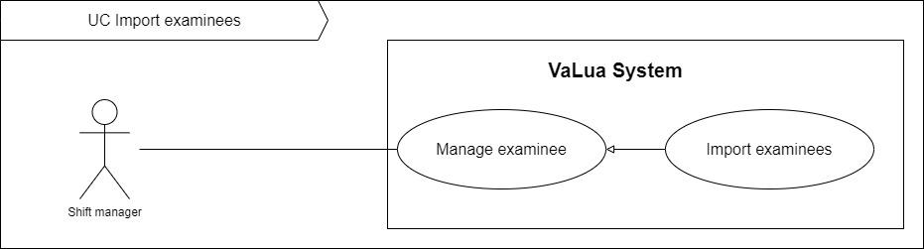

Figure 51. <Use case> Import examinees

Table 53. UC50 - Import examinees

|  |  |  |  |
| --- | --- | --- | --- |
| ID and Name: | **UC-50 Import examinees** | | |
| Created By: | LongTC | Date Created: | 07/02/2022 |
| Primary Actor: | Shift manager | Secondary Actors: |  |
| Description: | Shift managers can add examinees to a subject in a semester by importing a spreadsheet file which follows the required format. | | |
| Trigger: | A shift manager sends an import command by clicking on the “Import” examinees button from the “Examinee” tab. | | |
| Preconditions: | PRE-1. Shift manager has already logged in to VaLua.  PRE-2. A semester has been selected and not finished yet.  PRE-3. Current screen is “View examinee assignments” screen. | | |
| Post-conditions: | POST-1:   * Success: VaLua successfully creates a batch of unassigned examinees. * Fail: VaLua shows error messages. | | |
| Normal Flow: | **50.0 Import examinees** (Exception 50.0.E1)   1. Shift manager clicks on the “Import examinees” button. 2. VaLua popups a file upload modal containing:    * Hint: text, showing the required format    * Drag and drop upload sections    * “Submit” button 3. Shift manager uploads files then clicks on the “Submit” button. 4. VaLua tries to save examine assignments and return a list of results for each file. (See Exception E2, E3) | | |
| Alternative Flows: | N/A | | |
| Exceptions: | **50.0.E1 Internet connection lost**   1. System shows an error message (MSG0001).   **50.0.E2 At least 1 file was failed or partially failed to import**   1. VaLua shows a download link for a modified version of that file to show where the errors are.   **50.0.E3 At least 1 file’s name was invalid**   1. VaLua shows an error message for each result of the invalid file(s). | | |
| Priority: | High | | |
| Frequency of Use: | Medium | | |
| Business Rules: | BR-5000, BR-5001, BR-5002, BR-5003, BR-5004, BR-5005 | | |
| Other Information: | N/A | | |
| Assumptions: | N/A | | |

#### 2.2.51 UC51 – Remove examinees from semester’s subjects

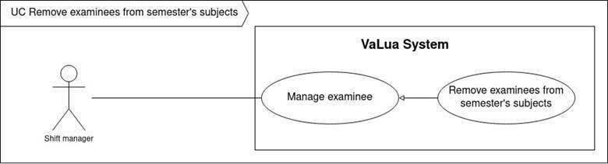

Figure 52. <Use case> Remove examinees from semester’s subjects

Table 54. UC51 - Remove examinees from semester’s subjects

|  |  |  |  |
| --- | --- | --- | --- |
| ID and Name: | **UC-51 Remove examinees from semester's subjects** | | |
| Created By: | LongTC | Date Created: | 07/02/2022 |
| Primary Actor: | Shift manager | Secondary Actors: |  |
| Description: | Shift managers can remove examinees from a subject in a semester with a reason. | | |
| Trigger: | A shift manager sends a remove examinee command by clicking on the “Remove” button from the “Action” buttons menu in the “Examinee list” screen. | | |
| Preconditions: | PRE-1. Shift manager has already logged in to VaLua.  PRE-2. Current screen is “View examinee list” screen.  PRE-3. Current subject examinees list has at least 1 examinee. | | |
| Post-conditions: | POST-1:   * Success: VaLua successfully removes the selected examinee from the subject and saves the reason. * Fail: VaLua shows error messages. | | |
| Normal Flow: | **51.0 Remove examinees from semester’s subject** (Exception 51.0.E1)   1. Shift manager clicks on the “Removes” button from an examinee list item. 2. VaLua popups a modal containing:    * Reason: text input    * “Submit” button 3. Shift manager inputs in this modal then clicks on the “Submit” button (Exception 51.0.E2). 4. VaLua saves the reason and disables the examinee then shows a success message (MSG5100). | | |
| Alternative Flows: | N/A | | |
| Exceptions: | **51.0.E1 Internet connection lost**   1. VaLua shows an error message (MSG0001).   **51.0.E2 Missing required input fields**   1. VaLua shows an error message (MSG5101). | | |
| Priority: | Medium | | |
| Frequency of Use: | Medium | | |
| Business Rules: | BR-5000, BR-5005, BR-5100 | | |
| Other Information: | N/A | | |
| Assumptions: | N/A | | |

#### 2.2.52 UC52 – View subject assignments list

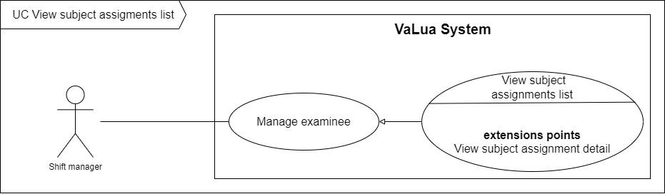

Figure 53. <Use case> View subject assignments list

Table 55. UC52 - View subject assignment list

|  |  |  |  |
| --- | --- | --- | --- |
| ID and Name: | **UC-52 View subject assignments list** | | |
| Created By: | LongTC | Date Created: | 07/02/2022 |
| Primary Actor: | Shift manager | Secondary Actors: |  |
| Description: | Shift managers can view examinees’ assignment by each subject or by each semester as subjects list. | | |
| Trigger: | A shift manager sends a view examinees’ assignment by clicking on the “Examinee” tab from the sidebar. | | |
| Preconditions: | PRE-1. Shift manager has already logged in to VaLua. | | |
| Post-conditions: | POST-1:   * Success: VaLua shows * Fail: VaLua shows error messages. | | |
| Normal Flow: | **52.0 View subject assignments list** (Exception 52.0.E1)   1. Shift manager clicks on the “Examinee” tab. (See alternative 52.0) 2. VaLua shows a list of examinees’ assignment group by each subject with each subject item containing these following fields (Exception 52.1.E1):    * Subject code: text    * Subject name: text    * Total examinees: number    * Total unassigned: number    * Status: text    * “Actions”: menu button with “Delete” and “View detail” buttons | | |
| Alternative Flows: |  | | |
| Exceptions: | **52.0.E1 Internet connection lost**   1. System shows message (MSG0001).   **52.1.E1 There is no examinee assigned in the chosen semester**   1. VaLua shows message (MSG5201). | | |
| Priority: | Medium | | |
| Frequency of Use: | Medium | | |
| Business Rules: | BR-0015, BR-0016, BR-5000 | | |
| Other Information: | N/A | | |
| Assumptions: | N/A | | |

#### 2.2.53 UC53 – Create exam room

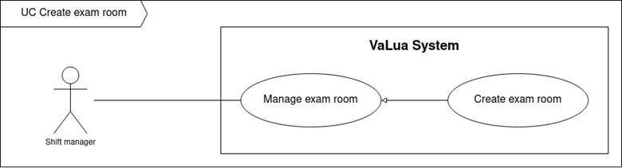

Figure 54. <Use case> Create exam room

Table 56. UC53 - Create exam room

|  |  |  |  |
| --- | --- | --- | --- |
| ID and Name: | **UC-53 Create exam room** | | |
| Created By: | LongTC | Date Created: | 07/02/2022 |
| Primary Actor: | Shift manager | Secondary Actors: |  |
| Description: | Shift managers can create exam rooms in a shift. | | |
| Trigger: | A shift manager sends a create exam room request by clicking on the “Add new” button from the exam room list in the “Shift’s detail” screen. | | |
| Preconditions: | PRE-1. Shift manager has already logged in to VaLua.  PRE-2. Current screen is “Shift’s detail”. | | |
| Post-conditions: | POST-1:   * Success: VaLua creates a new exam room and shows a success message. * Fail: VaLua shows an error message. | | |
| Normal Flow: | **53.0 Create exam room** (Exception 53.0.E1)   1. Shift manager clicks on the “Add new” button. 2. VaLua shows another screen, initially with a panel including:    * Subject: searchable dropdown selector    * “Assign examinee” button 3. Shift manager selects an available subject then clicks on the “Assign examinee” button. 4. VaLua shows a list of rooms in the lower panel including: (See exception 53.0.E2)    * “Create all” button    * A room list table with each item has the following fields:      + Select: radio button      + Room name: text      + Seat count: number      + “Create” button    * “Add room” button 5. Shift manager selects a room, customize examinees in the room table and clicks on the “Create” button on a specific room item. (See alternative 53.0, alternative 53.1) 6. VaLua saves the selected exam room and shows the success message (MSG5300) (See Exception 53.0.E3, 53.0E4) | | |
| Alternative Flows: | **53.0.0 Shift manager clicks on the “Create all” button**   1. Shift manager clicks on the “Create all” button. 2. VaLua saves all non-empty rooms in the room table and shows the success message (MSG5301).   **53.0.1 Shift manager clicks on the “Add room” button**   1. Shift manager clicks on the “Add room” button. 2. VaLua shows a popup with a searchable dropdown selector showing a list of “Empty” rooms and “Occupied” rooms to choose from, each item shows room name and floor and available seats. 3. Shift manager selects a room. 4. VaLua closes the popup, adds the selected room at the bottom of the room table. (See exception 53.0.E2) 5. Return the step 5 of the normal flow. | | |
| Exceptions: | **53.0.E1 Internet connection lost**   1. System shows the message (MSG0001).   **53.0.E2 Missing of required fields**   1. System shows a message asking manager to fill the required fields again (MSG5302, MSG5303). | | |
| Priority: | High | | |
| Frequency of Use: | High | | |
| Business Rules: | BR-0010, BR0011, BR-4402, BR-5300, BR-5301, BR5302, BR-5303, BR-5304, BR-5700 | | |
| Other Information: | N/A | | |
| Assumptions: | N/A | | |

#### 2.2.54 UC54 – Update exam room

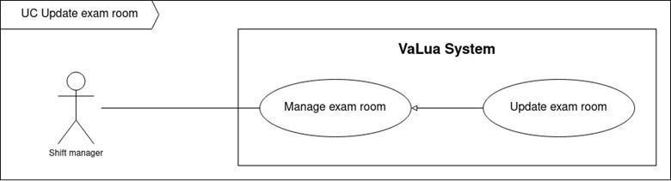

Figure 55. <Use case> Update exam room

Table 57. UC54 - Update exam room

|  |  |  |  |
| --- | --- | --- | --- |
| ID and Name: | **UC-54 Update exam room** | | |
| Created By: | LongTC | Date Created: | 07/02/2022 |
| Primary Actor: | Shift manager | Secondary Actors: |  |
| Description: | Shift managers can update exam rooms’ staff, room or attendances list in certain circumstances. | | |
| Trigger: | A shift manager sends an update exam room request by clicking on the “Edit” button on a specific exam room item or toggle on the edit icon in the “Exam room’s detail” screen. | | |
| Preconditions: | PRE-1. Shift manager has already logged in to VaLua.  PRE-2. Current screen is “Shift’s detail” or “Exam room’s detail”. | | |
| Post-conditions: | POST-1:   * Success: VaLua updates the current exam room’s information and shows a success message. * Fail: VaLua shows an error message. | | |
| Normal Flow: | **54.0 Update exam room** (Exception 54.0.E1)   1. Manager clicks the “Edit” button of a specific exam room item from the exam room list (See alternative 54.0). 2. VaLua navigates to the “Exam room’s detail” screen with enable fields:    * Exam room information:  * Assigned staff: searchable dropdown selector * Room: searchable dropdown selector * Update button * Delete button  1. Shift manager inputs in the exam room information panel and clicks on the “Update” button. 2. VaLua updates the exam room’s information and shows the success message (MSG5400). (See Exception 54.1.E1, 54.1.E2) | | |
| Alternative Flows: | **54.0 Shift manager toggles the “Edit” icon button from “Exam room’s detail” screen.**   1. Manager toggles the “Edit” icon button on. 2. Return to step 2 of normal flow. | | |
| Exceptions: | **54.0.E1 Internet connection lost**   1. System shows the message (MSG0001).   **54.0.E2 Missing of required fields**   1. System shows a message asking manager to fill the required fields again (MSG5401, MSG5402). | | |
| Priority: | Low | | |
| Frequency of Use: | Low | | |
| Business Rules: | BR-0011, BR-5301, BR-5302, BR-5400, BR-5401 | | |
| Other Information: | N/A | | |
| Assumptions: | N/A | | |

#### 2.2.55 UC55 – Remove exam room

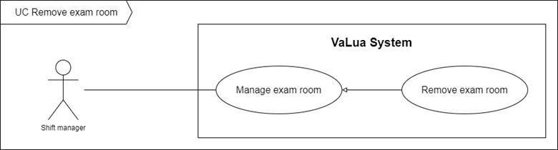

Figure 56. <Use case> Remove exam room

Table 58. UC55 - Remove exam room

|  |  |  |  |
| --- | --- | --- | --- |
| ID and Name: | **UC-55 Remove exam room** | | |
| Created By: | LongTC | Date Created: | 21/02/2022 |
| Primary Actor: | Shift manager | Secondary Actors: |  |
| Description: | Shift managers can remove an existing exam room. | | |
| Trigger: | A shift manager sends a remove exam room request by clicking on the “Delete” button from the action menu of a specific exam room item in the “Shift’s detail” screen or in the “Exam room’s detail” screen. | | |
| Preconditions: | PRE-1. Shift manager has already logged in to VaLua.  PRE-2. Current screen is “Shift’s detail” or “Exam room’s detail”. | | |
| Post-conditions: | POST-1:   * Success: VaLua changes exam room’s status to “Removed”, deletes all of its attendances and shows a success message. * Fail: VaLua shows an error message. | | |
| Normal Flow: | **55.0 Remove exam room** (Exception 55.0.E1)   1. Shift manager clicks on the “Delete” button of a specific exam room item from its action menu on the “Shift’s detail” screen. (See alternative 55.0) 2. VaLua shows confirm dialog (MSG5501) and two buttons for shift manager to select:  * Cancel button * Confirm button  1. Shift manager clicks on “Confirm” button. (See Alternative 55.1) 2. VaLua changes exam room’s status to “Removed”, deletes all of its attendances and shows the success message (MSG5500). | | |
| Alternative Flows: | **55.0 Shift manager clicks on the “Delete” button from the “Exam room’s detail” screen.**   1. Shift manager clicks on the “Delete” button while the exam room’s edit button is toggle on. 2. Return to step 2 of the normal flow.   **55.1 Shift manager chooses “Cancel” button or “X” button**   1. Shift manager clicks on “Cancel” button or “X” button. 2. VaLua closes the dialog. | | |
| Exceptions: | **55.0.E1 Internet connection lost**   1. System shows message (MSG0001). | | |
| Priority: | Low | | |
| Frequency of Use: | Low | | |
| Business Rules: | BR-0011, BR-0013, BR-5500, BR-5501 | | |
| Other Information: | N/A | | |
| Assumptions: | N/A | | |

#### 2.2.56 UC56 – View exam room detail

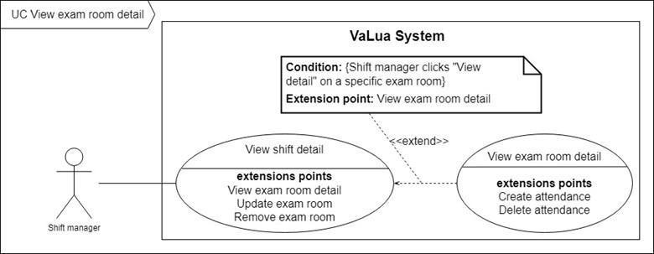

Figure 57. <Use case> View exam room detail

Table 59. UC56 - View exam room detail

|  |  |  |  |
| --- | --- | --- | --- |
| ID and Name: | **UC-56 View exam room detail** | | |
| Created By: | DucNT | Date created: | 21/02/2022 |
| Primary Actor: | Shift manager | Secondary Actor: |  |
| Description: | Shift managers can view detailed information about an exam room. | | |
| Trigger: | A shift manager sends a view exam room detail request by clicking on the “View detail” from the “Actions” buttons menu of a specific exam room list item. | | |
| Preconditions: | PRE-1. Shift manager has already logged in to VaLua.  PRE-2. Exam room exists in VaLua. | | |
| Post-conditions: | 1. POST-1. VaLua shows detailed information of the exam room. | | |
| Normal Flow: | **56.0 View exam room detail** (Exception 56.0.E1)   1. Shift manager clicks on the “View detail” button. 2. VaLua shows exam room detail information include:    * Shift information card showing the following information:  * Start time: date time in text * Finish time: date time in text   + Exam room information card showing an exam room table whose item has these following fields:     - Subject: text, subject name     - Staff: text, staff’s full name     - Room: text, room name     - Last updated date: date time in text     - Status: text     - Update button     - Delete button   + Exam seat list showing a table of attendances in the exam room, each attendance includes:     - Position: number     - Student code: text     - Name: text, student’s full name     - Remove button | | |
| Alternative Flows: | N/A | | |
| Exceptions: | **56.0.E1 Internet connection lost**   1. System shows an error message (MSG0001). | | |
| Priority: | Medium | | |
| Frequency of Use: | Medium | | |
| Business Rules: | BR-0015, BR-0016, BR-4302, BR-5300 | | |
| Other Information: | N/A | | |
| Assumptions: | N/A | | |

#### 2.2.57 UC57 – Create attendance

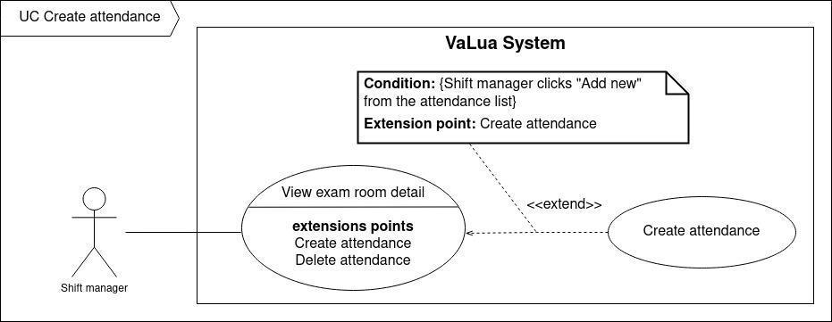

Figure 58. <Use case> Create attendance

Table 60. UC57 - Create attendance

|  |  |  |  |
| --- | --- | --- | --- |
| ID and Name | **UC-57 Create attendance** | | |
| Created By: | DucNT | Date Created: | 21/02/2022 |
| Primary Actor: | Shift manager | Secondary Actors: |  |
| Description: | Shift managers can add an examinee in an exam room by creating a new attendance. | | |
| Trigger: | A shift manager sends a create a new attendance request by clicking on “Add examinee” button from the exam seat table on the “Exam room’s detail” screen. | | |
| Preconditions: | PRE-1. Shift manager has already logged in to VaLua.  PRE-2. Current screen is “Exam room’s detail”. | | |
| Post-conditions: | POST-1:   * Success: VaLua creates a new attendance and shows a success message. * Fail: VaLua shows an error message. | | |
| Normal Flow: | **57.0 Create attendance** (Exception 57.0.E1)   1. Shift manager clicks on the “Add examinee” button. 2. VaLua pops up the “Create attendance” modal with a field:  * Available examinees: searchable dropdown selector.  1. Shift manager selects an examinee and clicks on the “Add” button. 2. VaLua saves the new attendance, closes the popup then shows the success message (MSG5700). | | |
| Alternative Flows: | N/A | | |
| Exceptions: | **57.0.E1 Internet connection lost**   1. System shows an error message (MSG0001). | | |
| Priority: | High | | |
| Frequency of Use: | Medium | | |
| Business Rules: | BR-0010, BR-5005, BR-5300, BR-5400, BR-5700 | | |
| Other Information: | N/A | | |
| Assumptions: | N/A | | |

#### 2.2.58 UC58 – Delete attendance

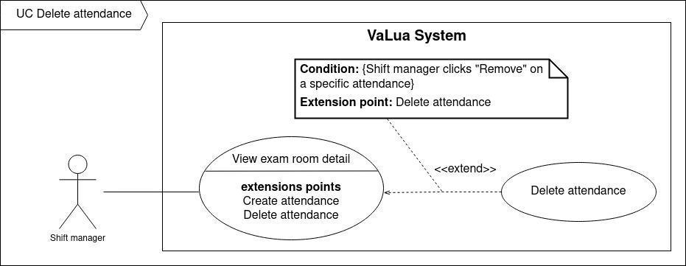

Figure 59. <Use case> Delete attendance

Table 61. UC58 – Delete attendance

|  |  |  |  |
| --- | --- | --- | --- |
| ID and Name | **UC-58 Delete attendance** | | |
| Created By: | DucNT | Date Created: | 21/02/2022 |
| Primary Actor: | Shift manager | Secondary Actors: |  |
| Description: | Shift managers can remove examinees from an exam room by deleting their attendance. | | |
| Trigger: | A shift manager sends a delete attendance request by clicking on “Remove” button from a specific attendance item on the “Exam room’s detail” screen. | | |
| Preconditions: | PRE-1. Shift manager has already logged in to VaLua.  PRE-2. Current screen is “Exam room’s detail”. | | |
| Post-conditions: | POST-1:   * Success: VaLua deletes the attendance and shows a success message. * Fail: VaLua shows an error message. | | |
| Normal Flow: | **58.0 Delete attendance** (Exception 58.0.E1)   1. Shift manager clicks on the “Remove” button from a specific attendance item. 2. VaLua deletes the selected attendance and shows the success message (MSG5800). | | |
| Alternative Flows: | N/A | | |
| Exceptions: | **58.0.E1 Internet connection lost**   1. System shows an error message (MSG0001). | | |
| Priority: | Low | | |
| Frequency of Use: | Low | | |
| Business Rules: | BR-5005, BR-5300, BR-5400 | | |
| Other Information: | N/A | | |
| Assumptions: | N/A | | |

#### 2.2.59 UC59 – Export attendance

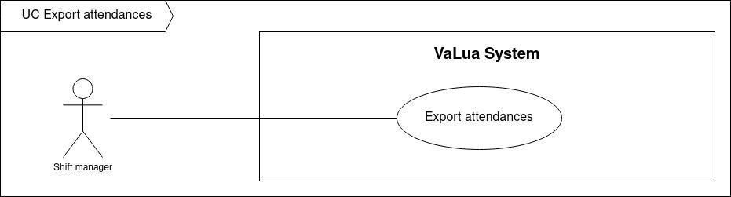

Figure 60. <Use case> Export attendance

Table 62. UC59 - Export attendance

|  |  |  |  |
| --- | --- | --- | --- |
| ID and Name | **UC-59 Export attendance** | | |
| Created By: | LongTC | Date created: | 21/02/2022 |
| Primary Actor: | Shift manager | Secondary Actors: |  |
| Description: | Shift managers can export examinees’ attendance from a shift as an Excel file. | | |
| Trigger: | A shift manager sends an export attendance request by clicking on “Export attendance” button in the “Shift’s detail” screen. | | |
| Preconditions: | PRE-1. Shift manager has already logged in to VaLua.  PRE-2. Current screen is “Shift’s detail”. | | |
| Post-conditions: | POST-1:   * Success: VaLua exports the shift’s attendances, web client downloads an Excel file reporting attendances in that shift. * Fail: VaLua shows an error message. | | |
| Normal Flow: | **59.0 Export attendance** (Exception 59.0.E1)   1. Shift manager clicks on the “Export attendance” button. 2. VaLua exports the shift’s attendances and downloads the attendances report. | | |
| Alternative Flows: | N/A | | |
| Exceptions: | **59.0.E1 Internet connection lost**   1. System shows an error message (MSG0001). | | |
| Priority: | Low | | |
| Frequency of Use: | Low | | |
| Business Rules: | BR-5005, BR-5900, BR-5901 | | |
| Other Information: | N/A | | |
| Assumptions: | N/A | | |

#### 2.2.60 UC60 – View report list

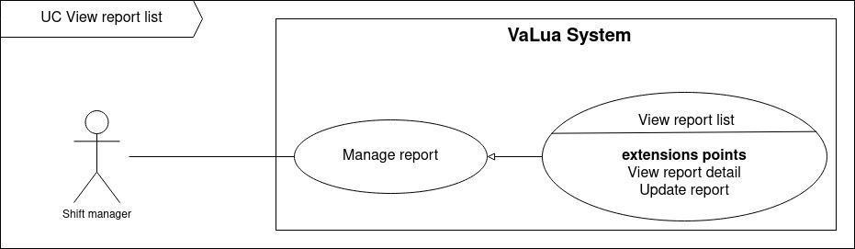

Figure 61. <Use case> View report list

Table 63. UC60 - View report list

|  |  |  |  |
| --- | --- | --- | --- |
| ID and Name: | **UC-60 View report list** | | |
| Created By: | LongTC | Date Created: | 21/02/2022 |
| Primary Actor: | Shift Manager | Secondary Actors: |  |
| Description: | Shift managers can view a list of reports occurred in exam rooms. | | |
| Trigger: | A shift manager sends a view report list request by clicking on the “Report” tab on the sidebar. | | |
| Preconditions: | PRE-1. Shift manager has already logged in to VaLua. | | |
| Post-conditions: | POST-1:   * Success: VaLua shows list of reports. * Fail: VaLua shows an error message. | | |
| Normal Flow: | **60.0 View exam report list** (Exception 60.0.E1)   1. Shift manager clicks on “Report” tab on the sidebar to send request to view list of reports. (See alternative 60.0, alternative 60.1). 2. VaLua shows list of reports (see Exception 60.1.E1), each row item displays:    * Room name: text    * Type: text    * Reporter: text    * Reported examinee: text    * Status: text    * Reported at: date time in text    * “View detail” button. | | |
| Alternative Flows: | **60.0 Shift manager is currently on the “Report list” screen inputs a search parameter.**   1. Shift manager submits input in the search bar. 2. Return to step 2 of the normal flow with a relevant report list.   **60.1 Shift manager is currently on the “Report list” screen and selects another status in the filter.**   1. Shift manager clicks on the filter button. 2. VaLua shows a dropdown containing report’s statues list 3. Shift manager selects a status. 4. Return to step 2 of normal flow. | | |
| Exceptions: | **60.0.E1 Internet connection lost**   1. System shows a message (MSG0001).   **60.1.E1 List of reports is empty**   1. VaLua shows a message (MSG0002). | | |
| Priority: | High | | |
| Frequency of Use: | High | | |
| Business Rules: | BR-0015, BR-0016, BR-6000, BR-6001 | | |
| Other Information: | N/A | | |
| Assumptions: | N/A | | |

#### 2.2.61 UC61 – View report detail

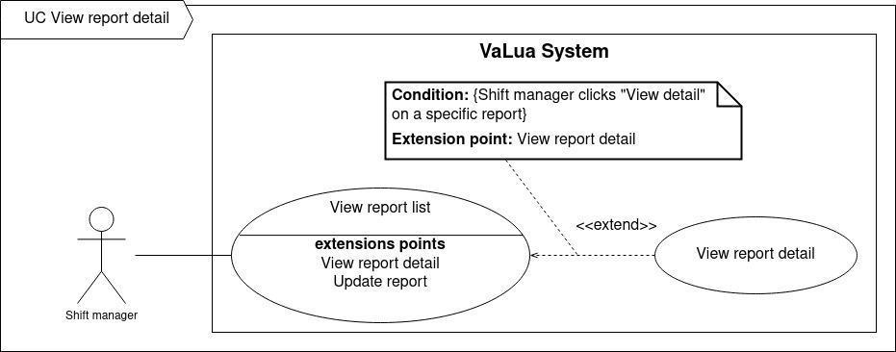

Figure 62. <Use case> View report detail

Table 64. UC61 - View report detail

|  |  |  |  |
| --- | --- | --- | --- |
| ID and Name: | **UC-61 View report detail** | | |
| Created By: | LongTC | Date Created: | 21/02/2022 |
| Primary Actor: | Shift Manager | Secondary Actors: |  |
| Description: | Shift managers can view detailed information about a report. | | |
| Trigger: | A shift manager sends a view report detail command by clicking on the “View detail” from the “Actions” buttons menu of a specific report list item. | | |
| Preconditions: | PRE-1. Shift manager or staff has already logged in to VaLua.  PRE-2. Report exists in VaLua. | | |
| Post-conditions: | POST-1. VaLua shows detailed information of the report. | | |
| Normal Flow: | **61.0 View report detail** (Exception 61.0.E1)   1. Shift manager clicks on the “View detail” button. 2. VaLua shows report detail information include:    * Report audit card:      + Exam room’s name: text      + Reported at: date time in text      + Status: date time in text      + Resolved at: date time in text      + Reported by: staff’s profile picture with full name and company ID in text    * Report information card:      + Description: text      + Note: text      + Solution: text      + Reported examinee: examinee’s profile picture with full name and company ID in text      + “Resolve” button (Pending reports only) | | |
| Alternative Flows: | N/A | | |
| Exceptions: | **61.0.E1 Internet connection lost**   1. System shows an error message (MSG0001). | | |
| Priority: | Medium | | |
| Frequency of Use: | Medium | | |
| Business Rules: | BR-6000, BR-6100 | | |
| Other Information: | N/A | | |
| Assumptions: | N/A | | |

#### 2.2.62 UC62 – Resolve report

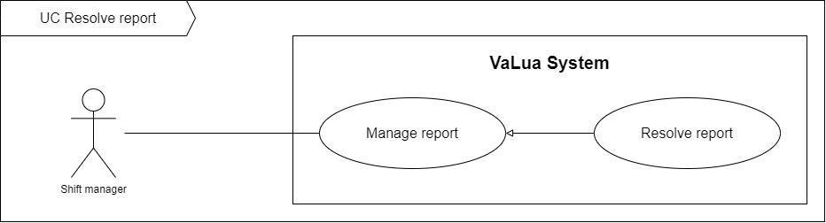

Figure 63. <Use case> Resolve report

Table 65. UC62 - Resolve report

|  |  |  |  |
| --- | --- | --- | --- |
| ID and Name | **UC-62 Resolve report** | | |
| Created By: | LongTC | Date Created: | 21/02/2022 |
| Primary Actor: | Shift manager | Secondary Actors: |  |
| Description: | Shift managers have to resolve a pending report occurred in exam rooms during a shift. | | |
| Trigger: | A shift manager sends a resolve report request by clicking on “Resolve” button from the “Report’s detail” screen. | | |
| Preconditions: | PRE-1. Shift manager has already logged in to VaLua.  PRE-2. Current screen is “Report’s detail”. | | |
| Post-conditions: | POST-1:   * Success: VaLua saves the report and shows a success message. * Fail: VaLua shows an error message. | | |
| Normal Flow: | **62.0 Resolve report** (Exception 62.0.E1)   1. Shift manager inputs in the “Solution” text field then clicks on the “Resolve” button. 2. VaLua save the report and shows the success message (MSG6200). (See exception 62.0.E2) | | |
| Alternative Flows: | N/A | | |
| Exceptions: | **62.0.E1 Internet connection lost**   1. System shows an error message (MSG0001).   **62.0.E2 Solution is missing**   1. System shows an error message asking shift manager to input solution (MSG6201). | | |
| Priority: | Low | | |
| Frequency of Use: | Low | | |
| Business Rules: | BR-6000, BR-6200 | | |
| Other Information: | N/A | | |
| Assumptions: | N/A | | |

#### 2.2.63 UC63 – View own exam schedules

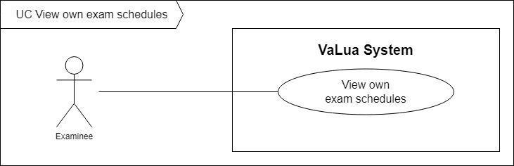

Figure 64. <Use case> View own exam schedules

Table 66. UC63 - View own exam schedules

|  |  |  |  |
| --- | --- | --- | --- |
| ID and Name: | **UC-63 View own exam schedules** | | |
| Created By: | DucNT | Date Created: | 21/02/2022 |
| Primary Actor: | Examinee | Secondary Actors: |  |
| Description: | Examinees can view their exam schedules. | | |
| Trigger: | Examinee sends request to view their exam schedules by tapping on the “Schedule” button from the home screen. | | |
| Preconditions: | PRE-1. Examinee has already logged in to VaLua Examinee.  PRE-2. The current screen is “Home”. | | |
| Post-conditions: | POST-1:   * Success: VaLua shows the examinee’s schedules. * Fail: VaLua shows an error message. | | |
| Normal Flow: | **63.0 View assigned exam rooms** (Exception 63.0.E1)   1. Examinee taps on “Schedule” button. 2. VaLua shows exam rooms list information with followings information: (see Exception 63.1.E1):  * Assigned exam room item: * Begin and finish time: text * Subject: text, subject code * Room: Text | | |
| Alternative Flows: | N/A | | |
| Exceptions: | **63.0.E1 Internet connection lost**   1. System shows message (MSG0001). | | |
| Priority: | Medium | | |
| Frequency of Use: | High | | |
| Business Rules: | BR-0015, BR-0018, BR-6300 | | |
| Other Information: | N/A | | |
| Assumptions: | N/A | | |

#### 2.2.64 UC64 – Check attendance

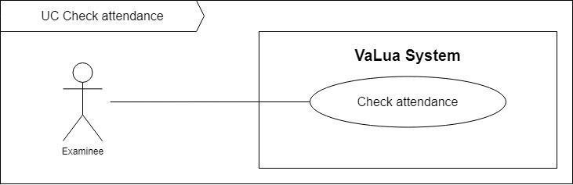

Figure 65. <Use case> Check attendance

Table 67. UC64 - Check attendance

|  |  |  |  |
| --- | --- | --- | --- |
| ID and Name: | **UC-64 Check attendance** | | |
| Created By: | LongTC | Date Created: | 21/02/2022 |
| Primary Actor: | Examinee | Secondary Actors: |  |
| Description: | Examinees are required to check in to start their exams. | | |
| Trigger: | Examinee sends request to check attendance by scanning the current exam room QR’s code. | | |
| Preconditions: | PRE-1. Examinee has already logged in to VaLua Examinee.  PRE-2. The current screen is “Home”. | | |
| Post-conditions: | POST-1:   * Success: VaLua updates the examinee’s attendance and shows information about the attendance. * Fail: VaLua shows an error message. | | |
| Normal Flow: | **64.0 Check attendance** (Exception 64.0.E1)   1. Examinee taps on the QR icon button. 2. VaLua navigates to the current device’s camera with the hint message (MSG6401) 3. Examinee uses the camera to scan the current exam room’s QR code. 4. VaLua gets the examinee’s attendance on the VaLua Camera application and navigates to its camera. (See exception 64.0.E2, 64.0.E3. 64.0.E4) 5. Examinee stands in front of the camera until the timer runs out and captures an image. 6. VaLua checks the attendance and shows the current attendance’s information including: (See exception 64.0.E5)    * Student code: text    * Last attempt: image    * Full name: text, examinee’s name    * Attended at: date time in text    * Seat position: number | | |
| Alternative Flows: | N/A | | |
| Exceptions: | **64.0.E1 Internet connection lost**   1. System shows message (MSG0001).   **64.0.E2 Examinee has checked the attendance successfully and try to scan the exam room’s QR code again.**   1. System shows an error message (MSG6404).   **64.0.E3 Examinee is not assigned to the current exam room**   1. System shows an error message (MSG6405).   **64.0.E4 Examinee has attempted to check in more than 3 times**   1. System shows an error message (MSG6406).   **64.0.E5 Examinee’s face does not match the captured image**   1. System shows an error message (MSG6402). | | |
| Priority: | High | | |
| Frequency of Use: | High | | |
| Business Rules: | BR-0015, BR-0018, BR-6400, BR-6401 | | |
| Other Information: | N/A | | |
| Assumptions: | N/A | | |

#### 2.2.65 UC65 – Export locked shifts

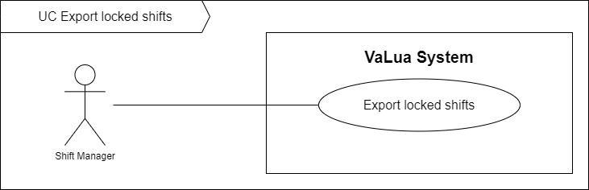

Figure 66. <Use case> Export locked shifts

Table 68. UC65 - Export locked shifts

|  |  |  |  |
| --- | --- | --- | --- |
| ID and Name: | **UC-65 Export locked shifts** | | |
| Created By: | LongTC | Date Created: | 21/02/2022 |
| Primary Actor: | Shift manager | Secondary Actors: |  |
| Description: | The shift manager can export shifts in a semester, each shift is a page containing information about its exam rooms. | | |
| Trigger: | Shift manager sends export locked shifts request clicking on the “Export shifts” button from the shift view list screen. | | |
| Preconditions: | PRE-1. Shift manager has already logged in to VaLua.  PRE-2. The current screen is “Shifts”. | | |
| Post-conditions: | POST-1:   * Success: VaLua downloads an export file about the current semester’s shifts. * Fail: VaLua shows an error message. | | |
| Normal Flow: | **65.0 Export locked shifts** (Exception 65.0.E1)   1. Shift manager clicks on the “Export shifts” button. (Exception 65.1.E1) 2. VaLua downloads an export file of the current semester. | | |
| Alternative Flows: | N/A | | |
| Exceptions: | **65.0.E1 Internet connection lost**   1. System shows a message (MSG0001).   **65.0.E1 There is no locked shifts**   1. System shows a message (MSG6501). | | |
| Priority: | Medium | | |
| Frequency of Use: | High | | |
| Business Rules: | BR-6500 | | |

#### 2.2.66 UC66 – Assign staff

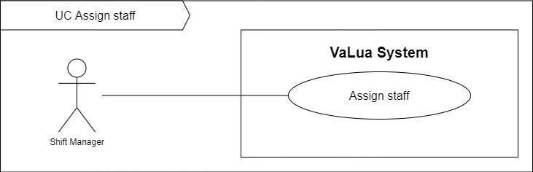

Figure 67. <Use case> Assign staff

Table 69. UC66 - Assign staff

|  |  |  |  |
| --- | --- | --- | --- |
| ID and Name: | **UC-66 Assign staff** | | |
| Created By: | LongTC | Date Created: | 21/02/2022 |
| Primary Actor: | Shift manager | Secondary Actors: |  |
| Description: | The shift manager can assign staff automatically in a semester or manually in a room from the shift detail screen. | | |
| Trigger: | Shift manager sends a staff assigning request by clicking on the “Auto assign staff” button from the shift view list or the “Assign” button from a specific room from the shift detail screen. | | |
| Preconditions: | PRE-1. Shift manager has already logged in to VaLua.  PRE-2. The current screen is “Shifts” or “Shift’s detail”. | | |
| Post-conditions: | POST-1:   * Success: VaLua updates staff into the current room or into all rooms from the current semester. * Fail: VaLua shows an error message. | | |
| Normal Flow: | **66.0 Assign staff** (Exception 66.0.E1)   1. Shift manager clicks on the “Assign” button from a specific room. (See Alternative 66.0) 2. VaLua shows a list of available staffs, each item has the following fields:  * Full name: text * Email: text  1. Shift manager clicks on a staff member. 2. VaLua assign the selected staff to the current room then shows a success message (MSG6600). | | |
| Alternative Flows: | **66.0 Shift manager clicks on the “Auto assign staff” button from the shift view list screen** (Exception 66.0.E1)   1. Shift manager clicks on the “Auto assign staff” button. 2. VaLua assigns all available staffs into as many as available rooms from the current semester and shows a success message (MSG6601) | | |
| Exceptions: | **66.0.E1 Internet connection lost**   1. System shows a message (MSG0001). | | |
| Priority: | Medium | | |
| Frequency of Use: | High | | |
| Business Rules: | BR-6600, BR-6601 | | |

#### 2.2.67 UC67 – Auto assign shifts

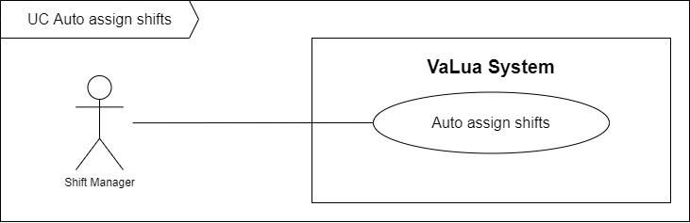

Figure 68. <Use case> Auto assign shifts

Table 70. UC67 - Auto assign shifts

|  |  |  |  |
| --- | --- | --- | --- |
| ID and Name: | **UC-67 Auto assign shifts** | | |
| Created By: | LongTC | Date Created: | 21/02/2022 |
| Primary Actor: | Shift manager | Secondary Actors: |  |
| Description: | The shift manager can assign shifts automatically. These shifts have exam rooms and attendances assigned optimally. | | |
| Trigger: | Shift manager sends an auto assign shifts request by clicking on the “Auto assign shifts” button from the action menu from the “Shift” screen. | | |
| Preconditions: | PRE-1. Shift manager has already logged in to VaLua.  PRE-2. The current screen is “Shifts”. | | |
| Post-conditions: | POST-1:   * Success: VaLua shows a success message indicates that the auto assign shifts request is in progress while assigning shifts before sending a notification to shift manager that shifts have been assigned. * Fail: VaLua shows an error message. | | |
| Normal Flow: | **67.0 Auto assign shifts** (Exception 67.0.E1)   1. Shift manager clicks on the “Auto assign shifts” button. 2. VaLua shows an input dialog with the following fields:  * Semester: dropdown selector * From date: date picker * Duration in days: int * Subjects list: multiple items selector  1. Shift manager inputs in the dialog then clicks on the “Assign” button. 2. VaLua puts the request in progress then shows a success message (MSG6700). | | |
| Alternative Flows: | N/A | | |
| Exceptions: | **67.0.E1 Internet connection lost**   1. System shows a message (MSG0001). | | |
| Priority: | Medium | | |
| Frequency of Use: | High | | |
| Business Rules: | BR-6700, BR-6701, BR-6702, BR-6703, BR-6704, BR-6705 | | |

#### 2.2.68 UC68 – View subject assignment detail

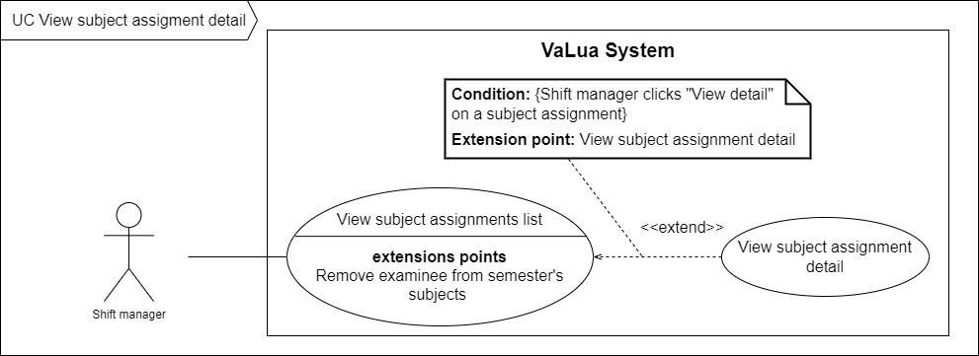

Figure 69. <Use case> View subject assignment detail

Table 71. UC68 - View subject assignment detail

|  |  |  |  |
| --- | --- | --- | --- |
| ID and Name: | **UC-68 View subject assignment detail** | | |
| Created By: | LongTC | Date Created: | 21/02/2022 |
| Primary Actor: | Shift manager | Secondary Actors: |  |
| Description: | Shift managers can view examinees’ assignment in a specific subject. | | |
| Trigger: | A shift manager sends a view examinees’ assignment by clicking on the “View detail” of a subject list item in the subject assignments list. | | |
| Preconditions: | PRE-1. Shift manager has already logged in to VaLua. | | |
| Post-conditions: | POST-1:   * Success: VaLua shows the detailed assignments in the current subject. * Fail: VaLua shows error messages. | | |
| Normal Flow: | **68.0 View subject assignment detail**   1. Shift manager clicks on the “View detail” button. 2. VaLua shows a new screen showing examinees’ assignment detail for that subject with:    * Subject information card:      + Semester: text, semester name      + Subject: text, subject name    * Examinee assignment summary: a pie chart displaying the percentage of assigned, unassigned and removed examinees.    * Examinee list table containing each examinee item with these following fields:      + Profile picture: image      + Student Code: text      + Full name: text      + Email text      + Phone number: text      + Status: text      + “Remove” button | | |
| Alternative Flows: | N/A | | |
| Exceptions: | **68.0.E1 Internet connection lost**   1. System shows message (MSG0001).   **68.1.E1 There is no examinee assigned in the chosen semester**   1. VaLua shows an error message (MSG0002). | | |
| Priority: | Medium | | |
| Frequency of Use: | Medium | | |
| Business Rules: | BR-0015, BR-0016, BR-5000 | | |
| Other Information: | N/A | | |
| Assumptions: | N/A | | |

## 3. Functional Requirements

### 3.1 System Functional Overview

#### 3.1.1. Screen Flow

##### Manager

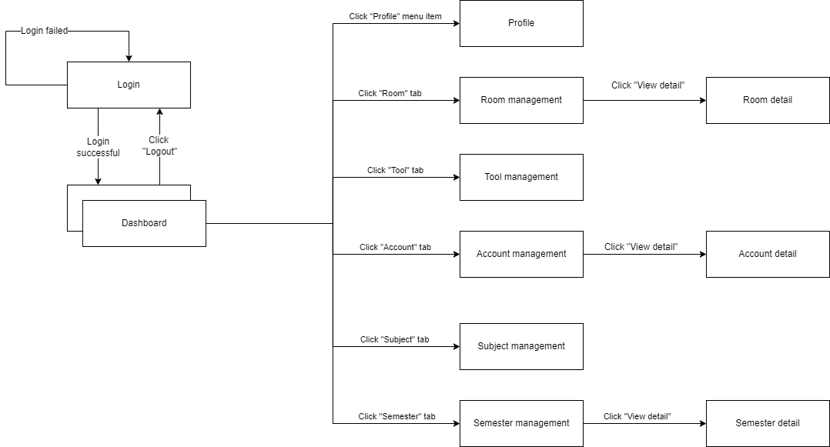

Figure 70. Manager screen flow

##### Shift manager

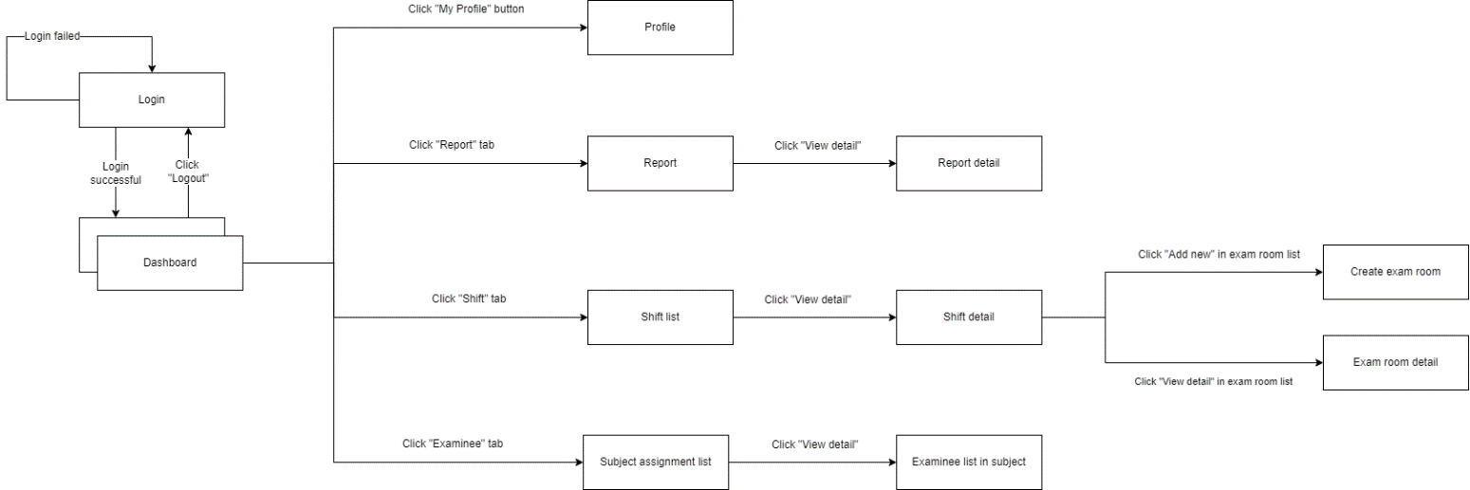

Figure 71. Shift manager flow

##### Staff

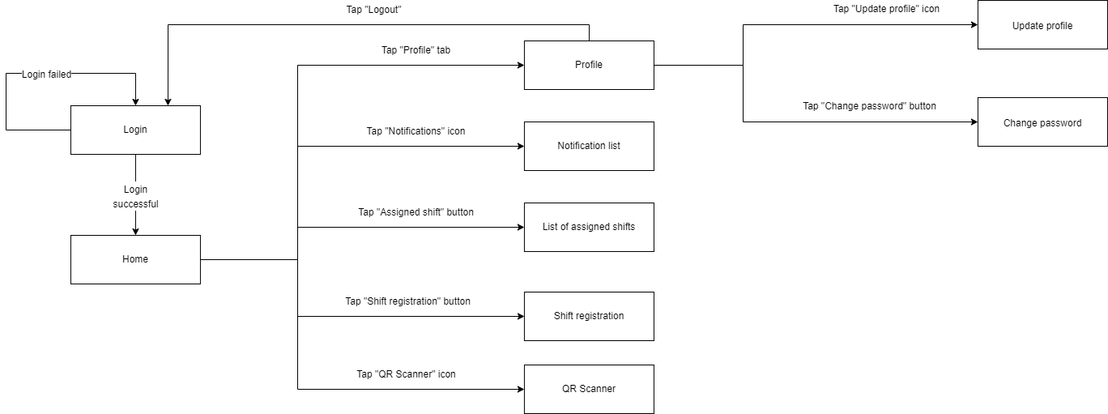

Figure 72. Staff mobile screen flow

##### Examinee

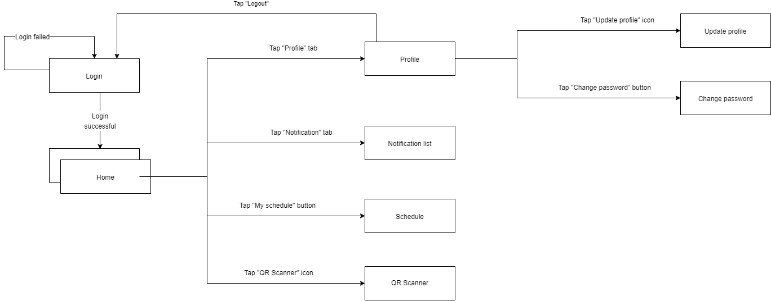

Figure 73. Examinee mobile screen flow

##### Camera

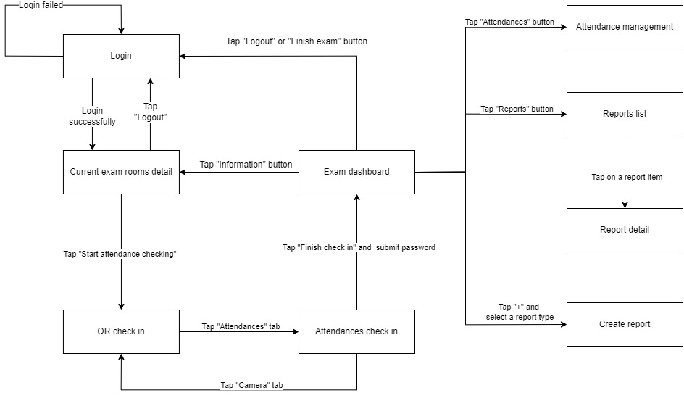

Figure 74. Camera screen flow

#### 3.1.2. Screen Authorization

Table 72. Web screen authorization

|  |  |  |  |
| --- | --- | --- | --- |
| **Screen / Popup / Modal** | **Unauthenticated User** | **Manager** | **Shift Manager** |
| Login | X |  |  |
| Dashboard |  | X | X |
| Notification List |  | X | X |
| View Profile |  | X | X |
| Manage Accounts |  | X |  |
| Select account role modal |  | X |  |
| Create account modal |  | X |  |
| View account detail |  | X |  |
| Manage Rooms |  | X |  |
| Create room modal |  | X |  |
| Manage Tools |  | X |  |
| Create tool modal |  | X |  |
| Manage Semesters |  | X |  |
| Create semester modal |  | X |  |
| View semester detail |  | X |  |
| Manage subjects |  | X |  |
| Create subject modal |  | X |  |
| Import account modal |  | X |  |
| Manage examinees |  |  | X |
| Import examinees modal |  |  | X |
| Subject’s examinees detail |  |  | X |
| Manage Shifts |  |  | X |
| Create shift modal |  |  | X |
| View shift detail |  |  | X |
| View exam room detail |  |  | X |
| Create exam rooms |  |  | X |
| Manage reports |  |  | X |
| View report detail |  |  | X |

Table 73. Mobile screen authorization

|  |  |  |  |
| --- | --- | --- | --- |
| **Screen / Popup** | **Unauthenticated User** | **Staff** | **Examinee** |
| Login | X |  |  |
| Home tab |  | X | X |
| Notification tab |  | X | X |
| Profile tab |  | X | X |
| View profile detail |  | X | X |
| View assigned exam shift list |  | X | X |
| Shift registration |  | X |  |
| Scan QR button |  | X | X |
| View current exam rooms detail |  | X |  |
| Attendance checking screen |  | X | X |
| Exam room dashboard |  | X |  |
| Manage attendance |  | X |  |
| Create report |  | X |  |
| View report detail |  | X |  |

In which:

* Unauthenticated User: Users who has not authenticated with VaLua
* Authenticated User: Users who currently authenticated with VaLua and are having a session for each user.
* Manager: Authenticated users who are authorized to manage accounts, subjects, tools, semesters, rooms.
* Shift Manager: Authenticated users who are authorized to manage shifts, exam rooms, examinees, reports.
* Staff: Authenticated users who have responsibility to manage exams in their assigned exam room, start and finish attendance checking, create reports.
* Examinee: Authenticated users who are authorized to view their own schedule and check attendance themselves.

#### 3.1.3. Non-Screen Functions

Table 74. Non-Screen Functions

|  |  |  |
| --- | --- | --- |
| **#** | **System Function** | **Description** |
| 1 | Send emails | VaLua sends emails in a batch of 100 items every 2 minutes when shifts are locked. |
| 2 | Push notification | VaLua send notifications to users on a specific event. |

#### Entity Relationship Diagram

##### Non-attributes Entity Relationship Diagram (Crow’s foot notation)

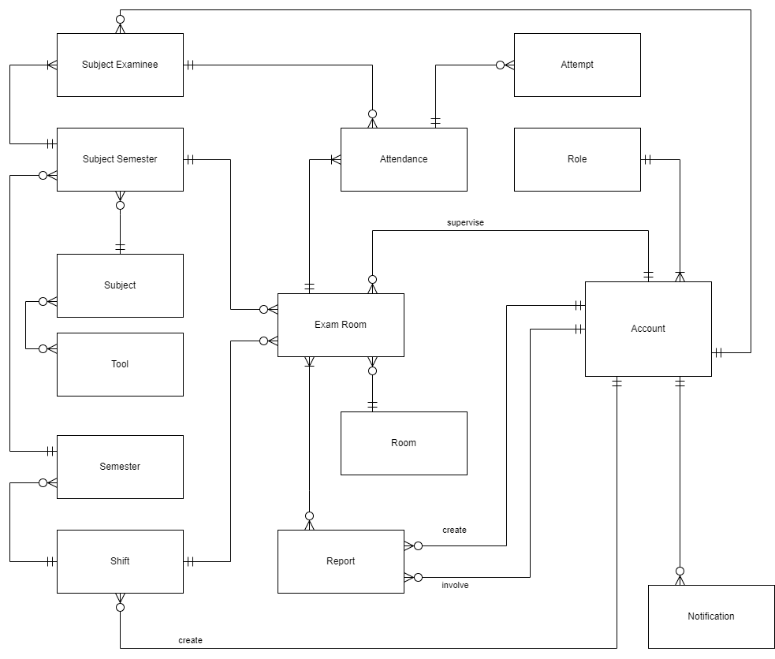

Figure 75. Non-attributes Entity Relationship Diagram (Crow’s foot notation)

##### Entity Relationship Diagram (Crow’s foot notation)

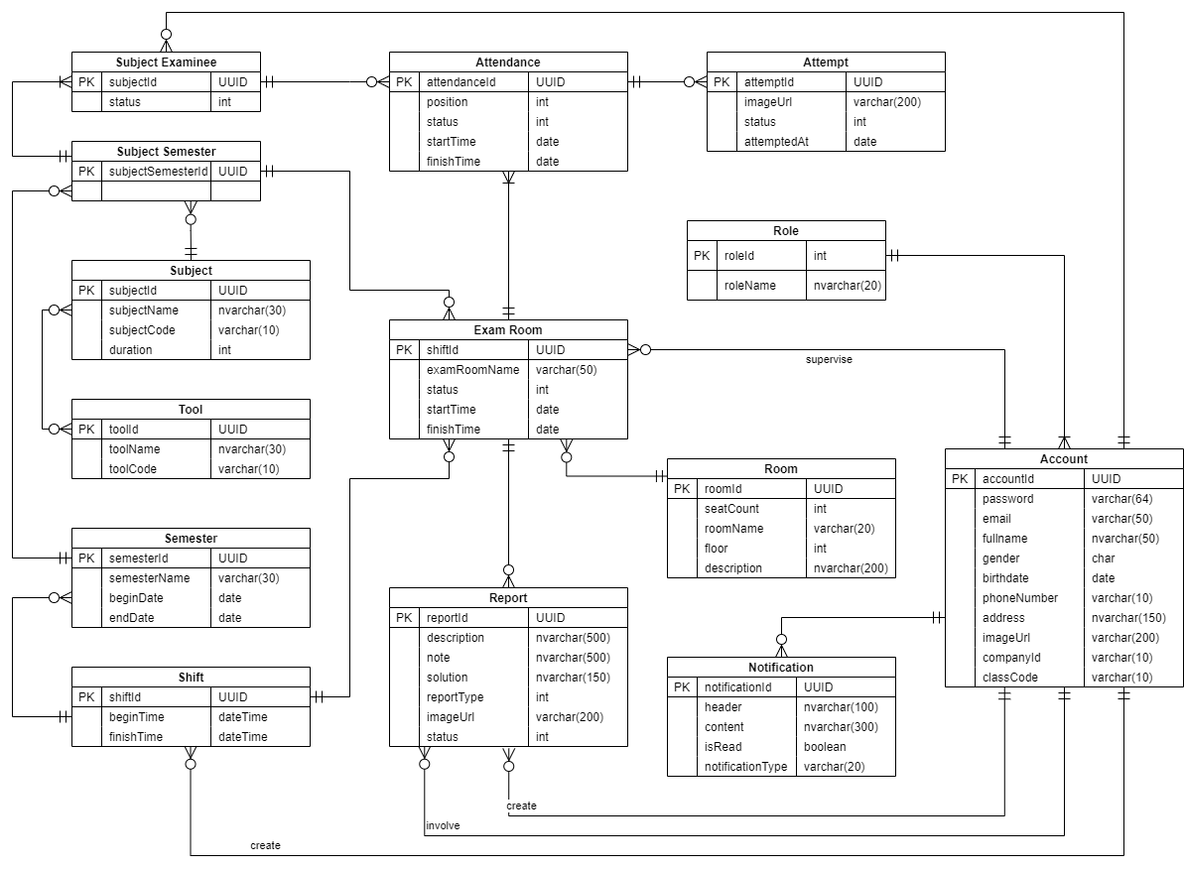

Figure 76. Entity Relationship Diagram (Crow’s foot notation)

##### Entities list

Table 75. Entities list

|  |  |  |
| --- | --- | --- |
| **#** | **Entity** | **Description** |
| 1 | Account | Basic information of users in the system |
| 2 | Role | System roles for account authorization |
| 3 | Notifications | System notification information |
| 4 | Shifts | The time frame in which a shift starts and finishes |
| 5 | Exam room | Information of an exam which specifies a room, a subject, a supervisor and a list of examinees |
| 6 | Report | Information about a report occurred during a shift. |
| 7 | Attendance | Information of an examinee’s attendance in an exam room |
| 8 | Attempt | Information of an examinee’s attempt to check attendance |
| 9 | Tool | Information about a tool which is allowed to be used in subjects |
| 10 | Semester | Information of a semester |
| 11 | Subject | Information of a subject |
| 12 | Room | Information of a room used as a location to conduct exams |
| 13 | Subject Examinee | Information of examinees’ assignments in a subject |
| 14 | Subject Semester | Information about subjects in semesters |

## 4. Non-Functional Requirements

### 4.1 External Interfaces

#### a. User Interfaces

UI-1: The user interface should be clear, consistent and easy to use

UI-2: The label of the input field and error message must be meaningful

UI-3: Optimized for both desktop and mobile

UI-4: UI must be in English

#### b. Software Interfaces

SI-1: For web applications, support Chrome (version 87 or higher), Internet Explorer (version 11 or higher), or any browser that support HTML5 and CSS3.

SI-2: For mobile applications, support Android version 6.0 (Marshmallow) or higher.

SI-3: For system handlers, it requires Windows 10 (Professional edition version 1909 or higher).

#### c. Hardware Interfaces

HI-1: A device with a 1080p camera or better and the viewing angle at least of 60°.

#### d. Communications Interfaces

CI-1: VaLua will send notifications or emails to manager, shift manager, staff, examinee based on specific events.

CI-2: VaLua uses HTTP protocol with RESTful standards to communicate between components (mobile, web, server)

### 4.2 Quality Attributes

#### a. Usability

* It takes at maximum 15 minutes to check attendances for 20 examinees.
* It takes 2 hours to train Manager functions.
* It takes 2 hours to train Shift Manager functions.
* It takes 1 hours to train Staff functions.
* It takes 30 minutes to train Examinee functions.
* The user interface is designed to be easy to use, even for non-IT staff.
* System support detects violations through cameras efficiently.

#### b. Reliability

* The accuracy of attendance checking must be at least 80%.

#### c. Performance

* The system must be able to handle multiple checking request with an image.
* The average response time is a 500ms.

#### d. Dependability

##### d1. Security

* JWT (Json Web Token) is used for authentication and authorization.
* All input and data are validated both in front end and back end.

##### d2. Safety

* Manager must ensure that the power supply for the camera and server when taking exam to ensure the detection working correctly.

#### e. Supportability

* Should apply RESTful Web API standard.
* Should follow the coding convention.
* All development tools and starting guidelines should be listed with the attached documents.

#### f. Design Constraints

* Using Flask, Python, OpenCV and PyTorch for face verification.
* Mobile application is built using Flutter framework and Dart.
* Web application is built from ReactJS.
* Back-end server is built using Java and Spring Boot follows the 3-layers architecture and repository pattern.

#### g. Support Documents

* Installation instruction should be detailed and easy to understand.
* Every configuration setting should be included.

## 5. Other Requirements

### 5.1 Messages List

Table 76. Message list

|  |  |  |  |  |
| --- | --- | --- | --- | --- |
| **#** | **Message code** | **Message type** | **Context** | **Content** |
| 1 | MSG0001 | Error message | Internet connection lost | Internet connection lost |
| 2 | MSG0002 | Information message | List is empty | No data |
| 3 | MSG0102 | Error message | User logged in Valua Camera app is not a staff | Only staffs are allowed to log into VaLua Camera |
| 4 | MSG0103 | Error message | User tried to use external Google account to login | You must be an internal user to log in the system. |
| 5 | MSG0104 | Error message | Login email is not in email format | Invalid email format |
| 6 | MSG0105 | Error message | Login email is required | Email is required |
| 7 | MSG0106 | Error message | Password is required | Password is required |
| 8 | MSG0107 | Error message | Bad login credentials | Invalid email or password |
| 9 | MSG0200 | Information message | Create a new account successfully | Create account successfully |
| 10 | MSG0202 | Error message | Company ID is required | Company ID is required |
| 11 | MSG0203 | Error message | Full name is required | Full name is required |
| 12 | MSG0204 | Error message | Email is required | Email is required |
| 13 | MSG0205 | Error message | Phone number is required | Phone number is required |
| 14 | MSG0206 | Error message | Address is required | Address is required |
| 15 | MSG0207 | Error message | Class is required | Class is required |
| 16 | MSG0208 | Error message | Full name is invalid | Full name must be letter only with length of 3 - 50 characters |
| 17 | MSG0209 | Error message | Email is invalid | Please enter a valid email |
| 18 | MSG0210 | Error message | Birthdate is invalid | Invalid date |
| 19 | MSG0211 | Error message | Phone number has more than 10 digits | Phone required length is 10 |
| 20 | MSG0212 | Error message | Phone number is invalid | Phone number is not valid |
| 21 | MSG0213 | Error message | Age is invalid | Age must be greater than or equal to 7 years old |
| 22 | MSG0214 | Error message | Class code is invalid | Maximum length of class field is 10 characters |
| 23 | MSG0215 | Error message | Company ID is invalid | Maximum length of company ID field is 10 characters |
| 24 | MSG0216 | Error message | Profile image is invalid | File type must be image/jpeg,image/png |
| 25 | MSG0217 | Error message | Company ID is duplicated | Company ID is duplicated |
| 26 | MSG0218 | Error message | Phone number is duplicated | Phone number is duplicated |
| 27 | MSG0219 | Error message | Email is duplicated | Email is duplicated |
| 28 | MSG0300 | Information message | Update account successfully | Update account successfully |
| 29 | MSG0400 | Information message | Disable account successfully | Disable account successfully |
| 30 | MSG0401 | Confirm message | Disable account confirmation | Do you want to disable this account? |
| 31 | MSG0600 | Information message | Reset password successfully | Reset password successfully |
| 32 | MSG0700 | Error message | Subject code is duplicated | Subject code is duplicated |
| 33 | MSG0701 | Error message | Subject code is invalid | Subject code max length is 10 |
| 34 | MSG0702 | Error message | Subject name is invalid | Subject name max length is 50 |
| 35 | MSG0703 | Error message | Subject duration is invalid | Max duration is 4h30 hours |
| 36 | MSG0704 | Error message | Subject code required | Subject code is required |
| 37 | MSG0705 | Error message | Subject name required | Name is required |
| 38 | MSG0706 | Information message | Subject duration required | Duration is required |
| 39 | MSG0707 | Information message | Create subject successfully | Create subject successfully |
| 40 | MSG0800 | Information message | update subject successfully | Update subject <subject code> successfully |
| 41 | MSG0900 | Information message | disable subject successfully | Disable subject successfully |
| 42 | MSG0901 | Confirm message | disable subject confirmation | Do you want to disable this subject? |
| 43 | MSG1200 | Information message | create a new semester successfully | Create semester successfully. |
| 44 | MSG1201 | Error message | required field semester name. | Name is required. |
| 45 | MSG1202 | Error message | duplicate semester name. | Semester name is already exists. |
| 46 | MSG1203 | Error message | Invalid semester name. Input value length > max length | Maximum length of semester name field is 50 characters. |
| 47 | MSG1204 | Error message | Begin date greater than end date. | Begin date must be less than end date. |
| 48 | MSG1205 | Error message | Begin date is less than present. | Begin date must be greater than present. |
| 49 | MSG1206 | Error message | Chosen date is duplicate. | There is already a semester that had taken the chosen date. |
| 50 | MSG1300 | Information message | Update a new semester successfully | Update semester successfully. |
| 51 | MSG1400 | Confirm message | Confirm to disable semester | Do you want to disable semester <Semester name> |
| 52 | MSG1401 | Information message | Disable semester successfully | Disable semester successfully |
| 53 | MSG1700 | Information message | Add subjects to semester successfully | Add subjects to semester successfully. |
| 54 | MSG1800 | Confirm message | Confirm to remove subject from semester. | Do you want to remove this subject <subject code>. This action can't be revert. |
| 55 | MSG1801 | Information message | Remove subject from semester successfully. | Remove subject from semester successfully. |
| 56 | MSG1802 | Error message | Updating a semester which is in progress | This semester have been put in use, removing subjects is not allowed! |
| 57 | MSG1900 | Information message | create tool successfully | Create tool successfully |
| 58 | MSG1901 | Error message | tool code required | Tool code is required |
| 59 | MSG1902 | Error message | tool name required | Name is required |
| 60 | MSG1903 | Error message | tool code is invalid | Tool code must have length of 3 - 50 characters |
| 61 | MSG1904 | Error message | tool name is invalid | Maximum length of tool name field is 3 - 50 characters |
| 62 | MSG1905 | Error message | tool code is duplicated | This tool code is already taken. |
| 63 | MSG2000 | Information message | update tool successfully | Update tool <tool code> successfully |
| 64 | MSG2100 | Information message | disable tool successfully | Disable tool successfully |
| 65 | MSG2101 | Confirm message | disable tool confirmation | Do you want to disable <tool name>? |
| 66 | MSG2500 | Information message | Create room successfully | Create room successfully |
| 67 | MSG2501 | Error message | Required field room's name | Name is required |
| 68 | MSG2502 | Error message | Required field floor | Floor is required |
| 69 | MSG2503 | Error message | Required field seat count | Seat count is required |
| 70 | MSG2504 | Error message | Max length of name is 255 | Max length is 255 |
| 71 | MSG2505 | Error message | Invalid seat count. Input value less than or equal 0 | Seat count must be a positive number |
| 72 | MSG2506 | Error message | Invalid floor. Input value less than 0. | Minimum floor is 0 |
| 73 | MSG2507 | Confirm message | Confirm to delete room | Do you want to disable this room. This action can't be revert. |
| 74 | MSG2508 | Information message | Disable room successfully | Disable room successfully. |
| 75 | MSG3101 | Information message | Change password successfully | Change password successfully |
| 76 | MSG3102 | Error message | Required field current password | Current password is required |
| 77 | MSG3103 | Error message | Confirm password doesn't match with new password | Confirm password doesn't match new password |
| 78 | MSG3104 | Error message | Required field new password | New password is required |
| 79 | MSG3301 | Error message | Required field full name | Full name is required |
| 80 | MSG3302 | Error message | Required field date time | Please pick a date |
| 81 | MSG3303 | Error message | Required field phone | Phone number is required |
| 82 | MSG3304 | Error message | Invalid full name. Input value length < min length or > max length. Input value not letter. | Full name must be letter only with length of 3 - 50 characters |
| 83 | MSG3305 | Error message | Invalid phone number | Please enter a valid Vietnamese phone number |
| 84 | MSG3400 | Information message | Empty notification list | There is no notification yet |
| 85 | MSG3500 | Information message | Update attendance successfully | Update attendance successfully |
| 86 | MSG3700 | Information message | Create report success | Create report successfully |
| 87 | MSG3701 | Error message | Required field report description | Description is required |
| 88 | MSG3702 | Error message | Required report's violator | A violator is required |
| 89 | MSG3703 | Error message | Required report's image | Image is required |
| 90 | MSG3704 | Error message | Invalid description. Description min length is 6 | Description must be at least 6 characters |
| 91 | MSG4000 | Information message | Register shifts successfully | Register successfully |
| 92 | MSG4001 | Confirm message | Confirmation before register shifts | Register this shift? This action can't be reverted. |
| 93 | MSG4002 | Error message | Register failed | One of the registered shift is not available to you! Please refresh and try again. |
| 94 | MSG4200 | Information message | Update report successfully | Update report successfully |
| 95 | MSG4300 | Information message | Create shift successfully | Create shift successfully |
| 96 | MSG4301 | Error message | Empty or invalid inputs on shift's begin time or end time | Invalid date |
| 97 | MSG4302 | Error message | Begin time is from the past | Begin time must be larger than current time |
| 98 | MSG4303 | Error message | Finish time is after begin time more than 8 hours | Max time range is 8 hours |
| 99 | MSG4304 | Error message | Begin time is after finish time | Begin time must be before finish time! |
| 100 | MSG4305 | Error message | Begin time is too soon from now | Begin time must be at least <min time threshold> hours later than now |
| 101 | MSG4306 | Error message | Duplicate in shift's time | There is already a shift that take the exact same time! |
| 102 | MSG4307 | Error message | Begin time or finish time is out of bound | Begin time and finish time must be in <current semester> duration. |
| 103 | MSG4308 | Error message | Create shift in semester with end date from the past | This semester <selected semester> has ended! No new shift can be created! |
| 104 | MSG4400 | Information message | Update shift successfully | Update shift successfully |
| 105 | MSG4500 | Information message | Delete shift successfully | Delete shift successfully |
| 106 | MSG4501 | Confirm message | Delete shift confirmation | Do you want to delete this shift? This action can’t be reverted. |
| 107 | MSG4800 | Information message | Lock shifts successfully | Lock <number of shifts> shift(s) sucessfully |
| 108 | MSG4801 | Information message | Lock shift successfully | Lock shift successfully |
| 109 | MSG4900 | Information message | Start staffing for shifts successfully | Start staffing for <number of shifts> shift(s) sucessfully |
| 110 | MSG4901 | Information message | Start staffing for shift successfully | Start staffing successfully |
| 111 | MSG5100 | Information message | Exempt examinee successfully | Remove examinee successfully |
| 112 | MSG5101 | Error message | Reason to exempt examinee is required | Reason must be 8 - 50 chars long |
| 113 | MSG5300 | Information message | Created exam room successfully | Created exam room successfully |
| 114 | MSG5301 | Information message | Created <number of created> exam room(s) successfully | Created <number of created> exam room(s) successfully |
| 115 | MSG5302 | Error message | An available subject is required. | Please select a subject to assign |
| 116 | MSG5303 | Error message | An available room is required. | An available room is required. |
| 117 | MSG5400 | Information message | Update exam room successfully | Update exam room successfully |
| 118 | MSG5401 | Error message | A reserved staff is required in ready shifts. | A reserved staff is required in ready shifts. |
| 119 | MSG5402 | Error message | A room is required. | A room is required. |
| 120 | MSG5500 | Information message | Delete exam room successfully | Exam room has been successfully deleted |
| 121 | MSG5501 | Confirm message | Delete exam room confirmation | Do you want to delete this exam room ?  This action can't be revert |
| 122 | MSG5700 | Information message | Add an examinee to an exam room successfully | <Examinee name> has been successfully added to this exam room |
| 123 | MSG5800 | Information message | Remove an examinee from an exam room successfully | Examinee has been successfully removed |
| 124 | MSG6200 | Information message | Resolve report successfully | Resolve report successfully |
| 125 | MSG6201 | Error message | Solution is required | Solution is required |
| 126 | MSG6401 | Information message | Directing message on camera app in attendance QR screen | Scan exam room's QR to check in |
| 127 | MSG6402 | Error message | AI return false when checking attendance | Your face did not match, please try again. |
| 128 | MSG6403 | Error message | The current attempt is more than 3 | This attendance has exceeded the maximum number of attempts! No more attempt allowed! |
| 129 | MSG6404 | Error message | The current attendance is already checked | This attendance has already been checked! No more attempt needed! |
| 130 | MSG6405 | Error message | No attendance found after scanning QR | No attendance for this examinee found in this room. |
| 131 | MSG6406 | Error message | Quitting camera capture screen | No picture can be taken |
| 132 | MSG6501 | Error message | There is no locked shifts. | There is no locked shifts. |
| 133 | MSG6600 | Information message | Auto assign staff successfully | Assign staff into <number of room> successfully |
| 134 | MSG6601 | Information message | Assign staff successfully | Assign staff into <room name> successfully |
| 135 | MSG6700 | Information message | Auto assign shift request sent | Auto assign shifts request sent successfully |

## 6. Algorithms

### 6.1 Face Detection

#### 6.1.1 Define Problem

* If the face is not detected exactly, it will lead to an error for the next step – face verification.

#### 6.1.2 Requirement

* The time for detection is fast.
* The face must be detected correctly.

#### 6.1.3 Solution

* We choose MTCNN (MultiTask Cascaded Convolutional Neural Network) - a deep learning model for face detection to solve this problem.

##### 6.1.3.1 MTCNN Architecture

* MTCNN includes three networks: P-Net, R-Net, and O-Net representing 3 main stages.

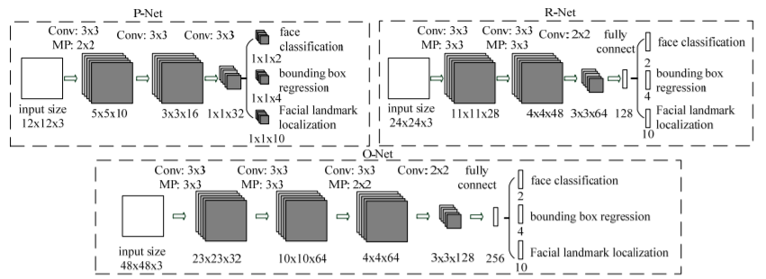

Figure 77: The architecture of P-Net, R-Net, and O-Net.

* Stage 1:
  + Firstly, the input image is used to create the image pyramid (resize to different sizes). The purpose of this is to detect all faces of various sizes.

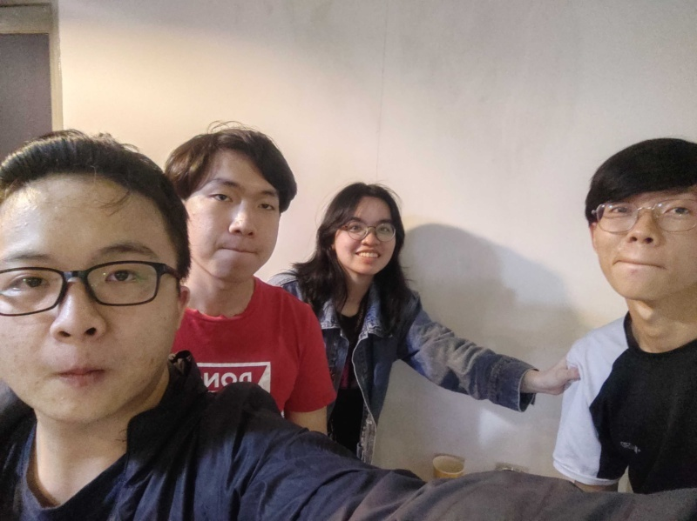

Figure 78. The original image

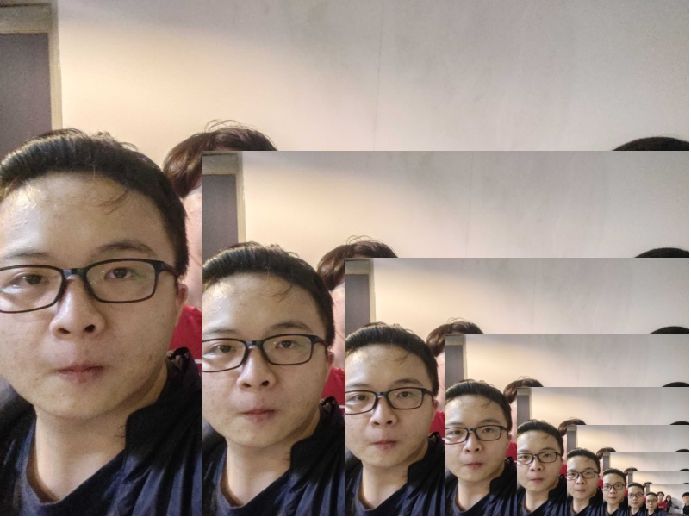

Figure 79: Stage 1 - Image Pyramid

* + A kernel with size 12x12 and stride is 2 goes through each sized copy image and detects faces.
  + Each kernel is fed through the P-Net, the output of the network is the bounding box coordinates and its confidence score if a face is detected.
  + Each kernel is fed through the P-Net, the output of the network is the bounding box coordinates and its confidence score if a face is detected.
  + After rescaled to the original image size, there are many bounding boxes that overlap with each other. To eliminate bounding boxes on images, MTCNN sets the threshold to remove low confident bounding boxes and uses NMS (Non-Maximum Suppression) to remove boxes that have high overlap.
  + About NMS (Non-Maximum Suppression):
    - The IOU computation is used to determine how much two bounding boxes overlap.
    - Remove that bounding box if the IOU exceeds the threshold N.

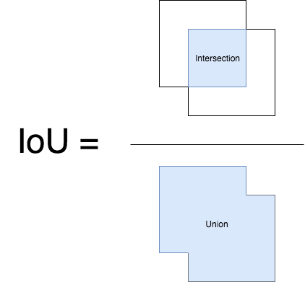

Figure 80: Intersection Over Union (IoU)

* MTCNN resizes the boxes to a square shape, gets the new coordinates of the boxes and feed into the next network.

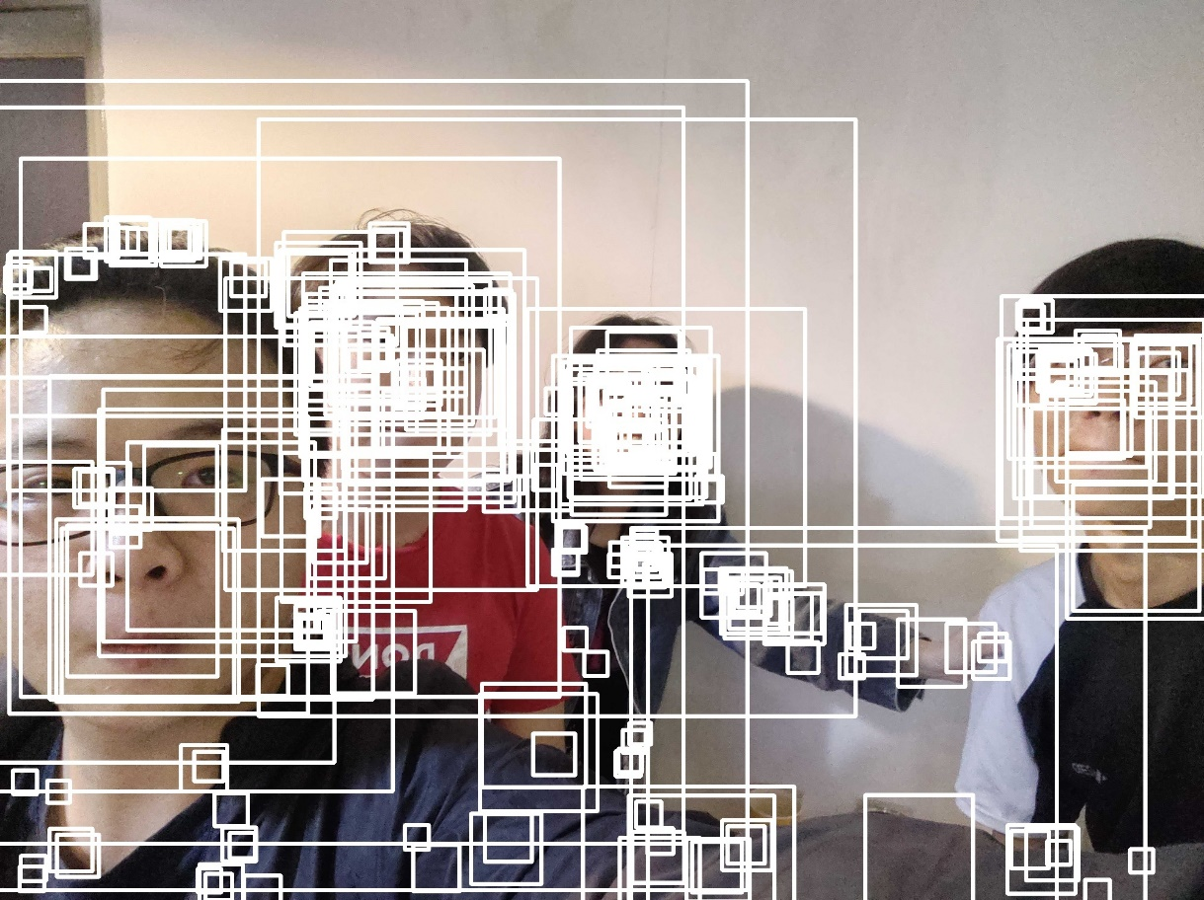

Figure 81. Stage 1 – Image result

* Stage 2:
  + The network uses a method called padding, which inserts zero-pixels into the missing parts of the bounding box if the bounding box exceeds the boundary of the image.
  + All bounding boxes will now be resized to 24x24, treated as a kernel and fed to the R-Net network.
  + The output of R-Net includes the coordinates of the new, more precise bounding boxes as well as the confidence of those bounding boxes.
  + Again, MTCNN removes low confidence bounding boxes and uses NMS to remove overlapping bounding boxes.

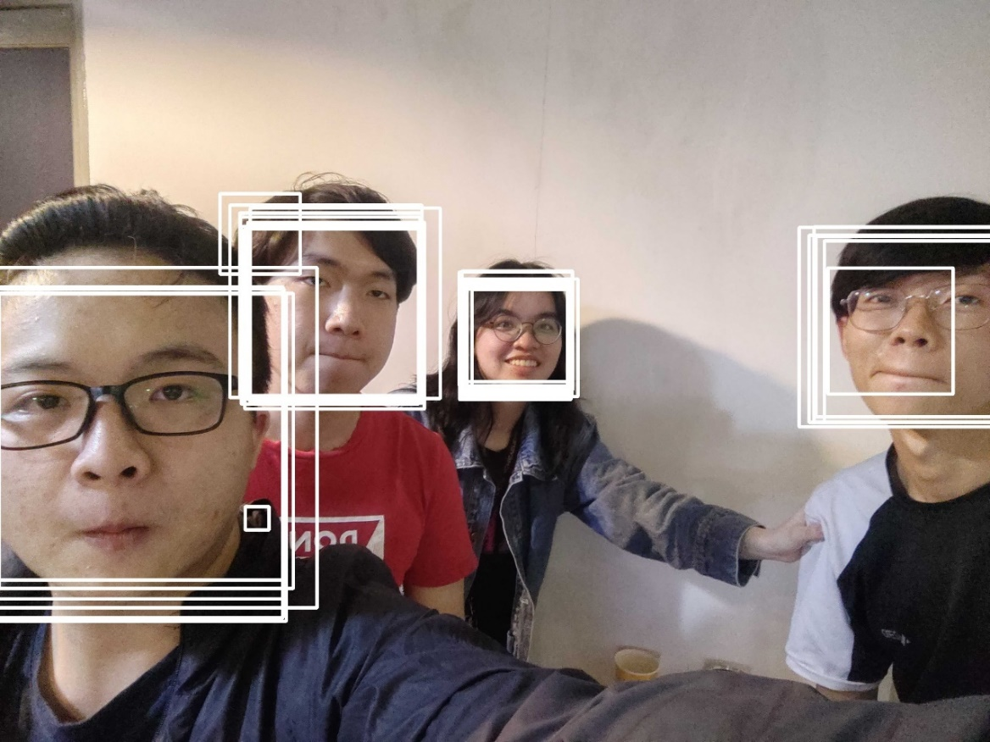

Figure 82. Stage 2 - Image before NMS

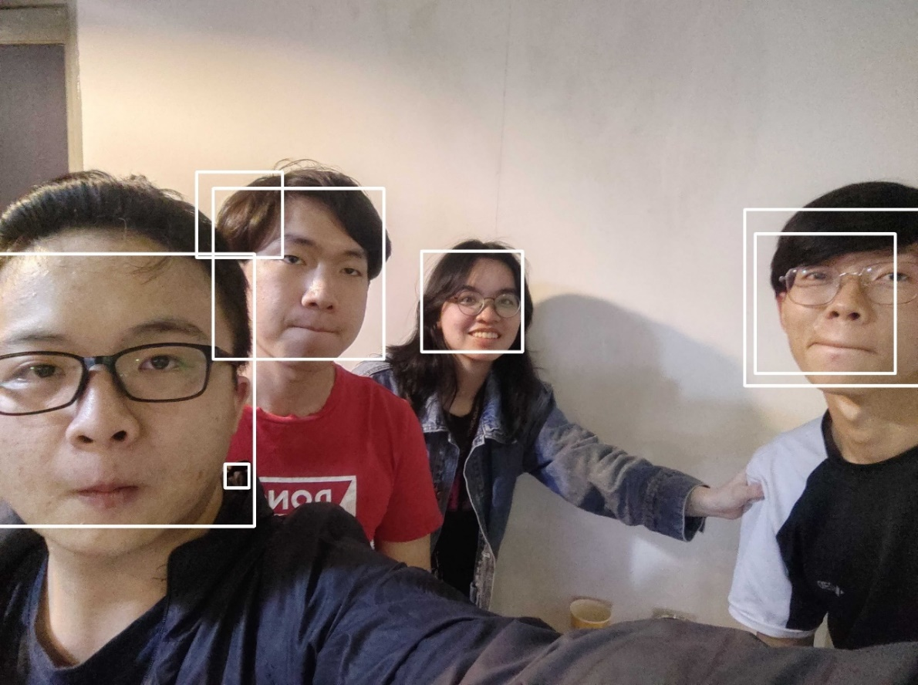

Figure 83: Stage 2 – Result image

* Stage 3:
  + Similar to stage 2, MTCNN need to pad the bounding boxes and resize them to 48x48. These new bounding boxes fed into the O-Net network.
  + However, the output of the network is 3 values ​​including:
    - 4 coordinates of the bounding box.
    - 5 coordinates of landmarks on the face, including 2 eyes, 1 nose, 2 sides of the lips
    - The confidence score of each box.

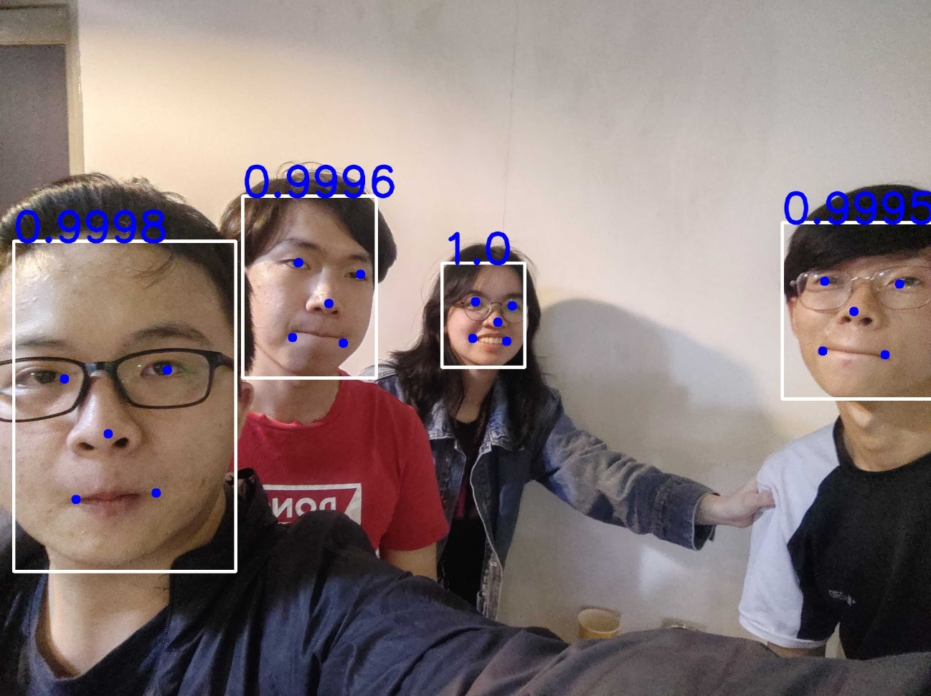

Figure 84: Stage 3 - The final image

* + During roll call, we only take attendance one person at a time, so we will take the face with the largest bounding box area and crop that face to include in the next step – face verification.



Figure 85. Cropped face

### 6.2 Face Verification

#### 6.2.1 Define Problem

* Face verification is a one-to-one problem. Find out the answer to the question are these two the same person.
* The number of students at FPT University is large and many new students enroll each year. As a result, the data set is always changing.
* People in images have different face angles which makes it difficult to be verified.

#### 6.2.2 Requirement

* The time for verification is fast.
* Accuracy must be high.
* Target’s identity must have face embedding file in dataset to be verified.

#### 6.2.3 Solution

* We choose Siamese Network to resolve the problem.
  + Siamese Network does not need to retrain all face student data when new students enter, but only needs to update embedding vector for that new data.

##### 6.2.3.1 Siamese Network

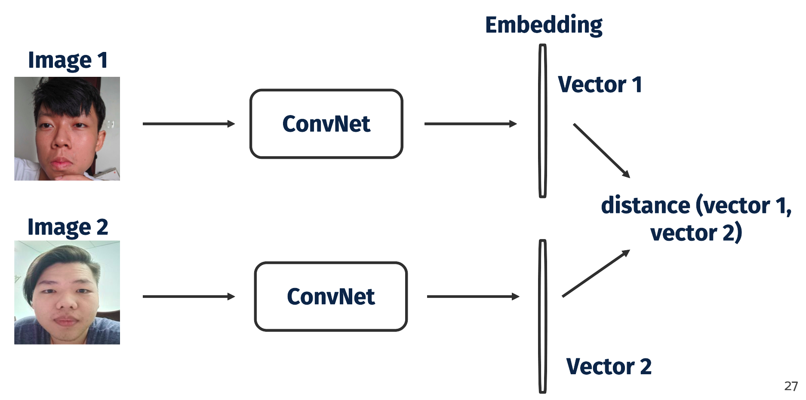

Figure 86: Siamese Network

* Siamese network is built based on the network which is a CNN architecture without an output layer (usually classifier), which encodes images into vector embedding.
* Workflow of Siamese Network:
  + The input to the Siamese Network is any two pictures randomly selected from the image data.
  + The output is 2 vectors encoding corresponding to the representation of 2 input images.
  + Calculate the distance between those 2 embedding vectors.
* The advantage of this network is that there is no need to train the last layer (usually classifier) every time new classes (examinee’s face) are added.
* But we need to find a Loss Function that is good enough to train the CNN model with the goal minimize the distance among samples of intra-class and increasing the inter-class distance.

##### 6.2.3.2 ArcFace model

* ArcFace uses a loss function called additive angular margin to train CNN.
* Instead of using the euclidean distance, ArcFace calculates the geodesic distance on the hypersphere.

.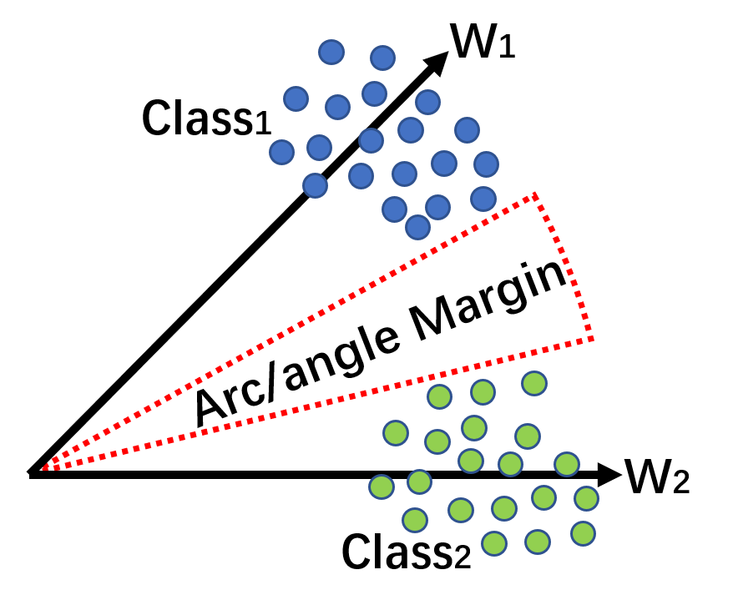

Figure 87: Illustration of ArcFace

* Blue and green points represent embedding features from two different classes. There is an angel margin added between 2 classes.
* ArcFace loss function is improved from the Softmax loss function, the goal of the improvement is to make the prediction depend entirely on the angle (θ) between features (x) and weights (W).

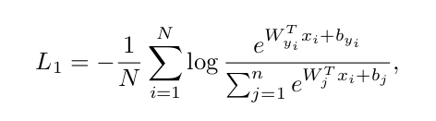

Figure 88: Softmax loss

* Finally, add an additive angular margin penalty m between the angle of features (x) and weights (W) to simultaneously enhance the intra-class compactness and inter-class discrepancy.

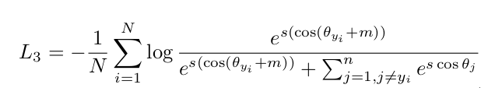

Figure 89: Formula - ArcFace Loss Function

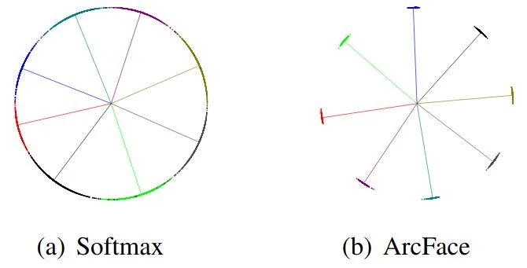

Figure 90: Example of class separation between Softmax and ArcFace

* When preparing data for face verification, each examinee will have 5 images from different angels (front, left side, right side, top, bottom) to encode into one embedding vector 512-d.



Figure 91. Example of examinee face images

##### 6.2.3.3 Distance Metric

* To measure the distance between two embeddings extracted from images of faces, we need some metrics.
  + Cosine distance:

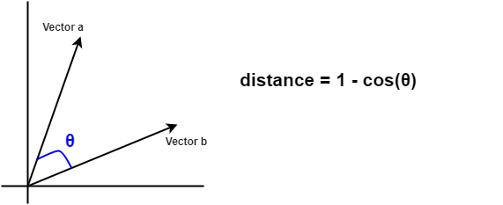

Figure 92. Cosine distance

* + Euclidean distance:

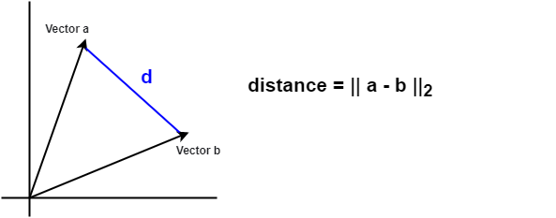

Figure 93. Euclidean distance

* + In ArcFace model, embedding vectors are normalize vectors. It means:

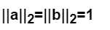

Figure 94. Normalize vector

* + Now, squared Euclidean distance has a formular:

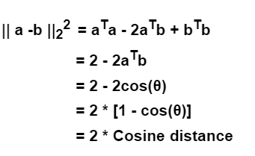

Figure 95. Change subject of Squared Euclidean distance formula

* + After the transformation, the formula for calculating the Squared Euclidean distance is two times the Cosine distance formula. That means using these two formulas is the same.

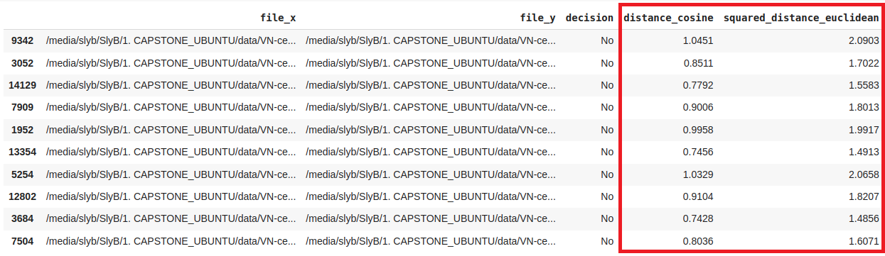

Figure 96. Squared Euclidean distance proportional to Cosine distance

* + We select cosine distance to masure distance between two embedding vectors.

##### 6.2.3.4 Threshold

* + To find the appropriate threshold, we use a statical approach by calculating mean and standard deviation of the dataset then apply the 68-95-99.7 rule to find that threshold.
  + About data test set, we use part of VN-Celeb data then generate to positive set and negative set.

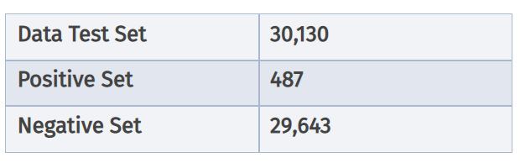

Figure 97. Size of dataset

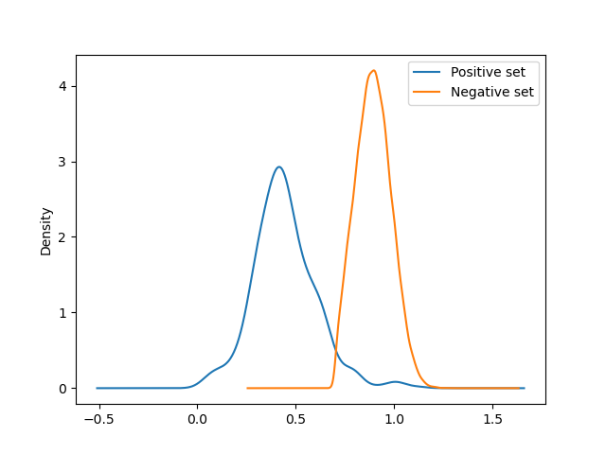

Figure 98. A kernel density estimate (KDE) plot - Cosine distance

* + Cosine distance:
    - Mean of true positives = 0.44
    - Standard deviation of true positives = 0.16
    - Mean of false positives = 0.89
    - Standard deviation of false positives = 0.09
  + Threshold = 0.89 – 0.09 * 2 = 0.71
    - 0.89: mean of false positives
    - 0.09: standard deviation of false positives
    - 2: sigma
  + If the distance is smaller than the threshold, the two faces are the same. Otherwise that two faces are different.

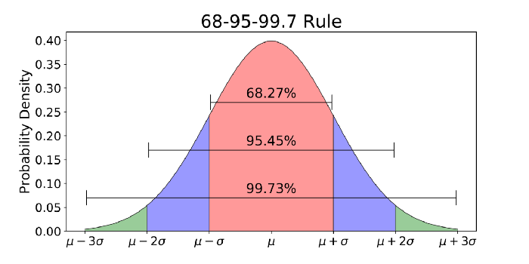

Figure 99. 68-95-99.7 rule for a Normal Distribution

#### 6.2.4 Model Evaluation

* We apply threshold 0.71 to our model and keep using VN - Celeb dataset to evaluate our model.
* Our model is evaluated based on precision, recall and f1 score.
  + Precision: correct predictions/ total predictions.
  + Recall: The metrics which measure the accuracy of the model, represented by the number of positive correct predictions over the total positive correct predictions that the model made.
  + F1 score: The harmonic mean of precision and recall.

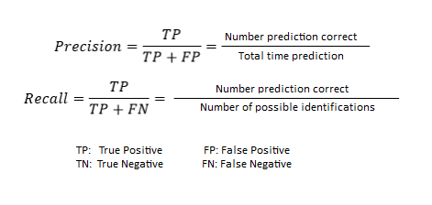

Figure 100. Precision and Recall

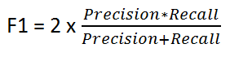

Figure 101. Formula - F1 Score

* After evaluating the model:
  + Recall: 95,28%
  + Precision: 72,5%
  + F1 Score: 82,34%
* **Conclusion**: In general, our model reached an accuracy of around 82,34% on the VN-Celeb small dataset, which is the acceptable standard.